**Shortest Path in Undirected Graph with Unit Weights**

1. 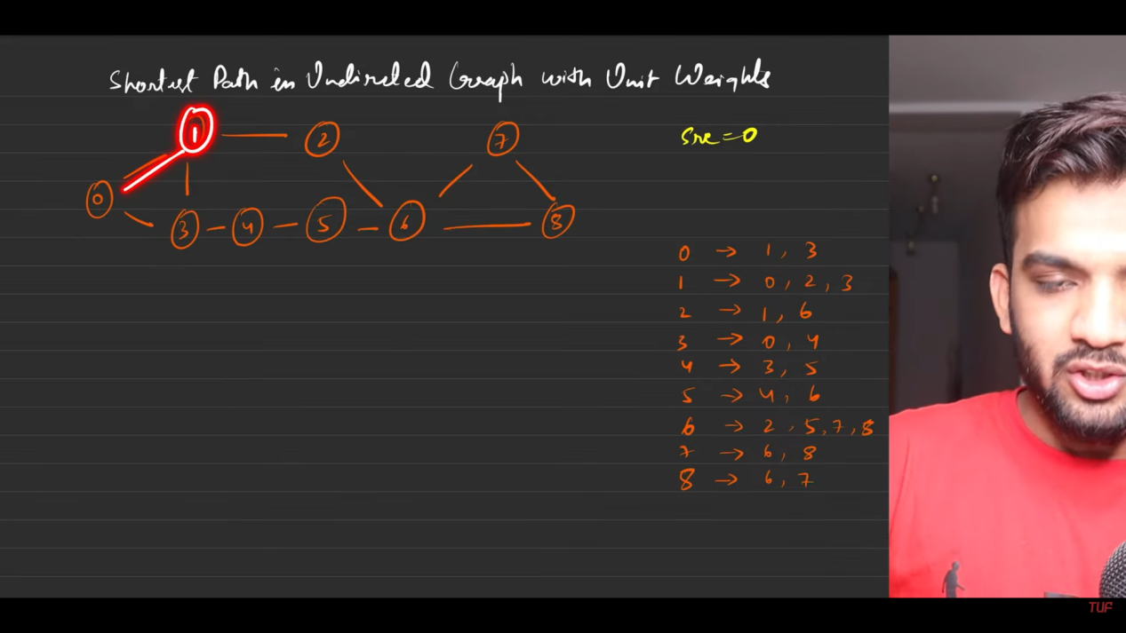
2. 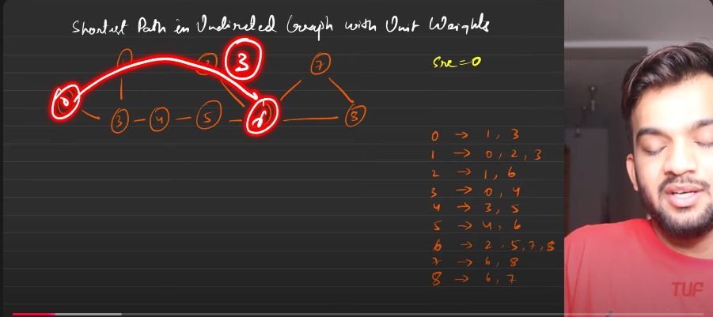
3. 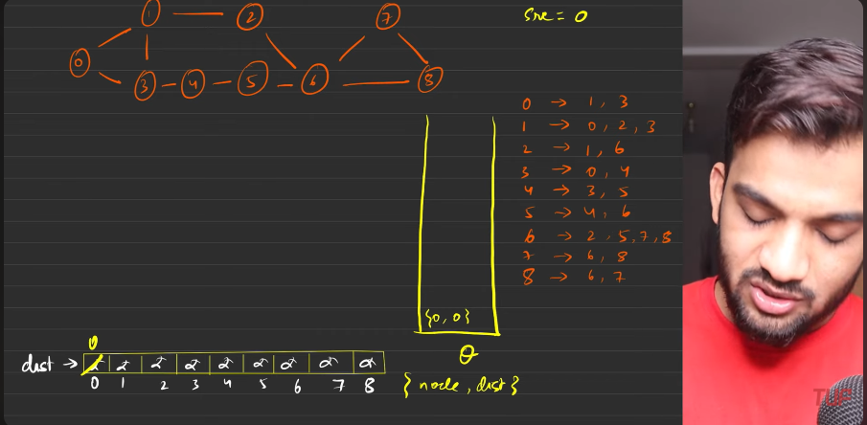
4. 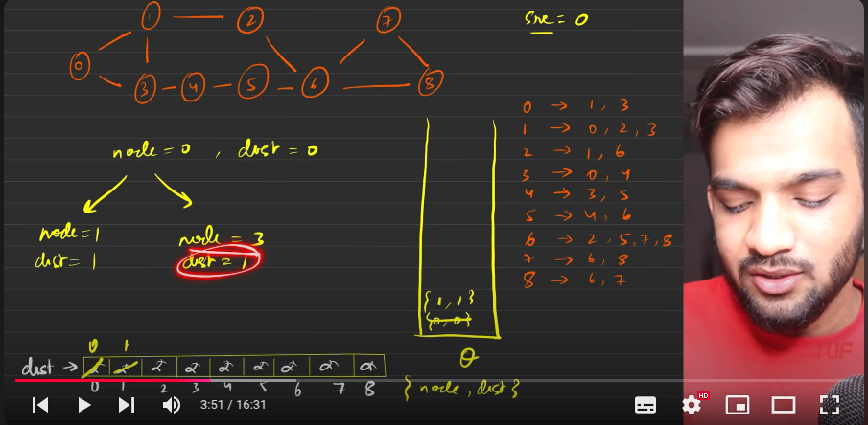
5. 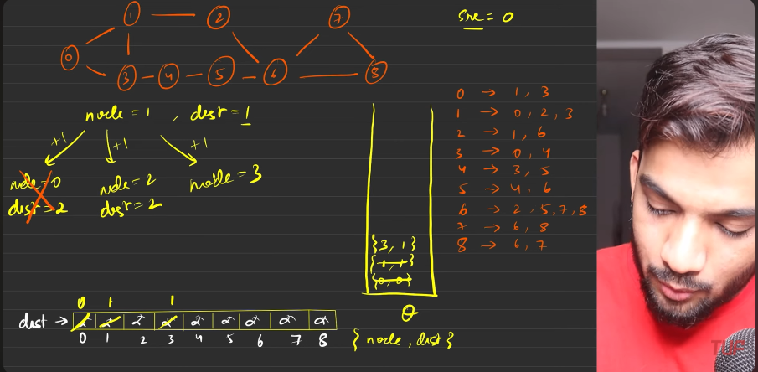
6. The reason why I’m not going to the node 0 from node 1 is because that is having distance less than the current node.
7. 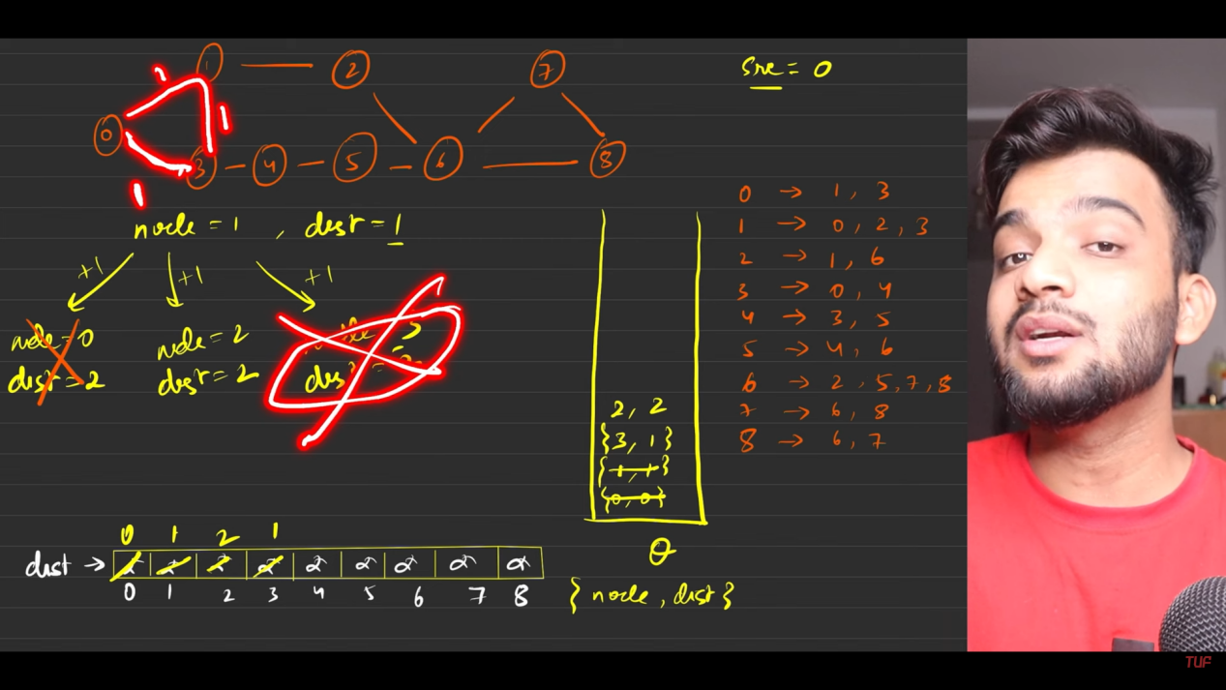
8. 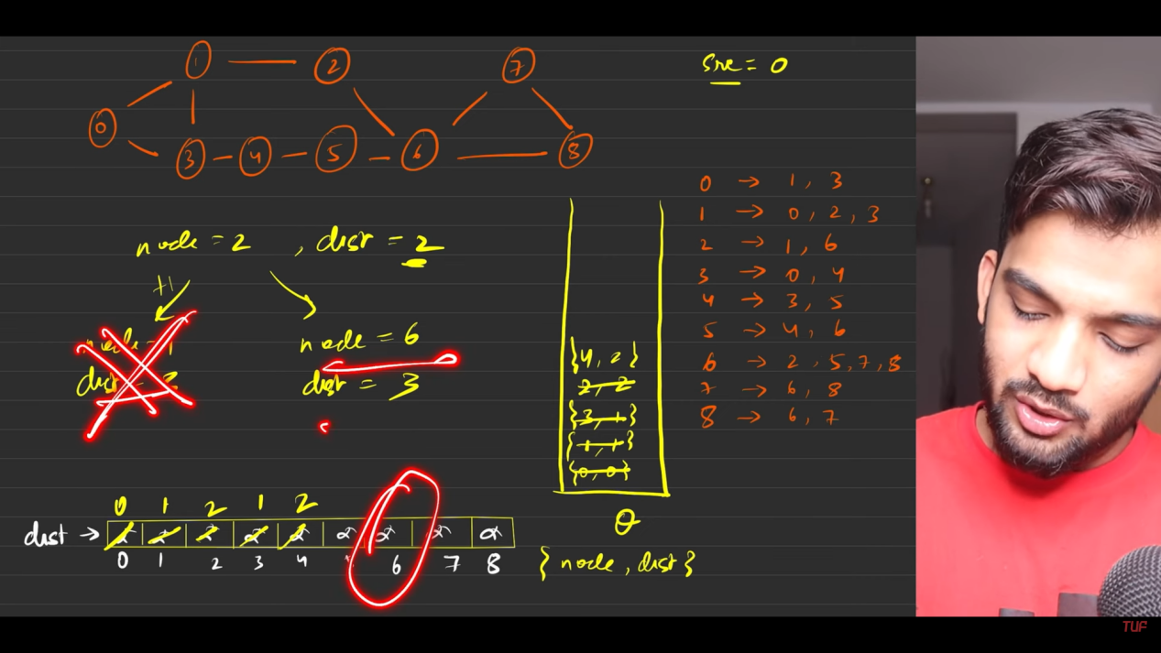
9. 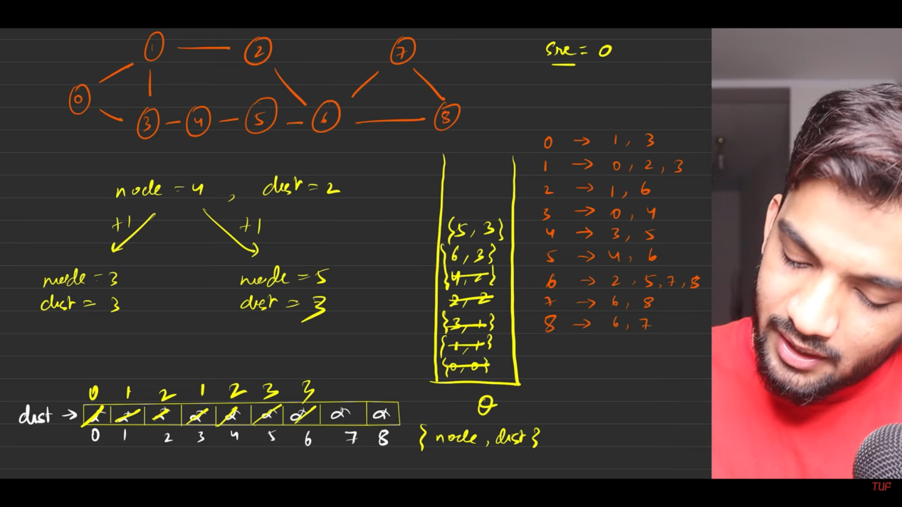
10. 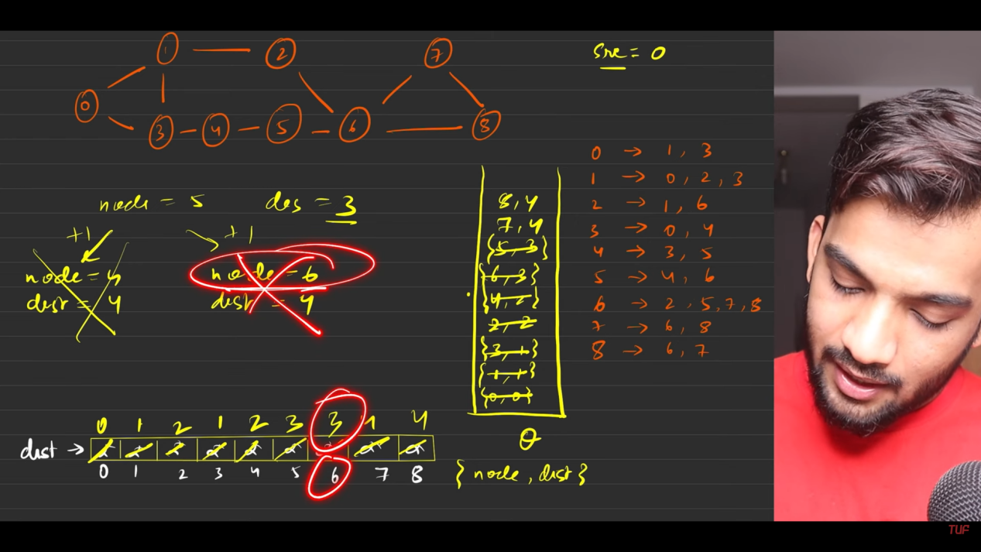
11. 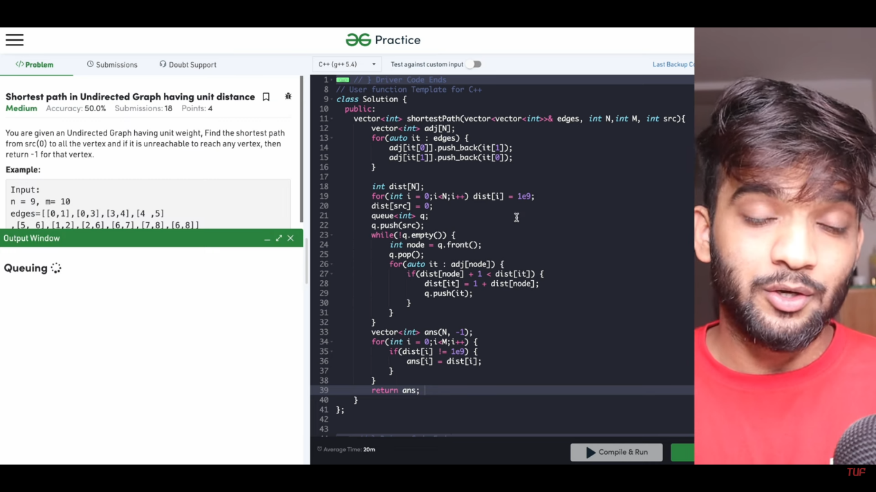
12. Te reason why we have used queue here over any other things is because , we are increasing the distance increasng everytime by one, so BFS is used.

**Shortest Path in Directed Acyclic Graph - Topological Sort**

1. 
2. 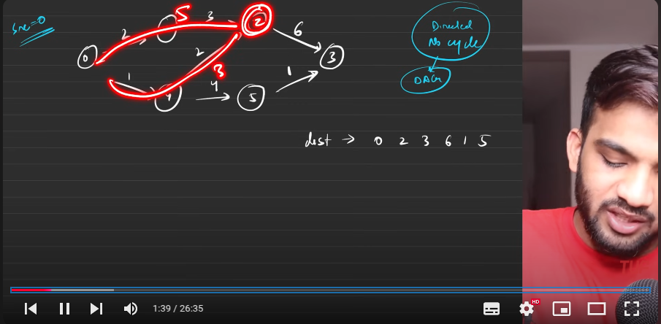
3. 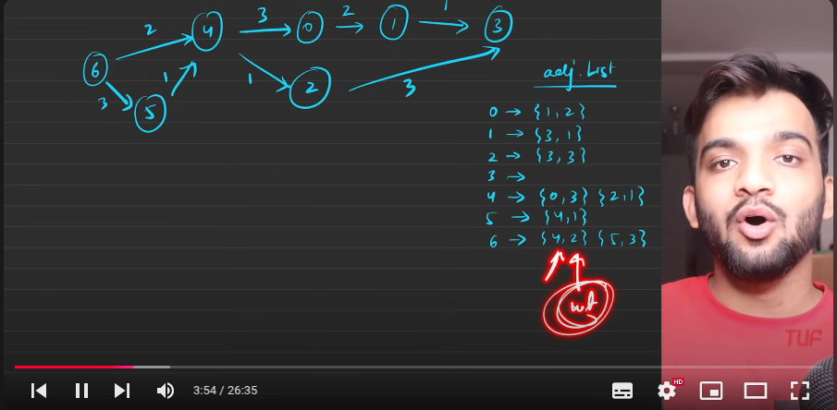
4. The toposort in DFS :
   1. Traverse the nodes till we reach maximum depth , once we reached themaximum depth, when coming back we use to make the entry in the stack.
   2. Removing from the stack and printing the stack entries will generate the topo sort order.
   3. 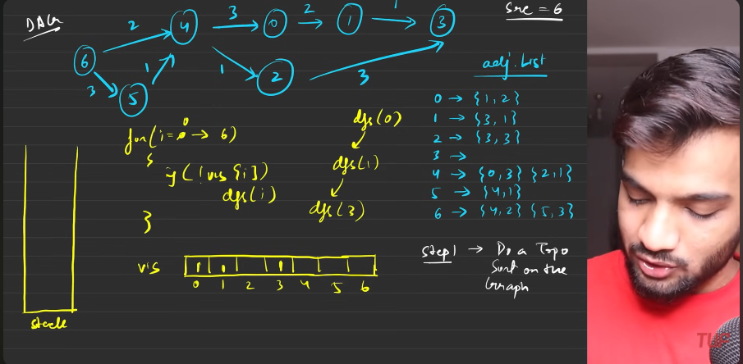
   4. 
   5. 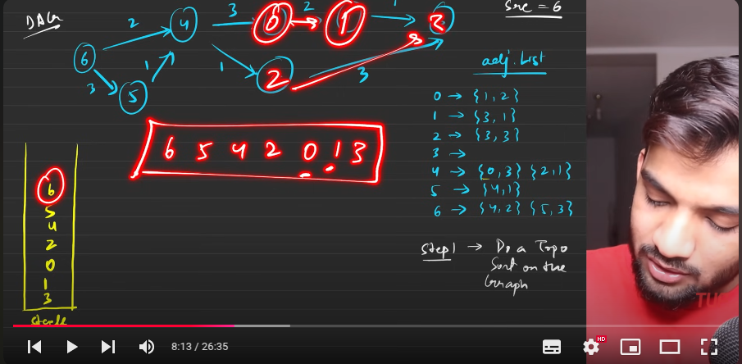
   6. STep 2: 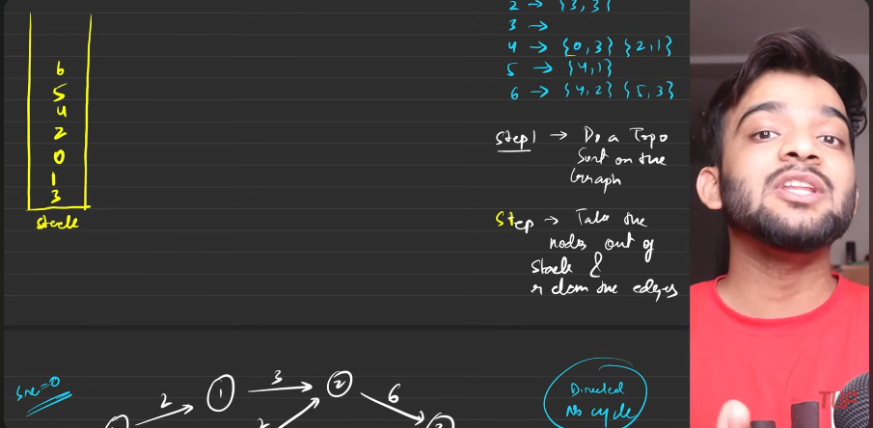
   7. 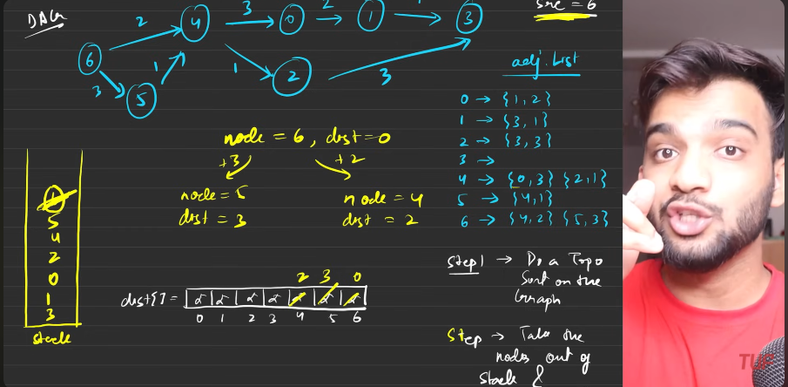
   8. 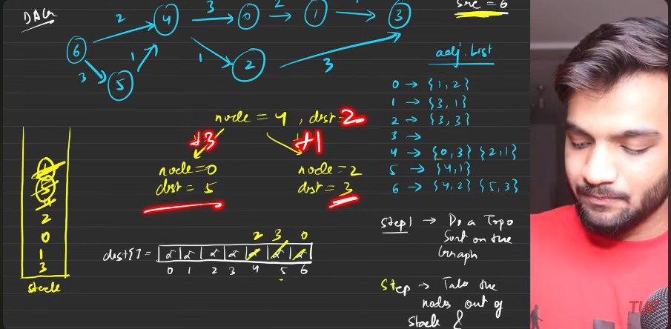
   9. 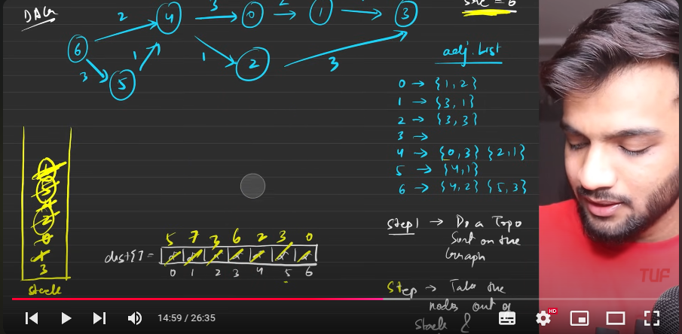
   10. 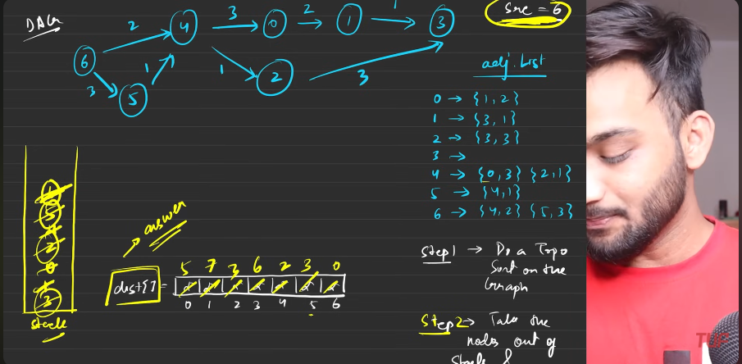
   11. 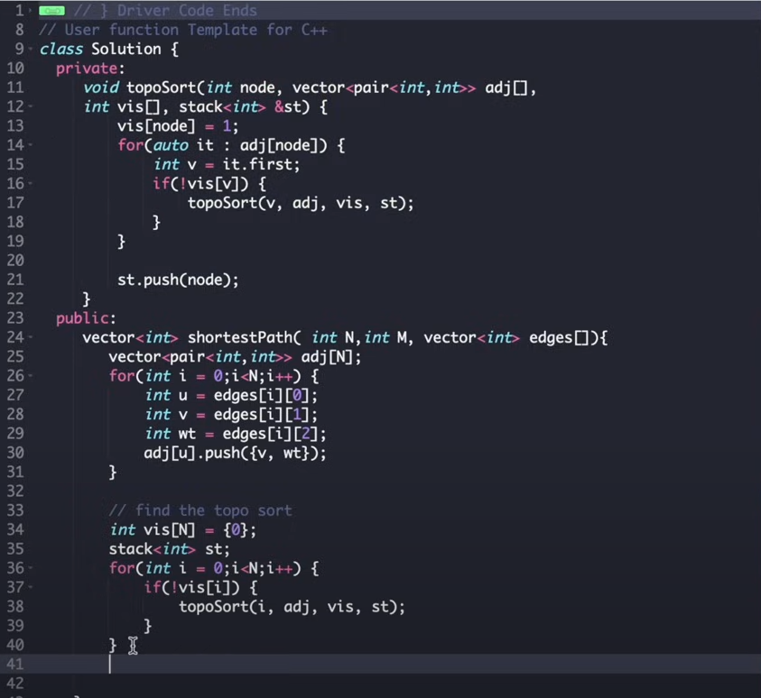
   12. 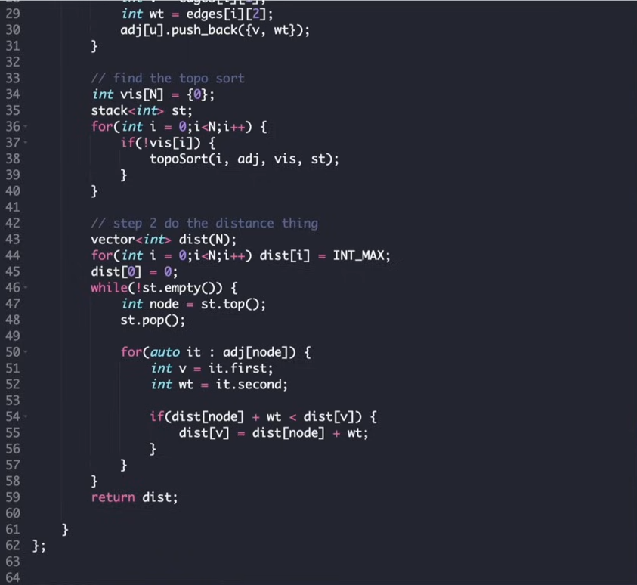
   13. 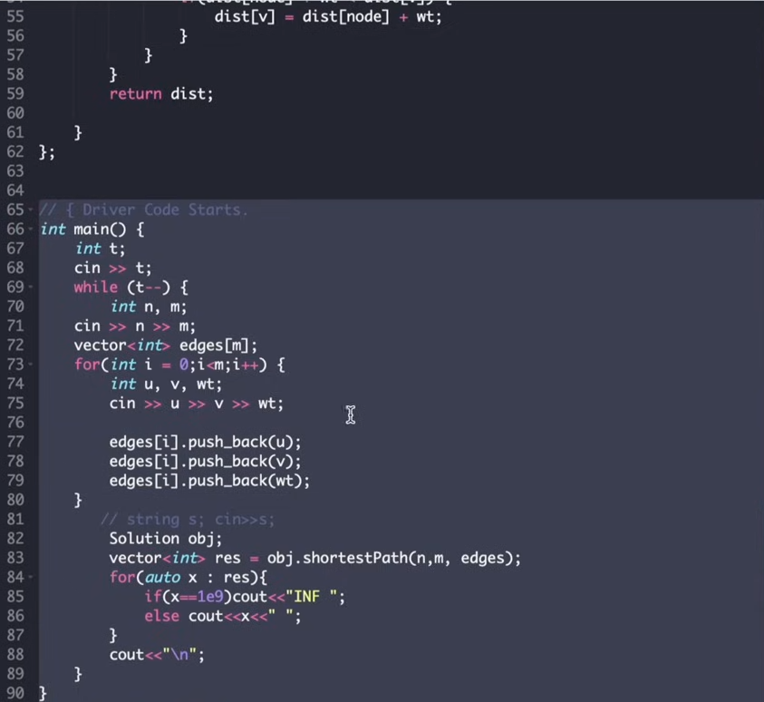
   14. 
   15. 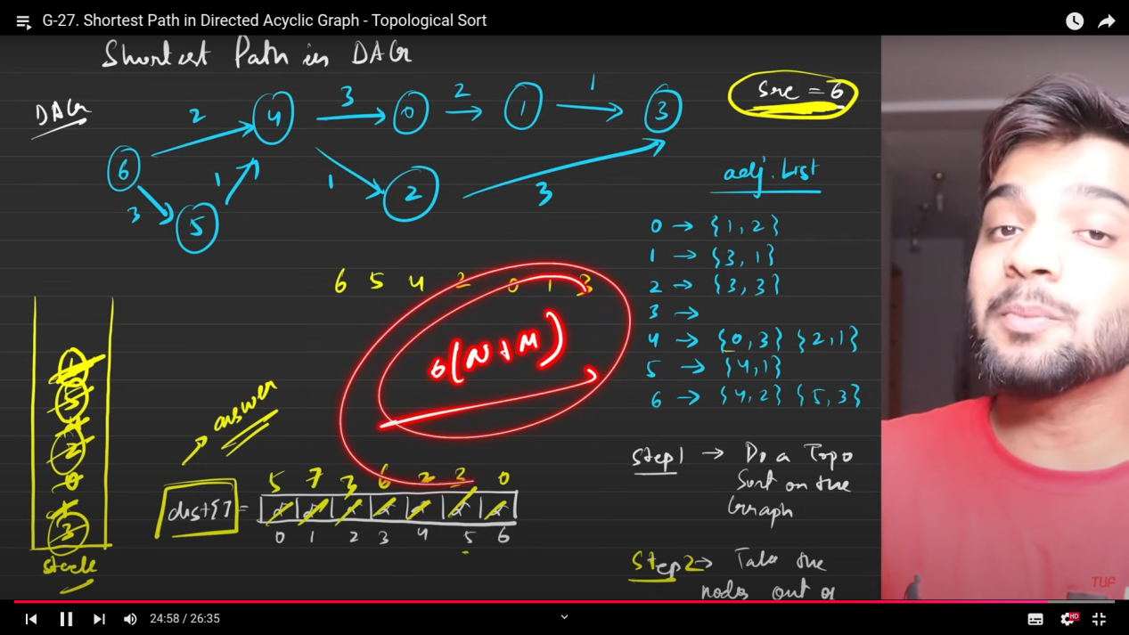

**Word ladder 1.**

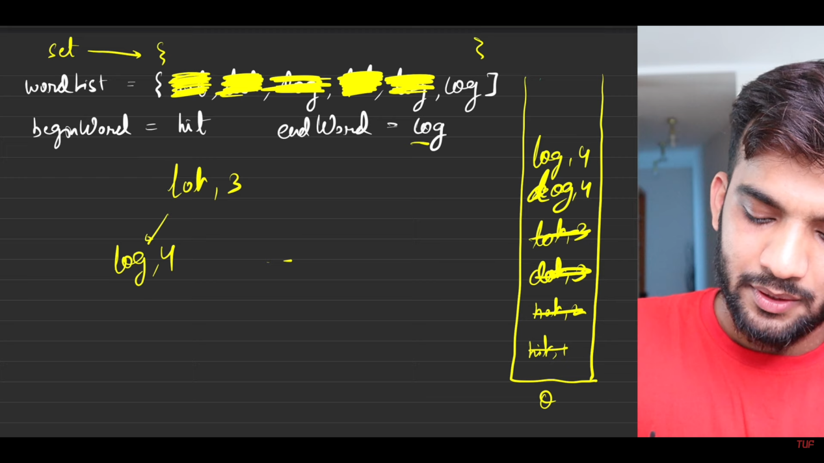

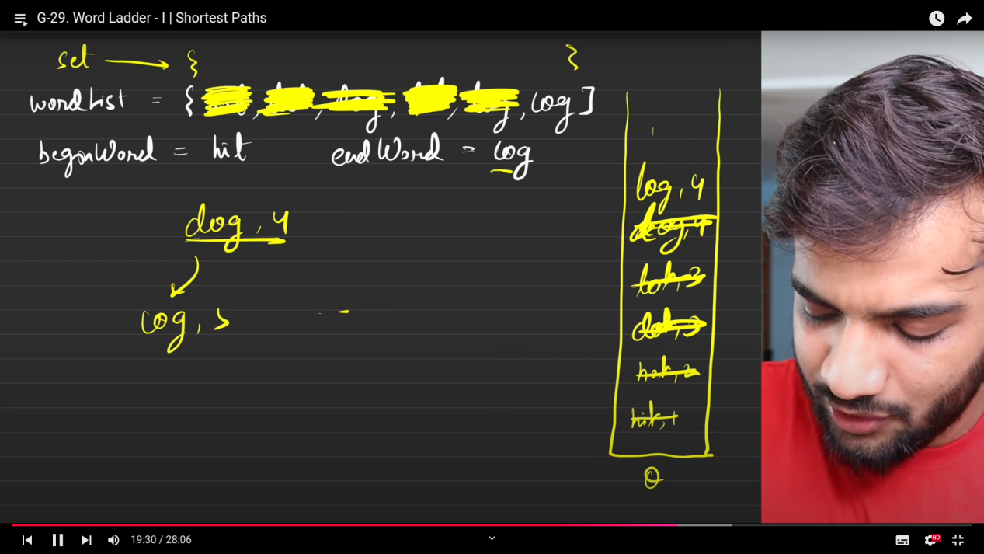



**Print Shortest Path - Dijkstra's Algorithm(PQ)**

1. 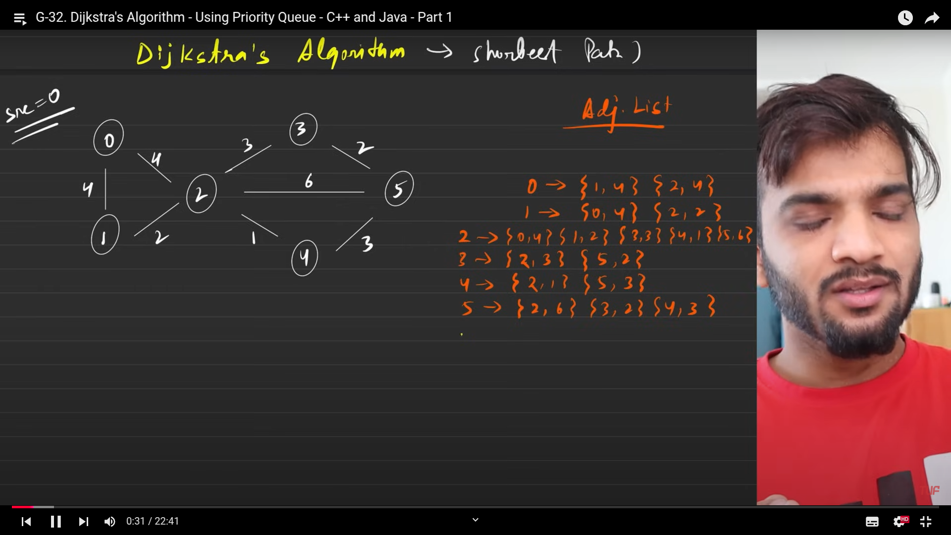
2. 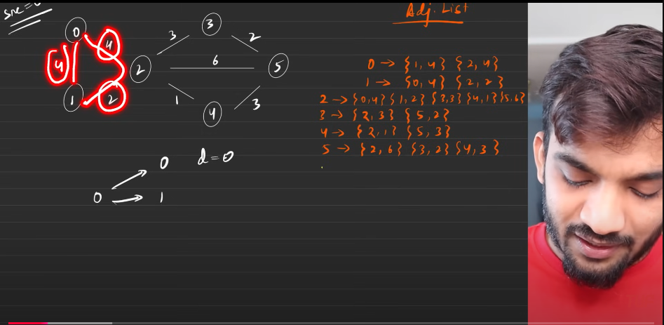
3. 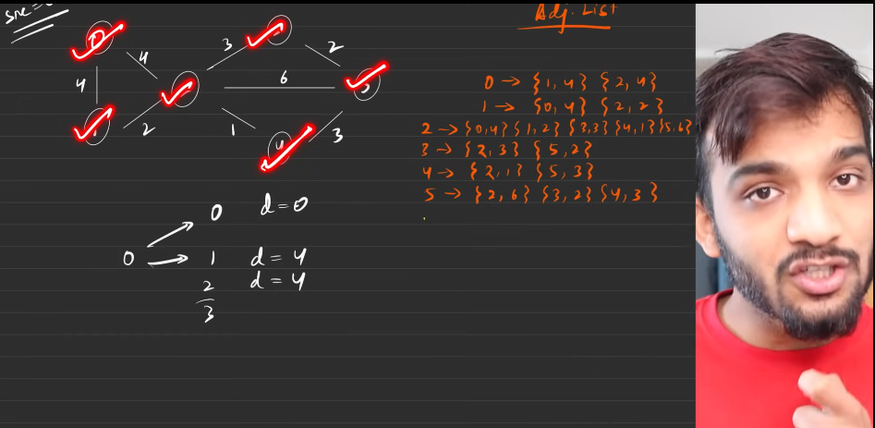

Data structures used.

1. 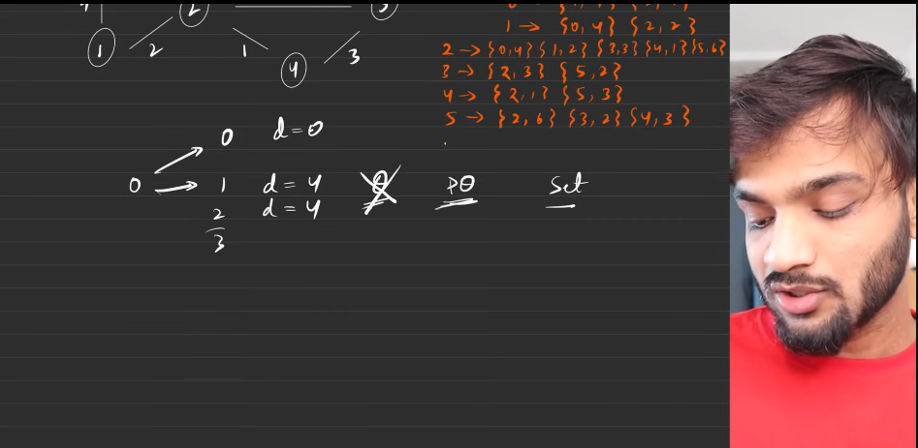
2. 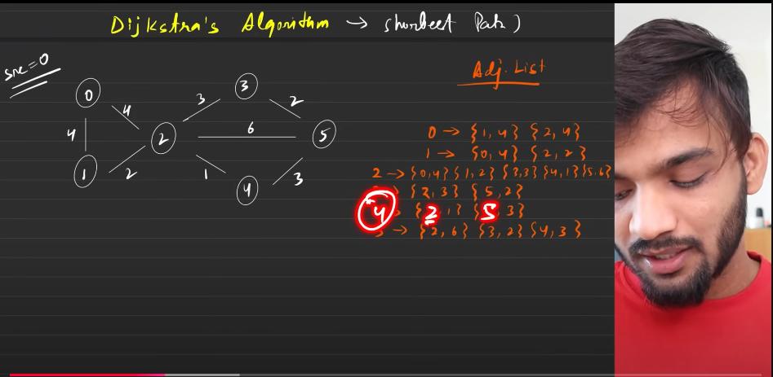
   1. **Initial Configuaration**

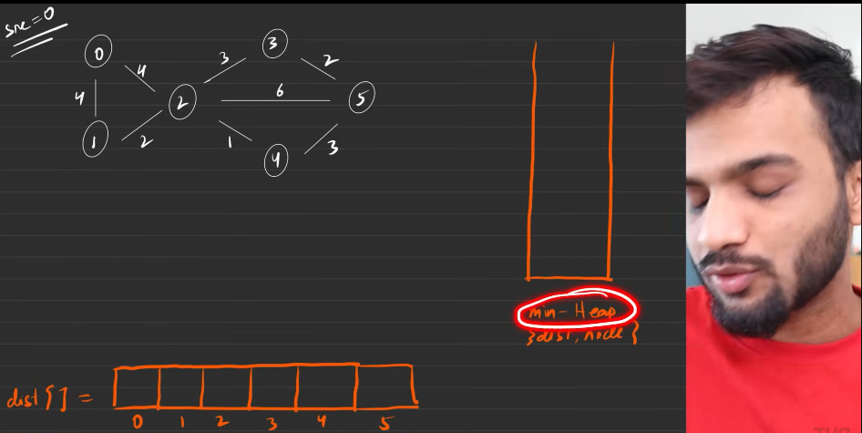

The **min heap** is used to store the shorter distant node at the top and if the shorter distant are equal then shorter node will be stored t the top.

Distance array: We always use this distant array to keep track of the distance. initialised wih infity, especially with 1e9, in cpp.



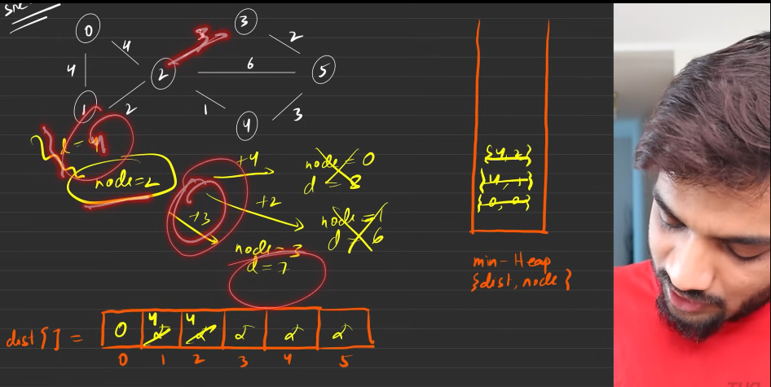

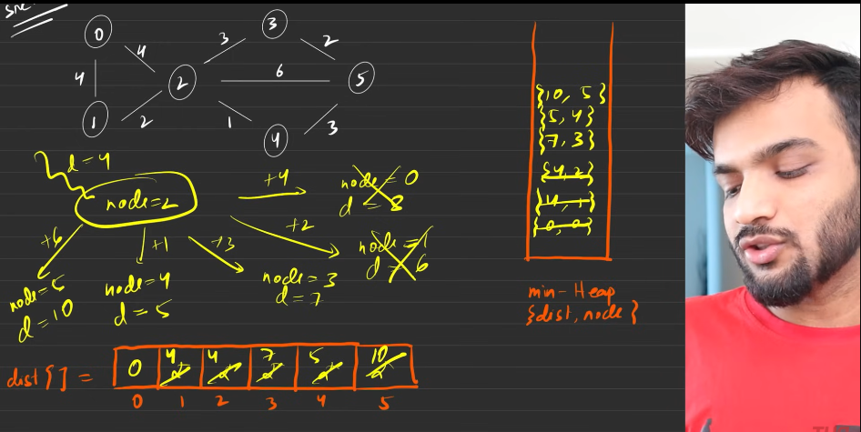

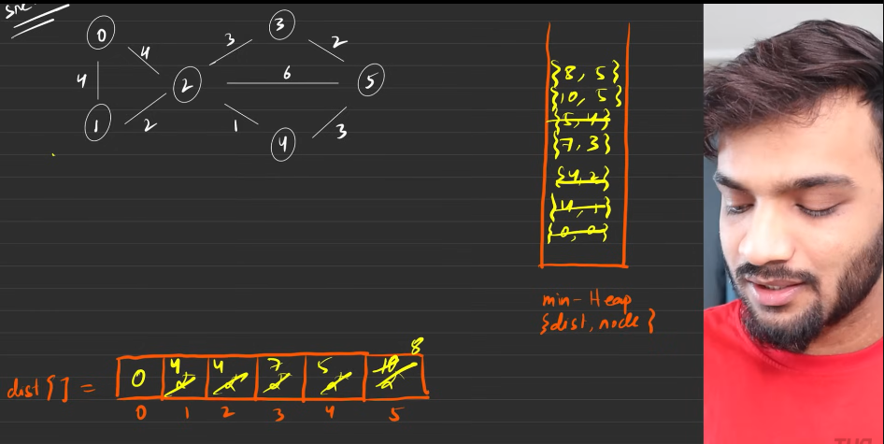

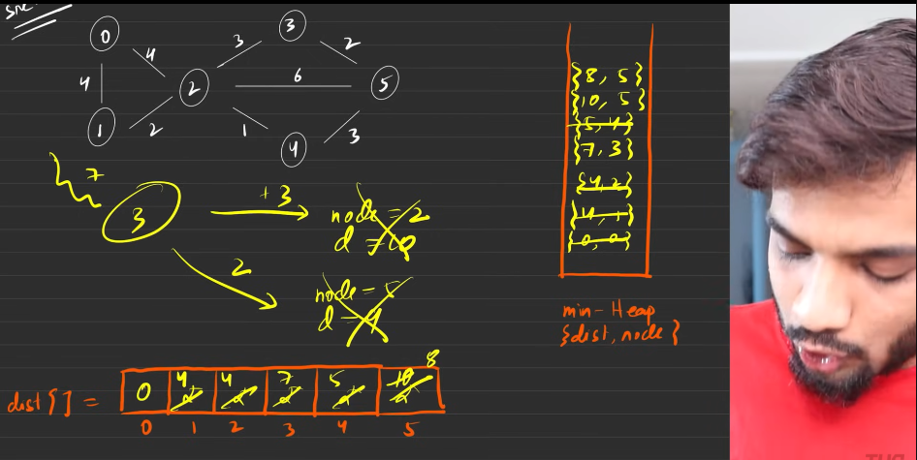

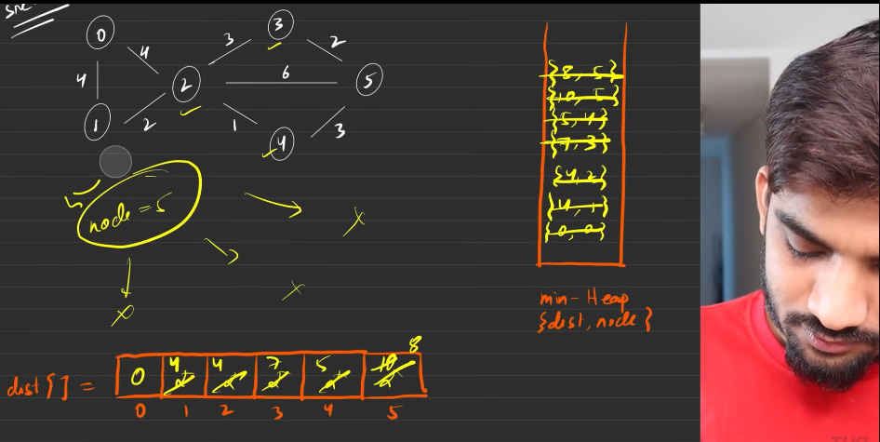

Explanation from my side:

1. You will be given with the adjacency matrix and with the source node.
2. Based on the number of nodes present, we consider the size of teh array. Initalised with 1e9.
3. Based on the source node, we start the algorithm:
   1. The distance with the source node is given as 0.
   2. SO initially we push this into the min heap(diatance and node).
   3. We take that element from the min heap, then start to traverese the adjacency vector of the node. The nodes which are all reachable wil be with the values distance of the current node taken out of the min heap + the edge of the node.
   4. if the abve fprumla is having the values lesser than the the distance in the distance vector then we will be having the value updated in the distance vector. hence update into the mein heap, since minimum distance than the repvious node is found.
   5. Like the above keep removing the elemen t from the min heap and keep following the above steps till min heap becomes empty.
   6. Hence you will definitley have the ans vector at the end.
   7. Just return the above.
4. **Important**:
   1. Dijkstras will not work when we have negetive edge weights.
   2. 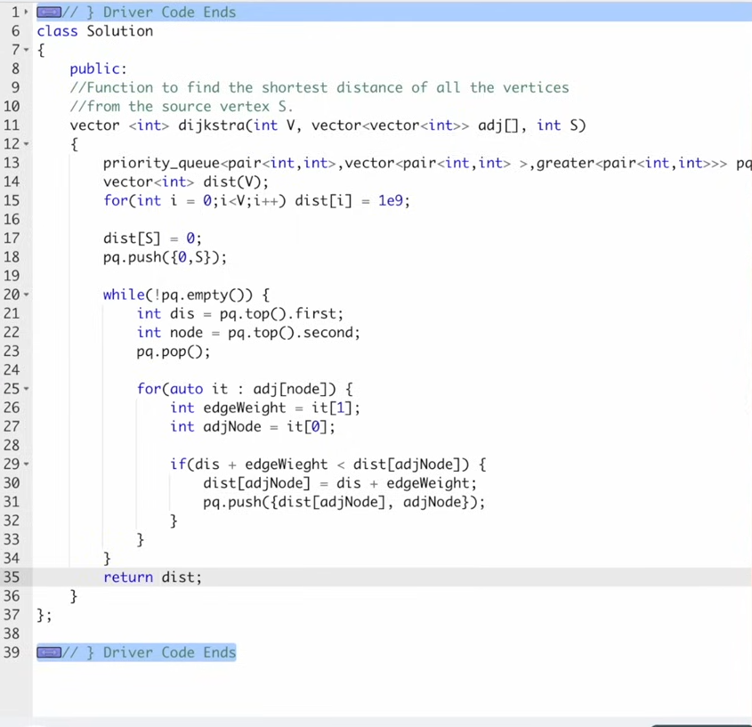
5. The raeson why it is not going to work for the graph with negative weights, because of oscillation effect, which always keeps reducing the distance from one node to another node. Hence making the distance always to come down, which will definitley reduce the distance when comapred to the previous distance. Hence this ill not work.
6. 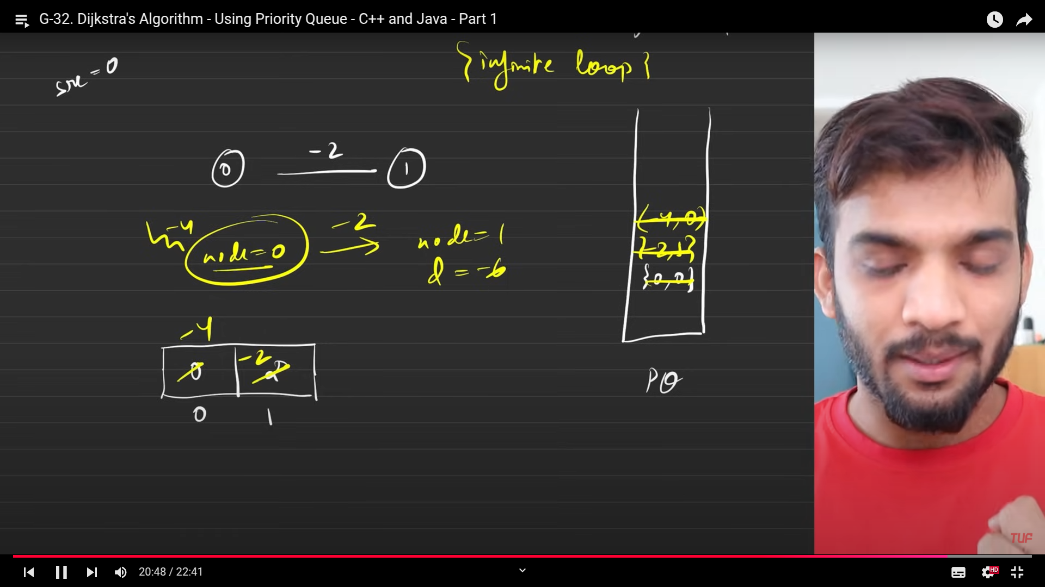
7. 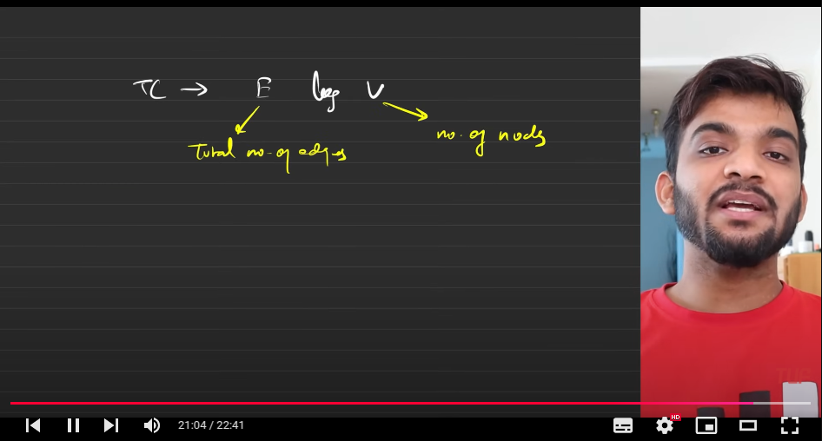
8. The dataset is going to use **set**, for making Disjkstras algortihm
9. 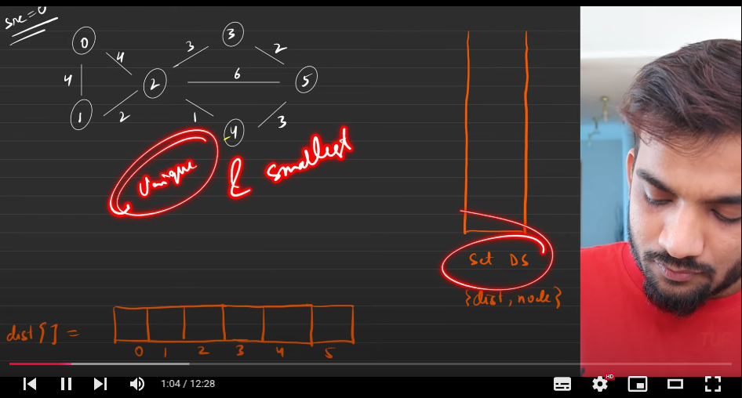
10. 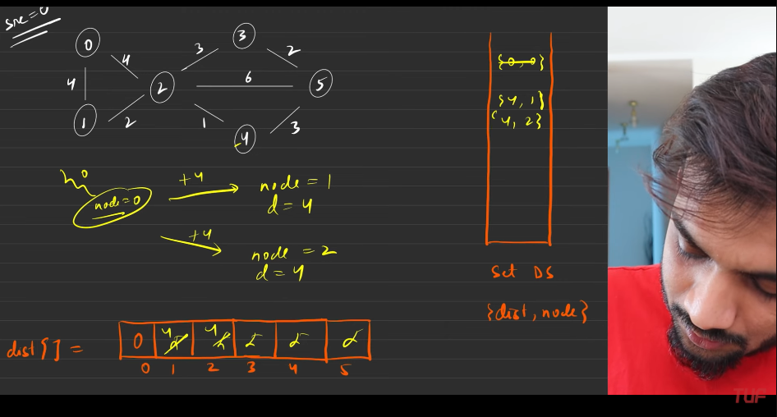
11. 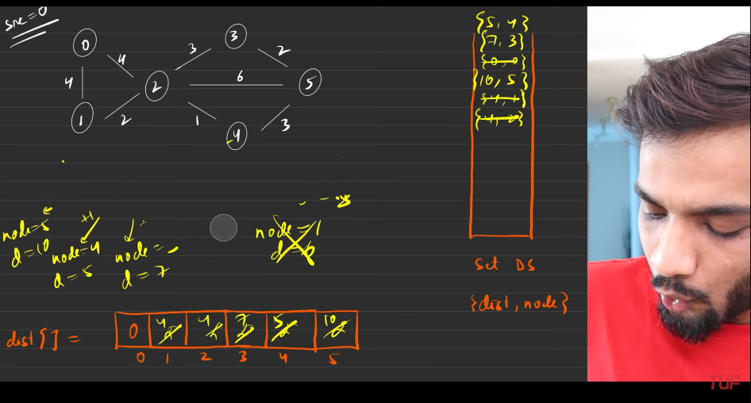
12. 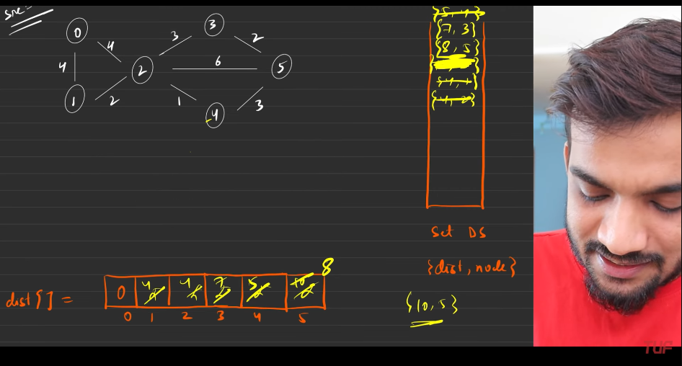
13. Here the minimum distance of 8 for the 5th node, bu previously it was not the case, it was giving the distance 10, hence when th values are inserted the entry which is making the 10,5 is erased automaticaly, but this facility was not there with the min heap, hence it keep making many mor iterations till we reach the end if the queue .
14. Set = sorted(so kees minimum at the top), distinct - always distinct.
15. So set is used for erasing already existing paths(manually you need to do it),
    1. But cannot say, whether this will improve the time complexity or not.
    2. Because many things depends , like what is the size of the graphs, since it ill stop the iteratins that is going to come further. [minor changes].
    3. Erasing will make the logarithmic time complexity.
    4. 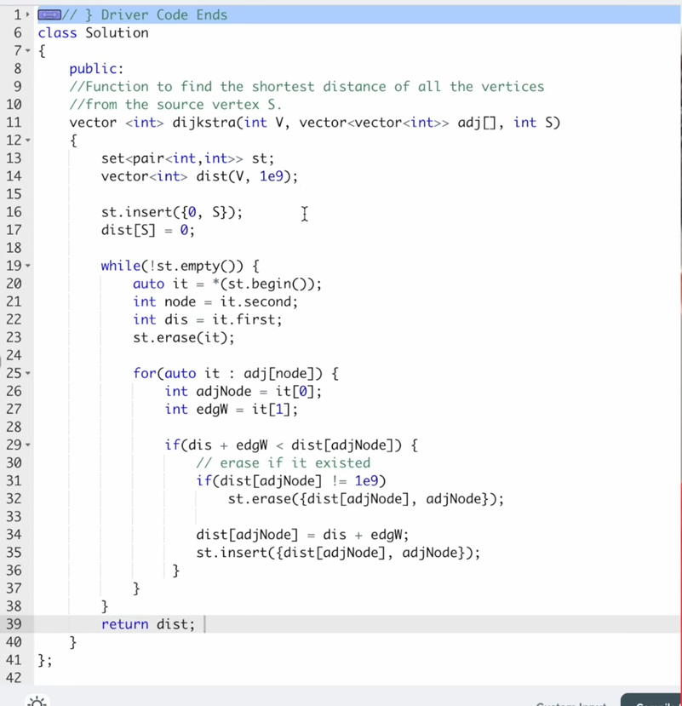
16. Dijkstras with queue
    1. 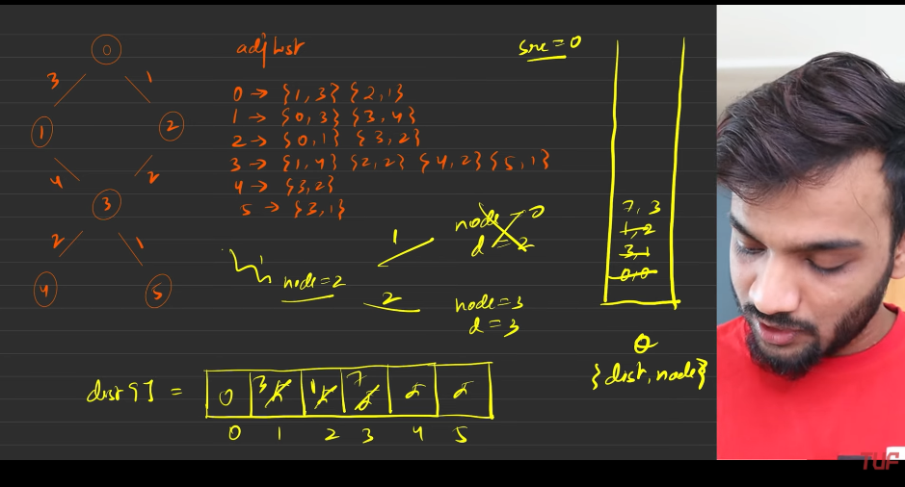
    2. 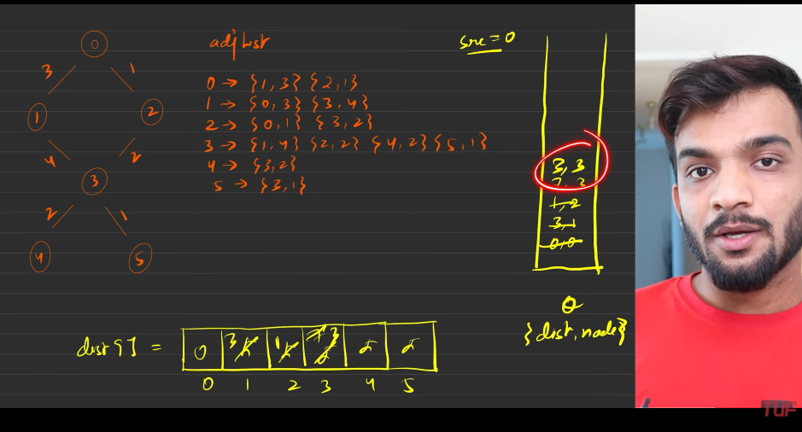
    3. So if PQ IS used directl wthen we would have not inserted the (7,3) to the queue. Increae much more iterations.
    4. 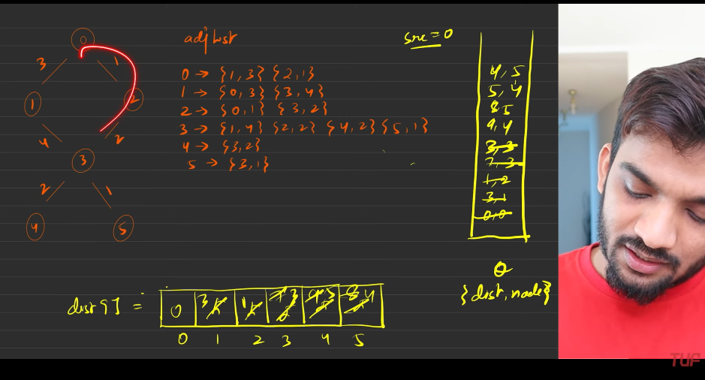
    5. So by making the use of min heap, we would have not made the unnecessary paths .
    6. 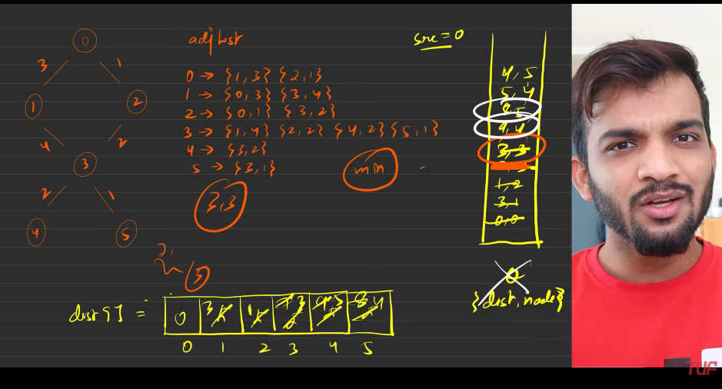
    7. 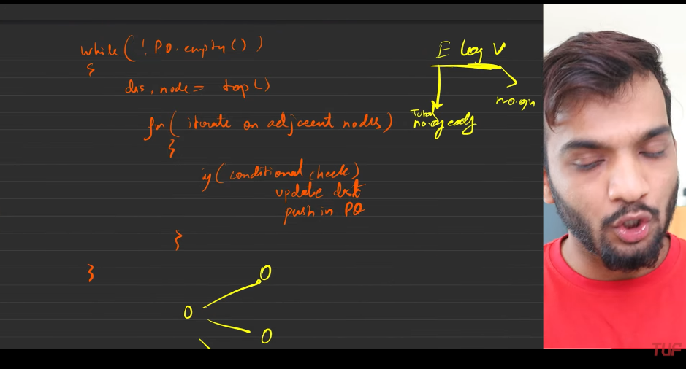
       1. PQ
    8. 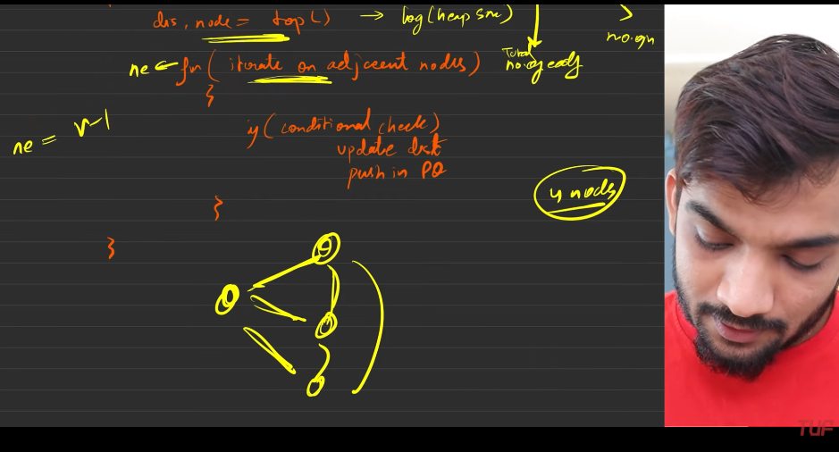
    9. 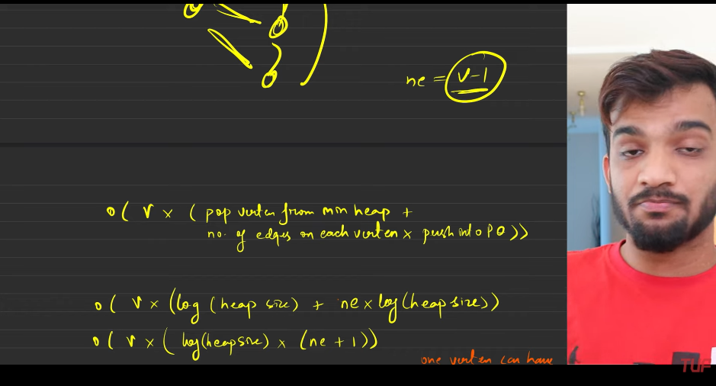
    10. 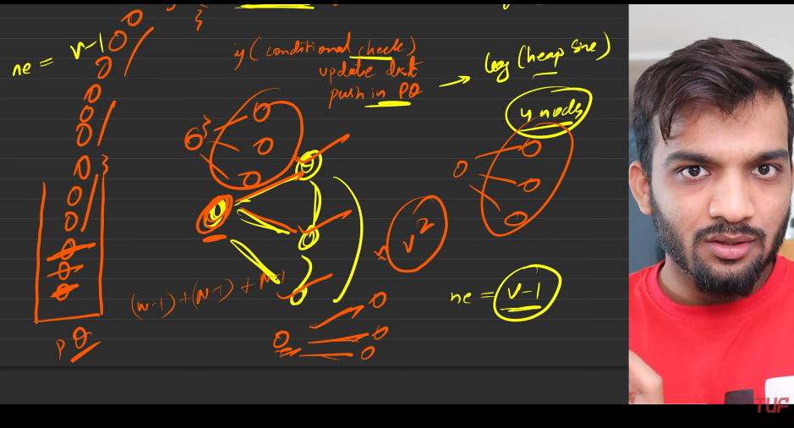
    11. 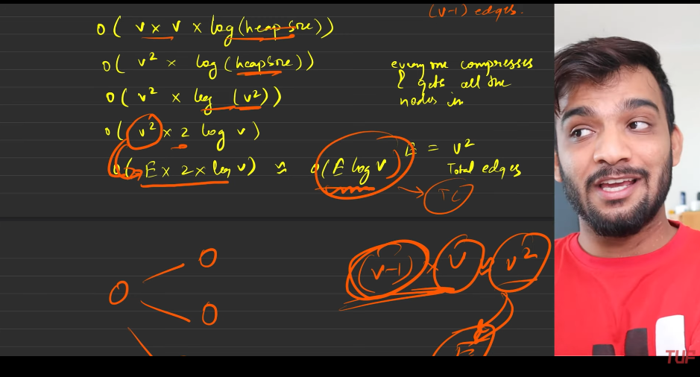
17. **Now it time to print the shortest path using the dikstras algorithm**
    1. 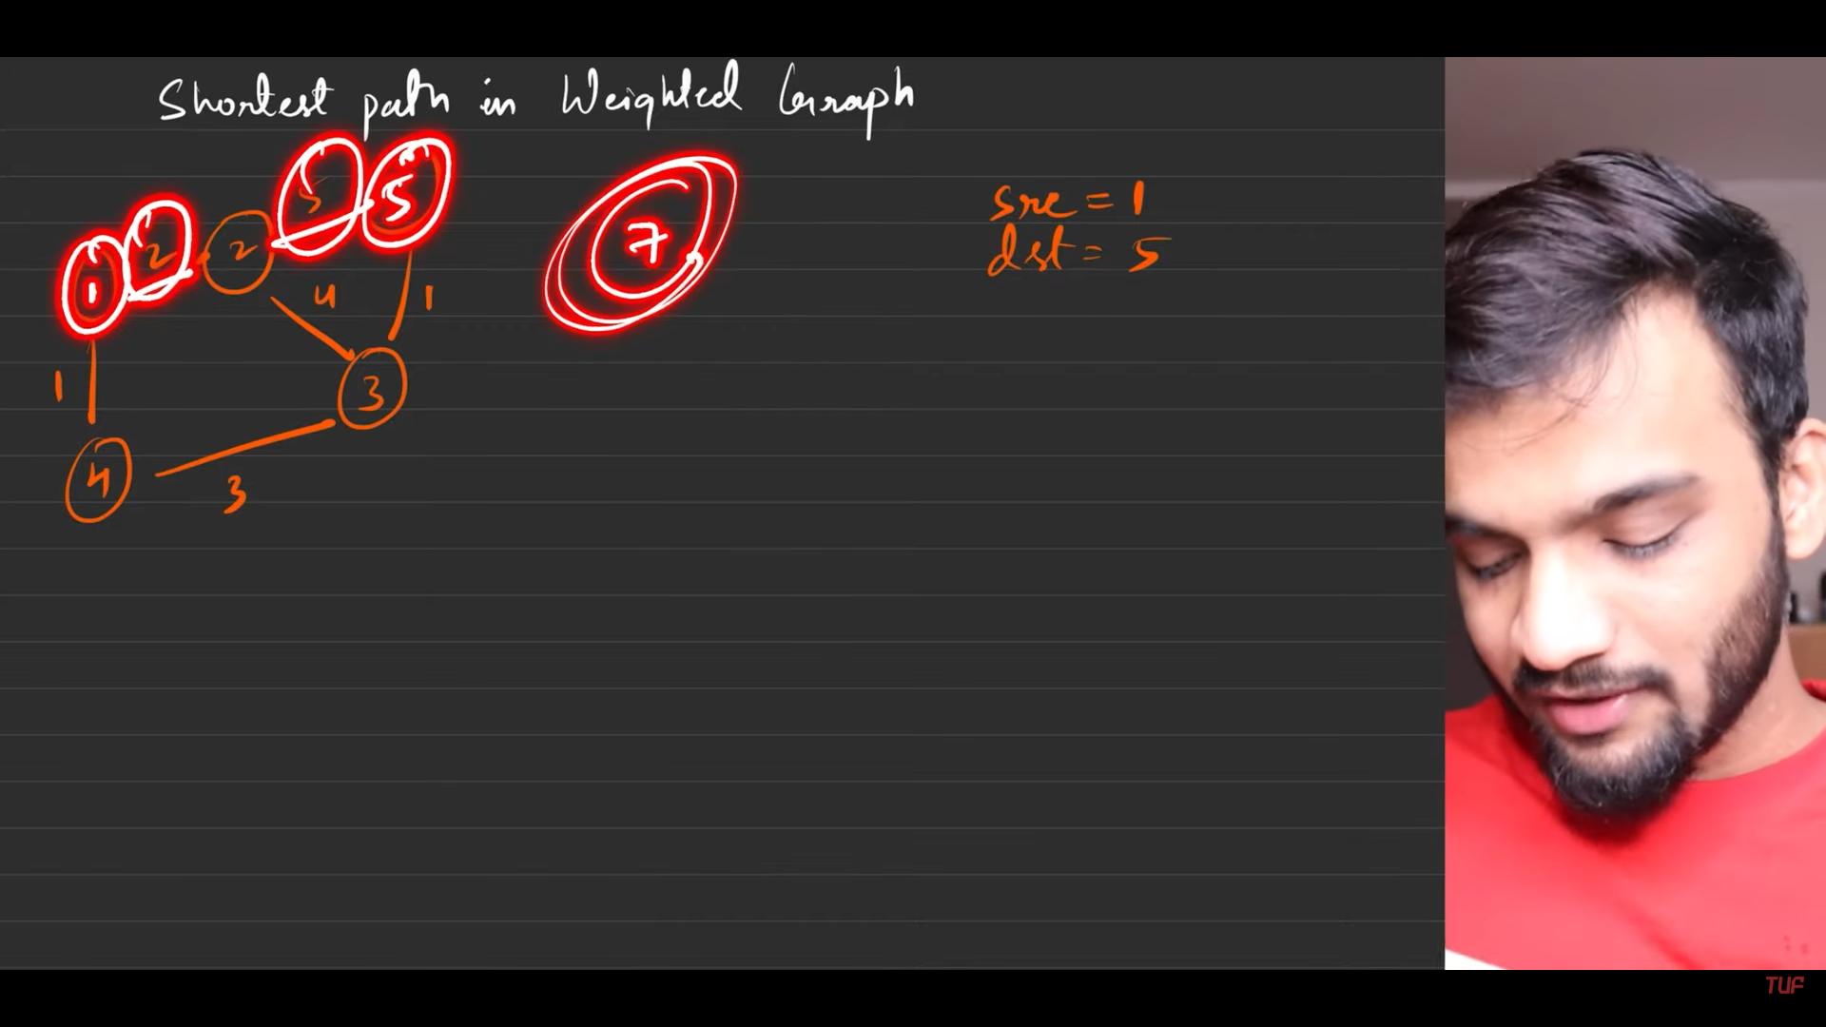
    2. 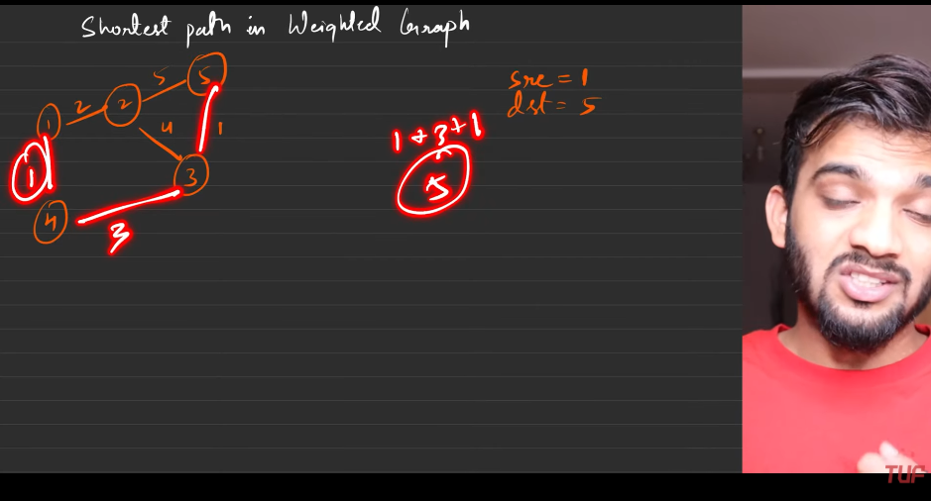
    3. 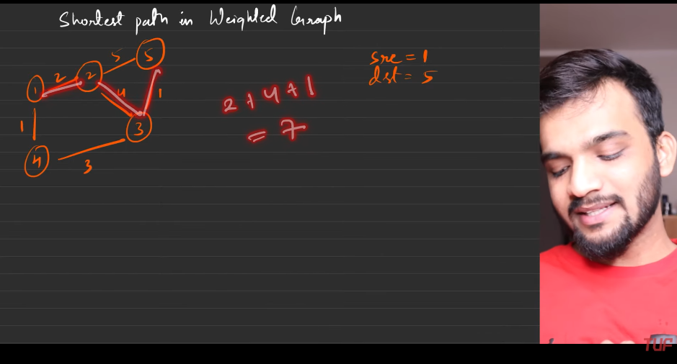
    4. 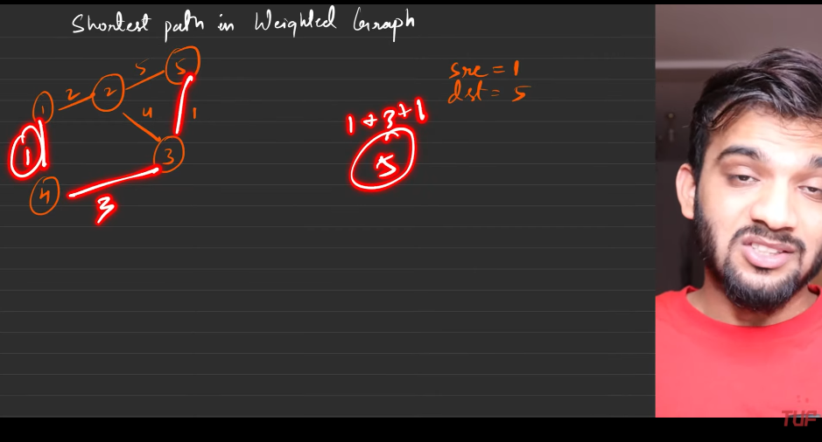
    5. 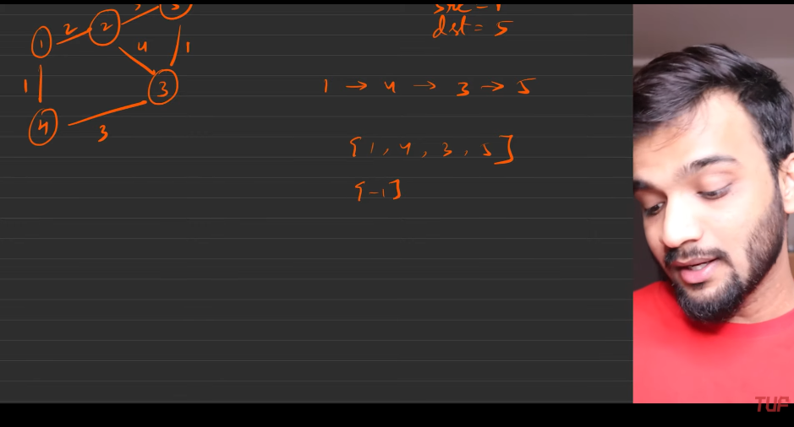
    6. 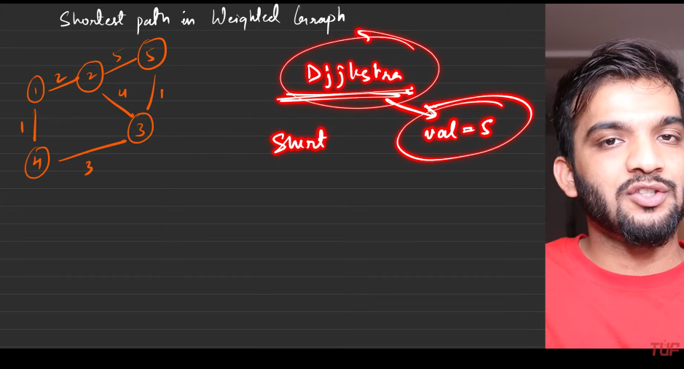
    7. 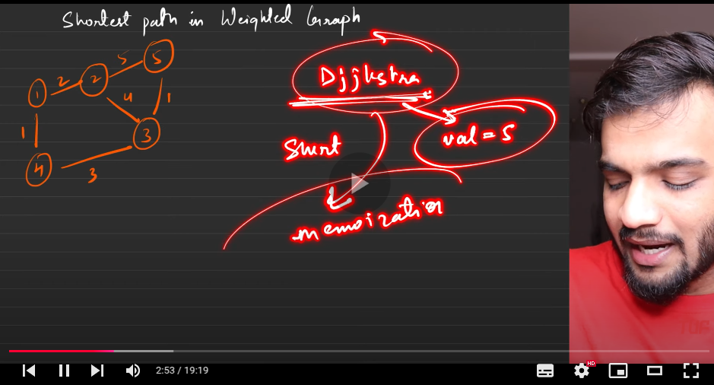
    8. 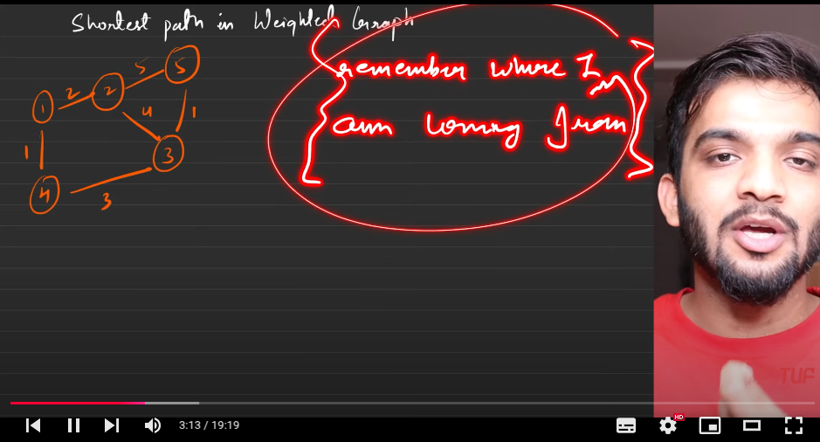
    9. 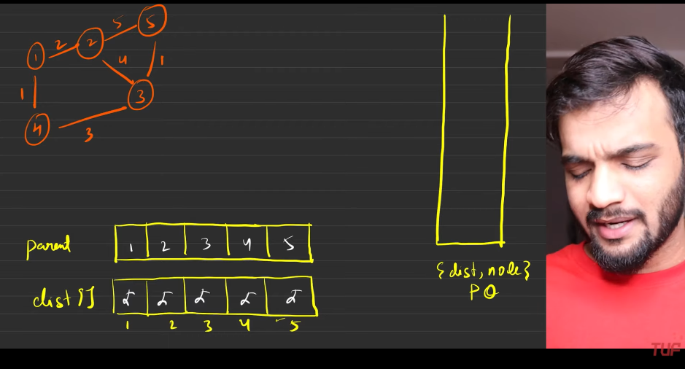
    10. 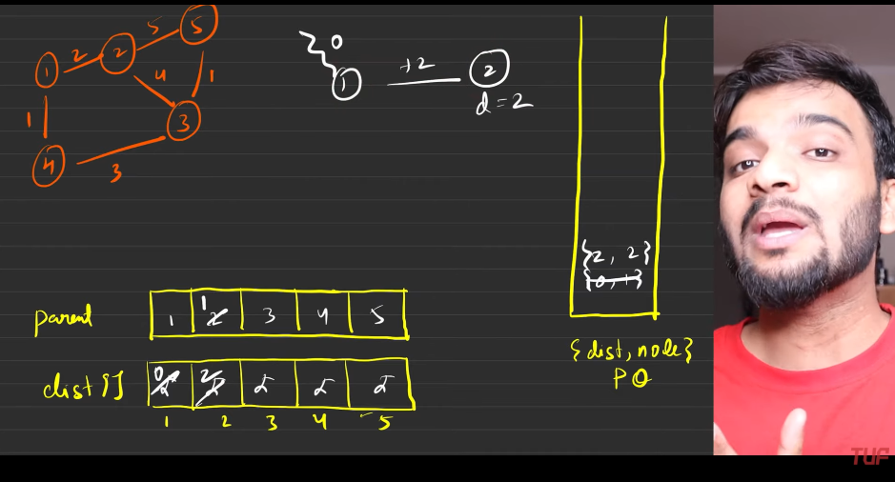
    11. 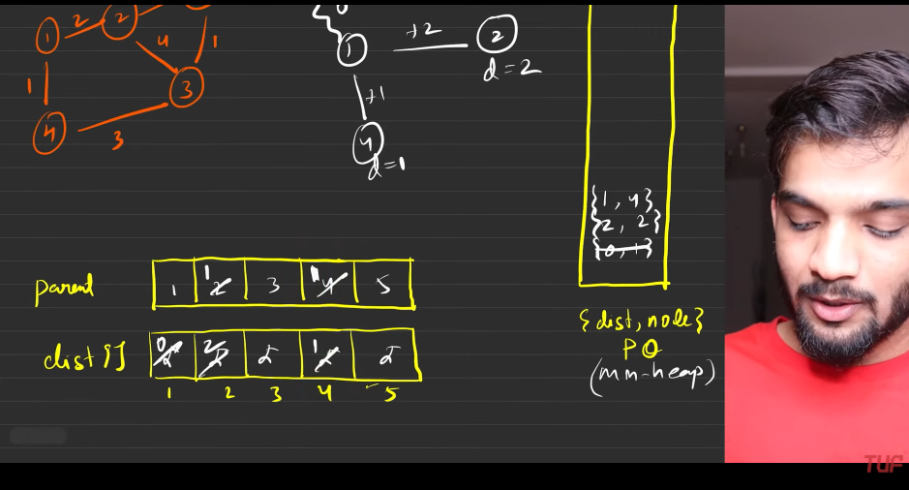
    12. 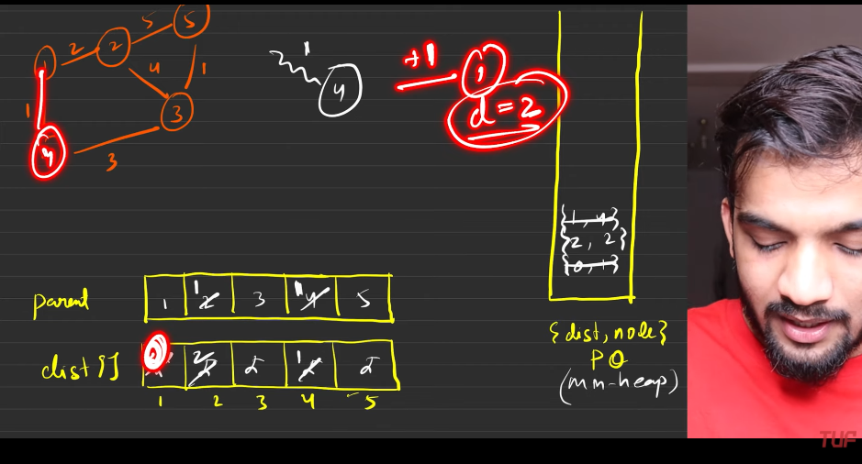
    13. 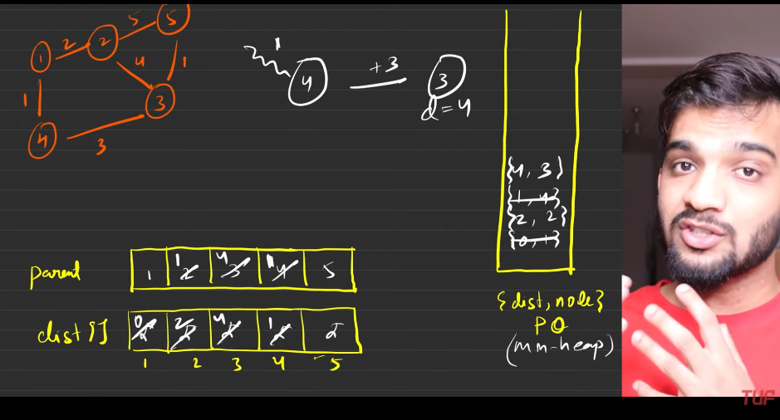
    14. 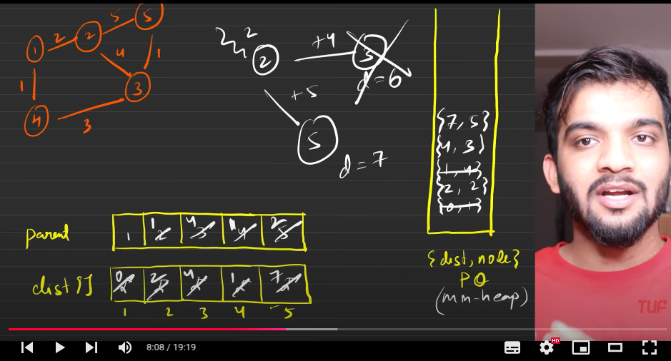
    15. 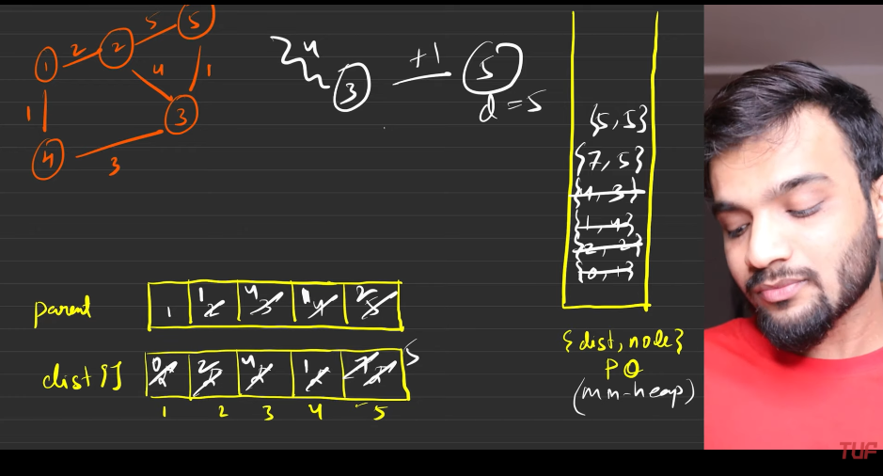
    16. 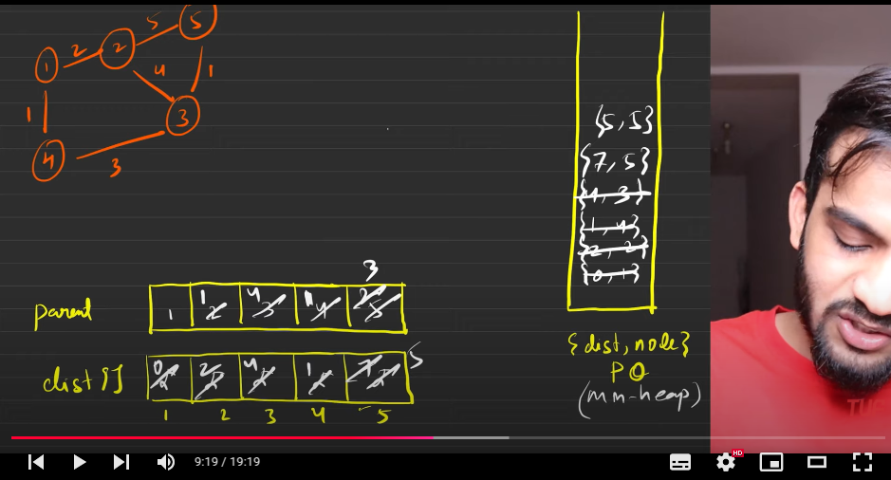
    17. 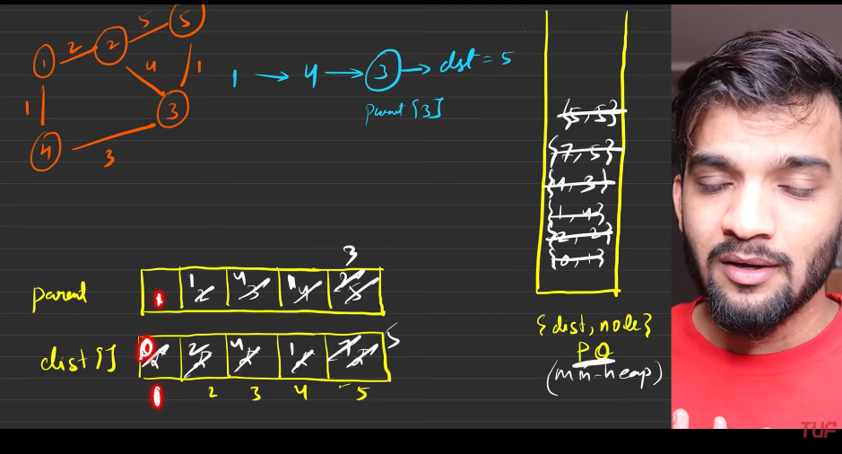
    18. start from the destination node and end at the start node, where the start node will have :
        1. Parent and the node both are same
        2. The source will ahve the distance zero.
        3. Any one one the aboe can be used for stopping condition and return the value.
    19. 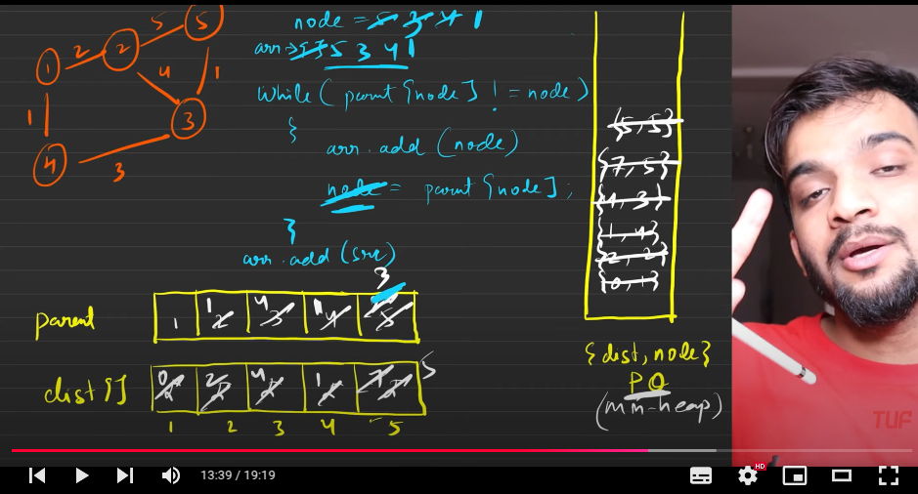
    20. 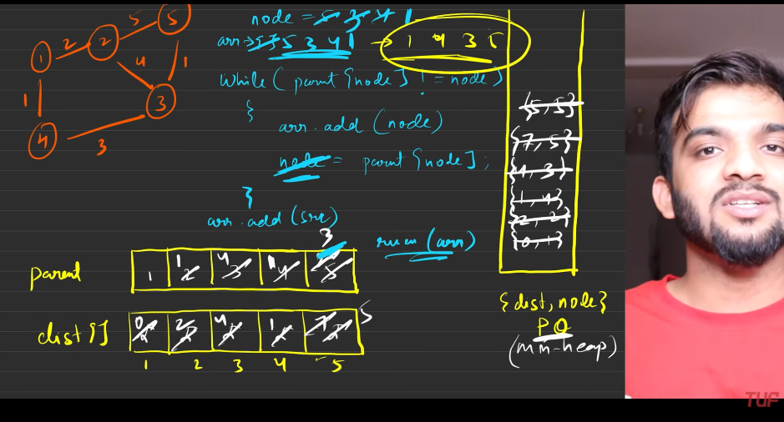
    21. 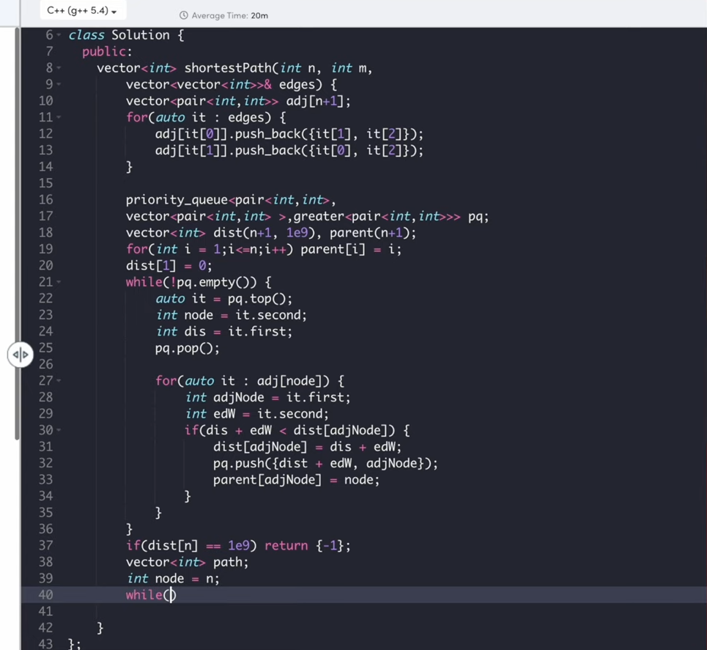
    22. 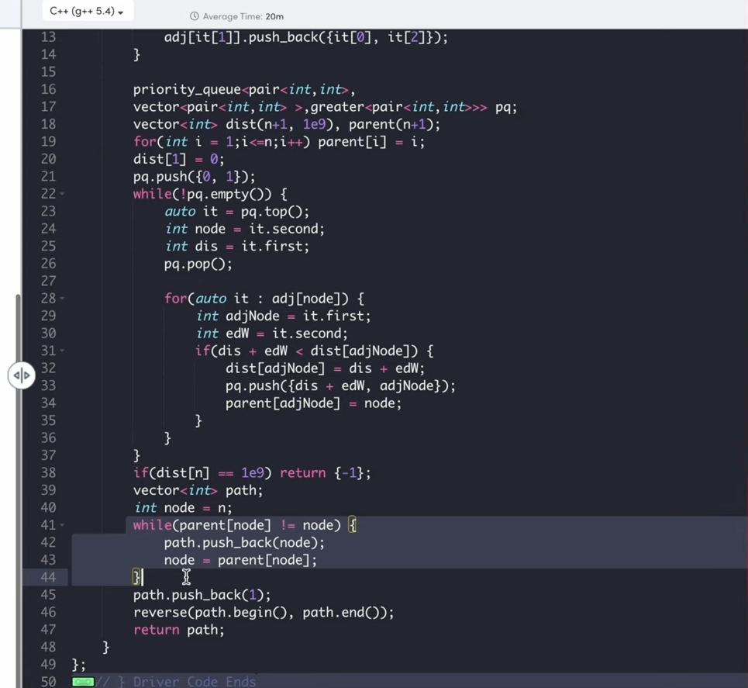
    23. 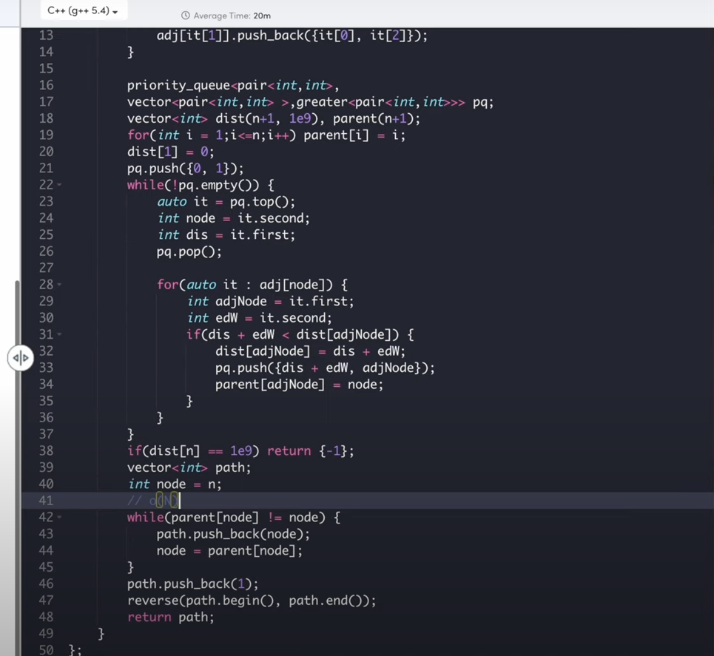

**Shortest Path in Binary Maze**:

1. 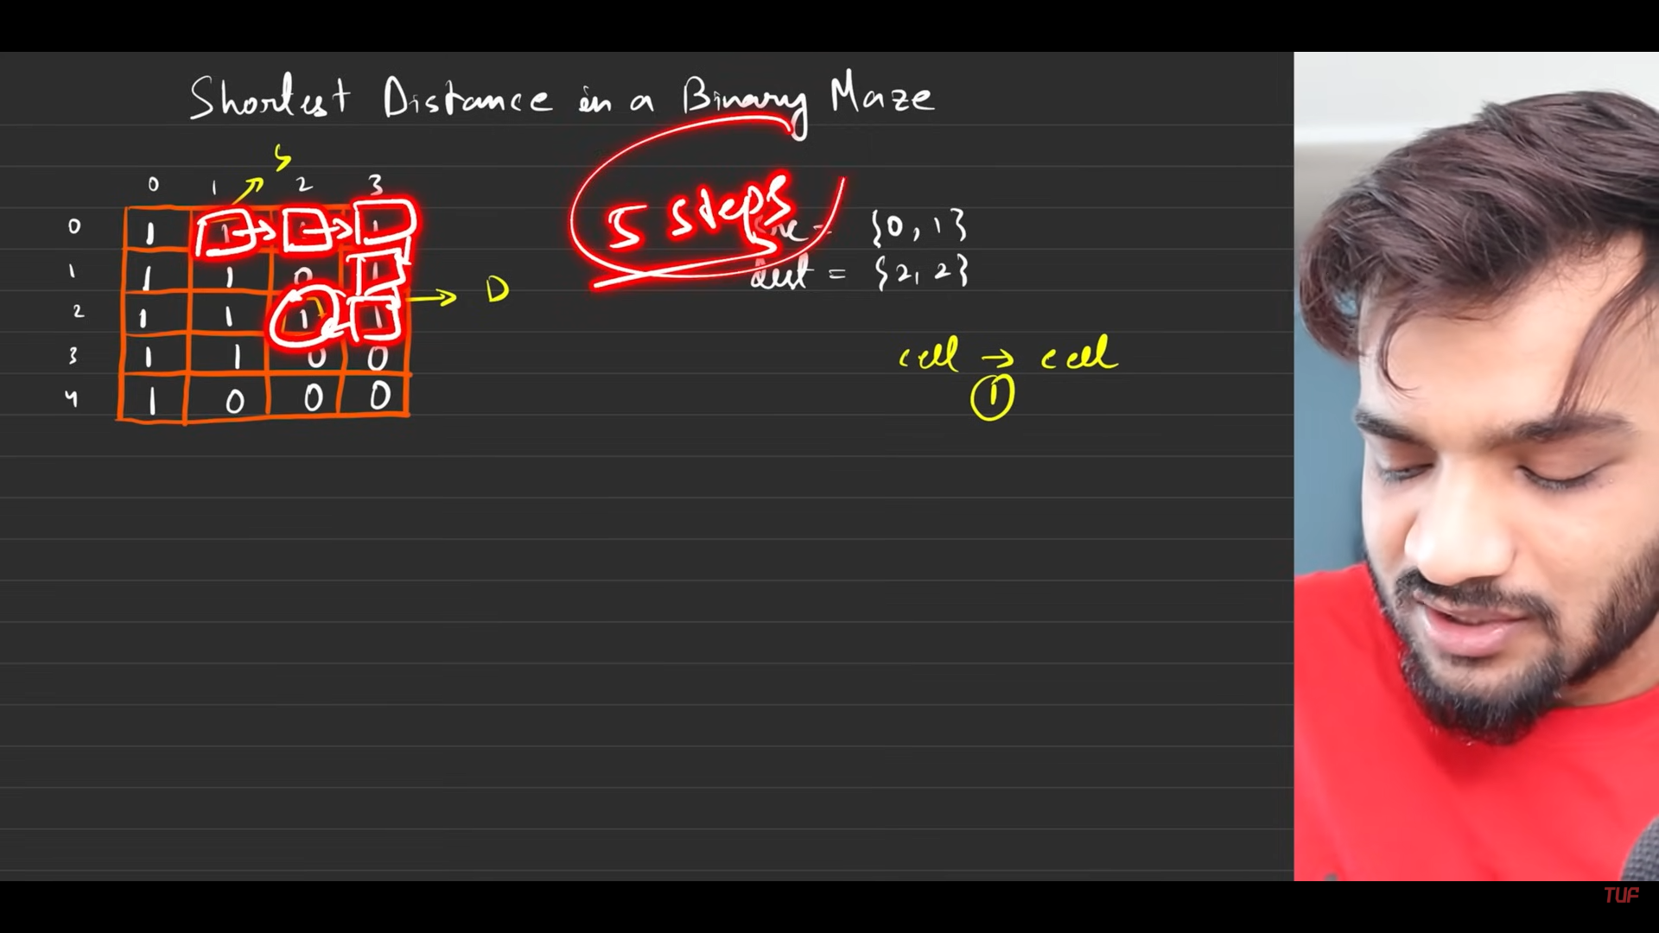
2. 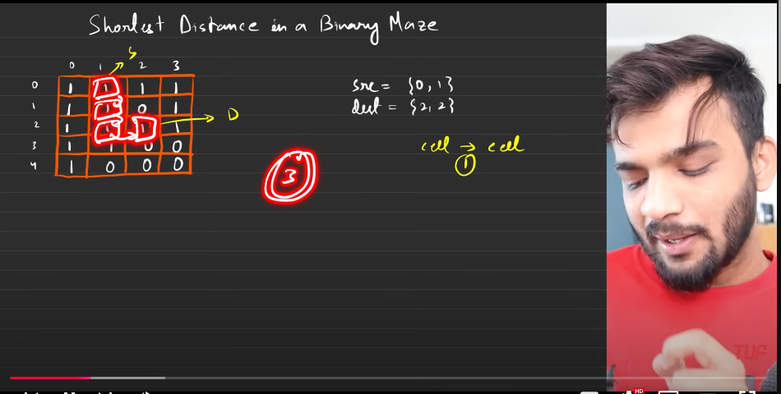
3. The movement can be there only in 4 directions, left, right, up, down. If we could have moved in 8 directions then the number of steps required to reach the destination would be only 2 steps.
4. 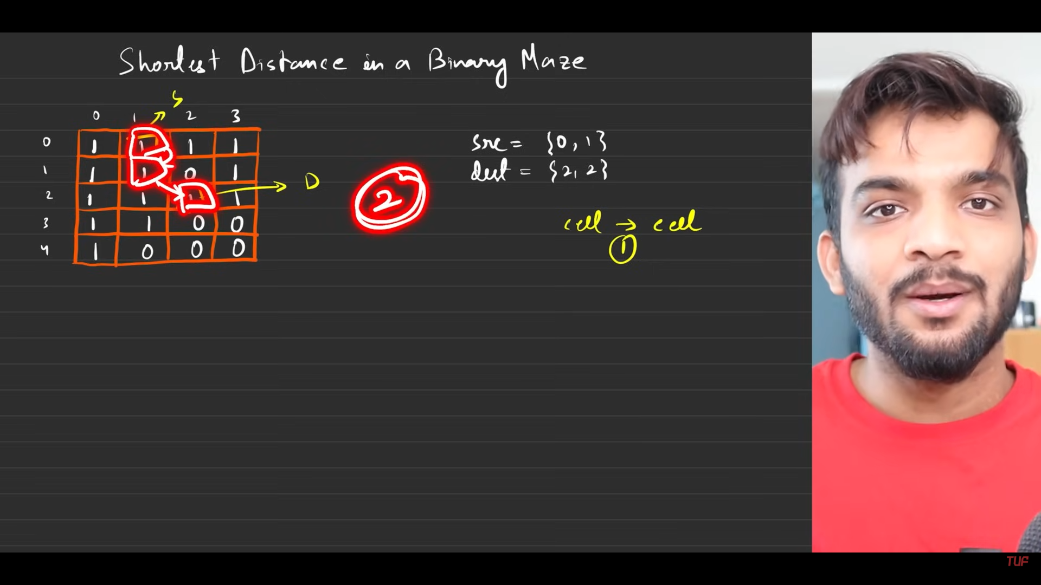
5. The shortest path is nothing but dijkstras algortihm. Always take PQ.
6. Inital configuarations
7. 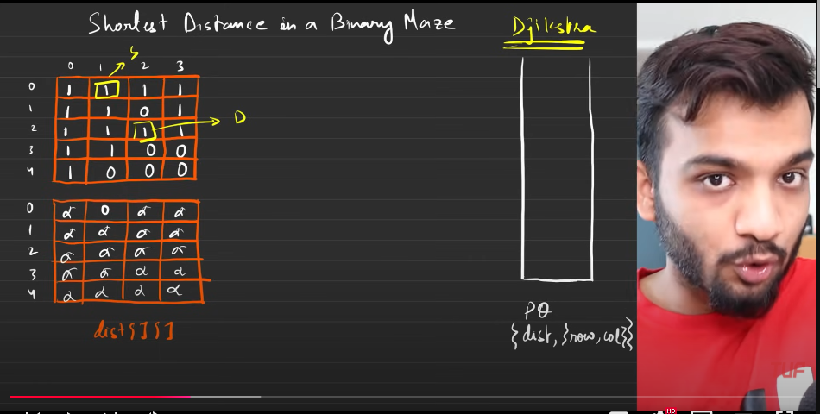
8. Now start disjskras algo.
9. 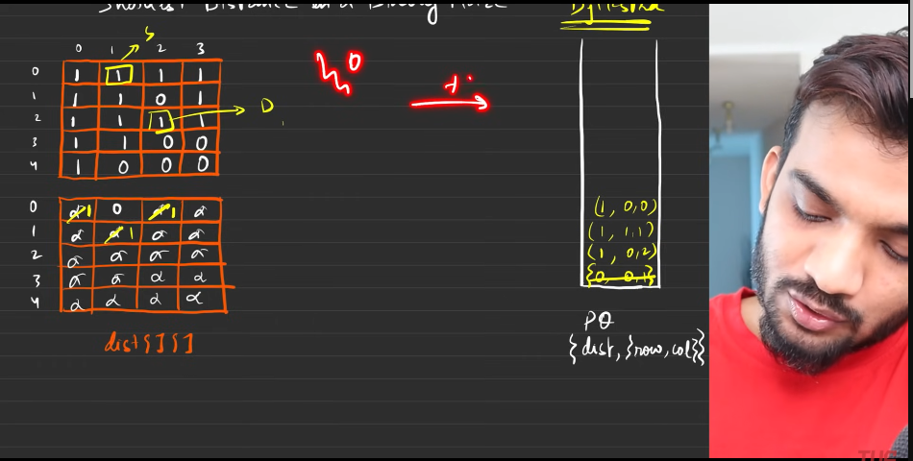
10. 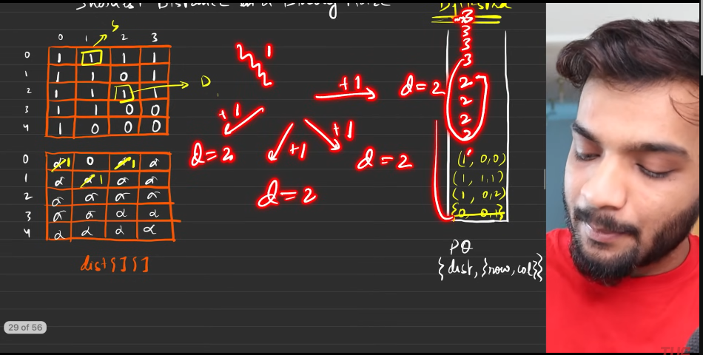
11. The reason why we needed this PQ in disjkstras was to prevent the extra iterations. But if I going to use the PQ in this, will cost me with log(n) extra. So remove the PQ nd start using the queue here.
12. 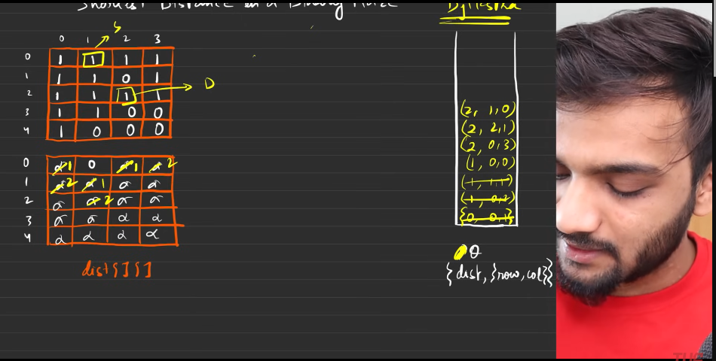
13. 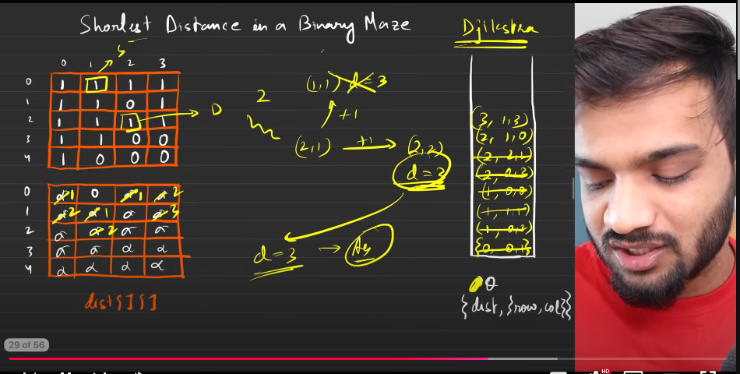
14. 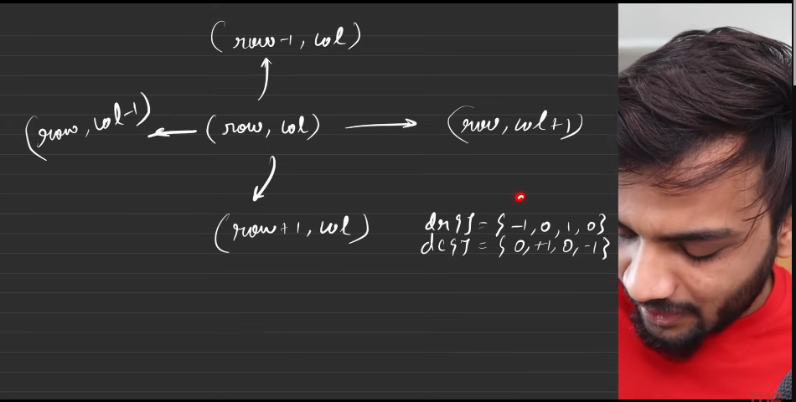
15. 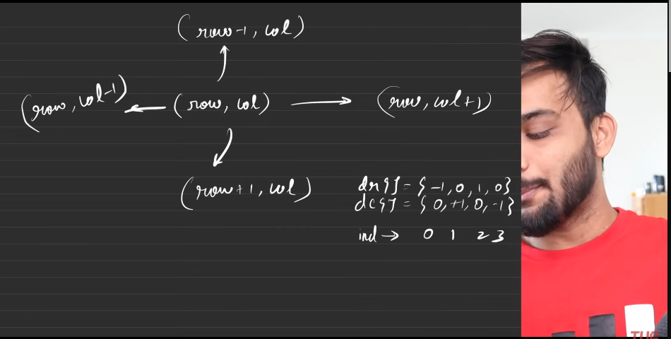
16. 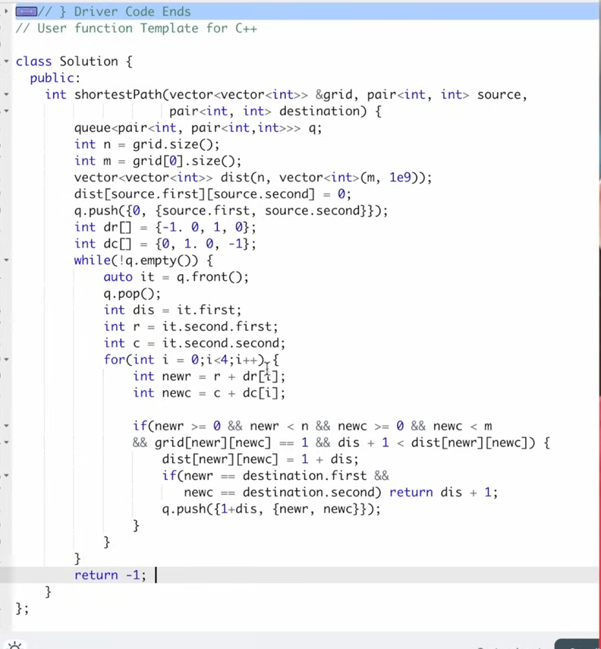

**Path with minimum effort**

1. 
2. 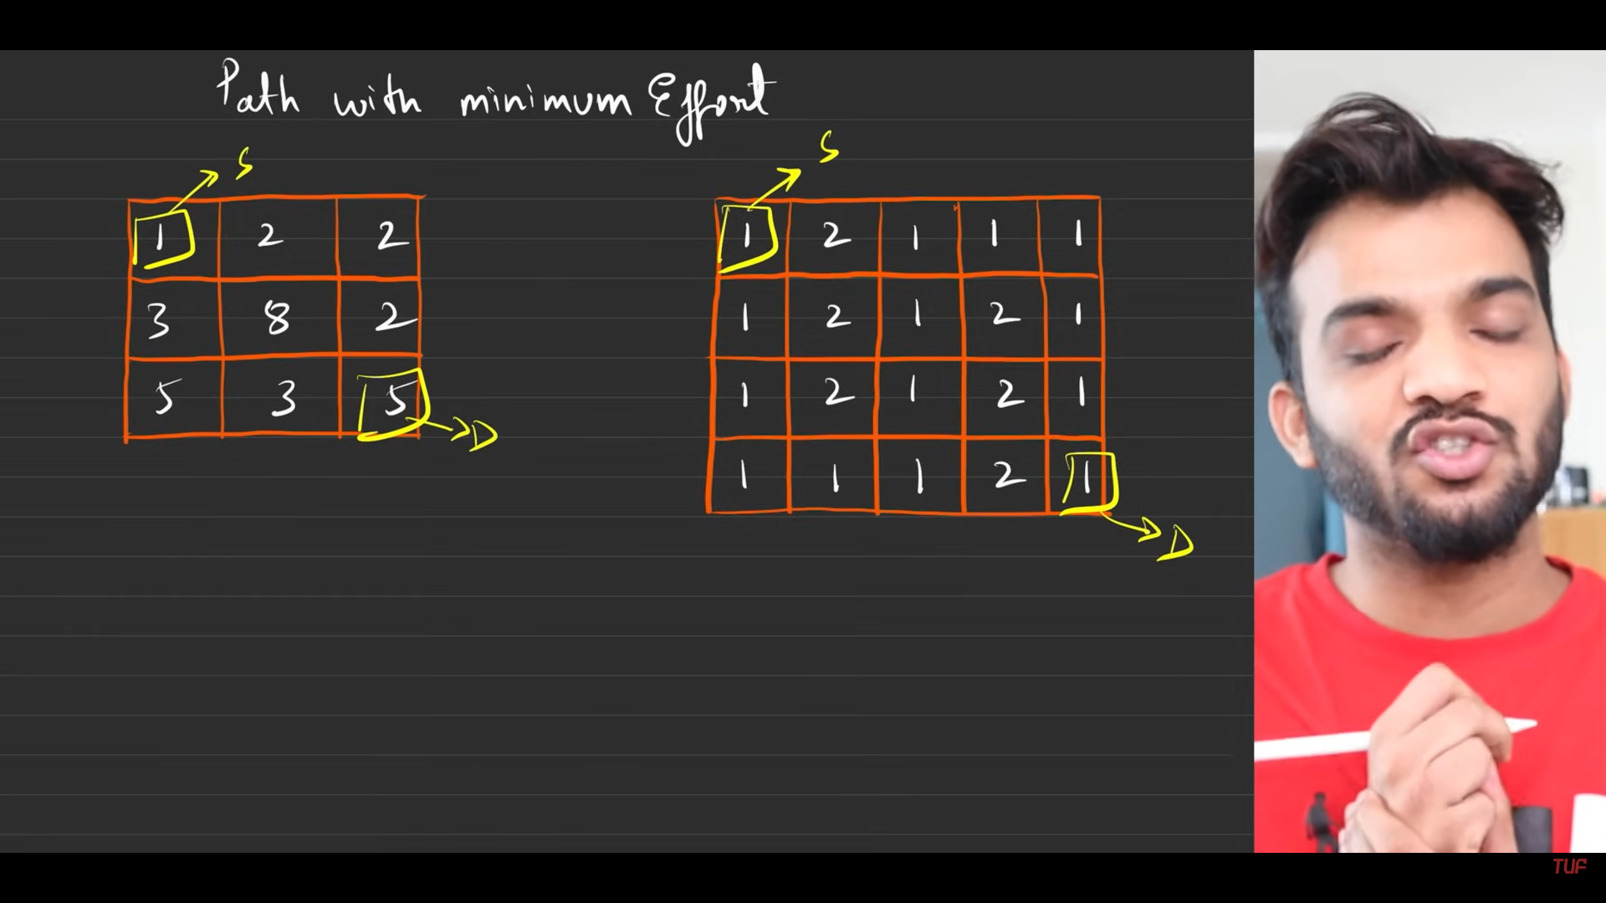
3. 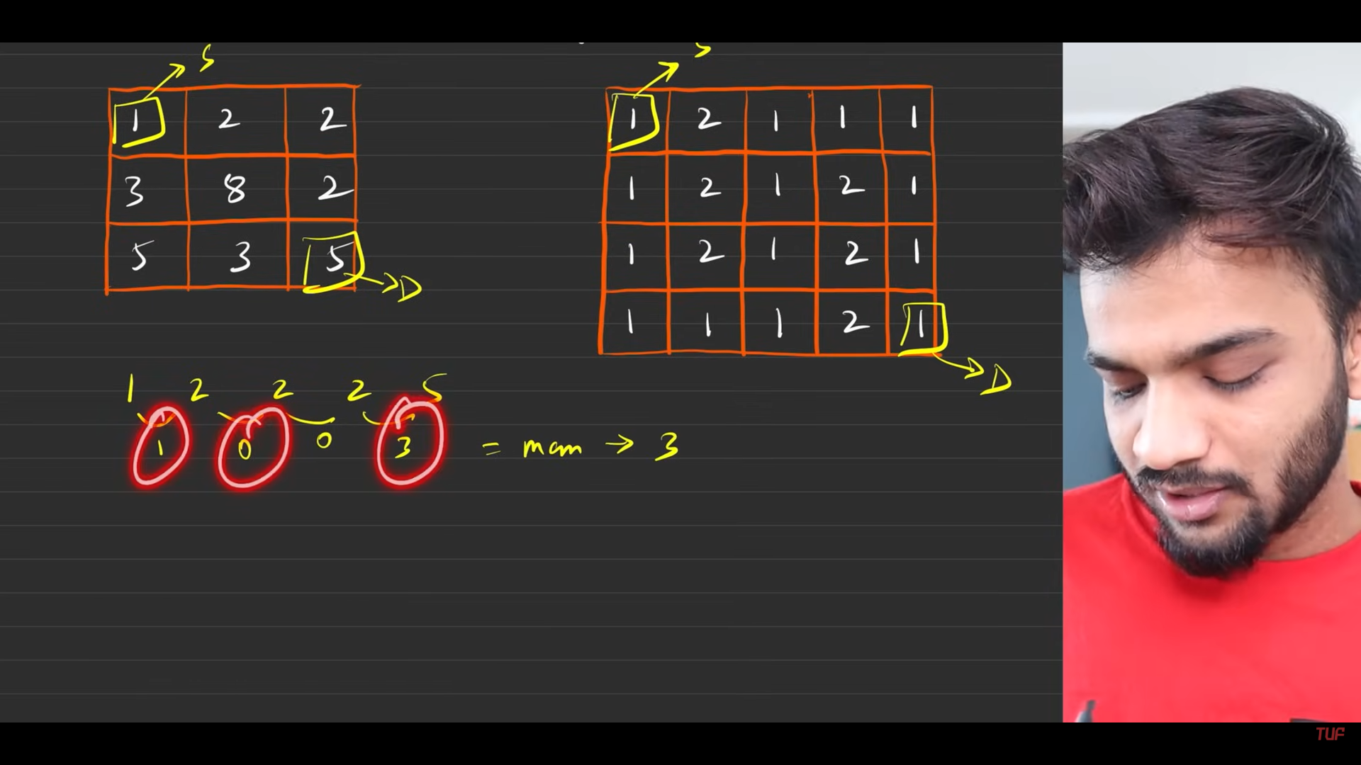
4. 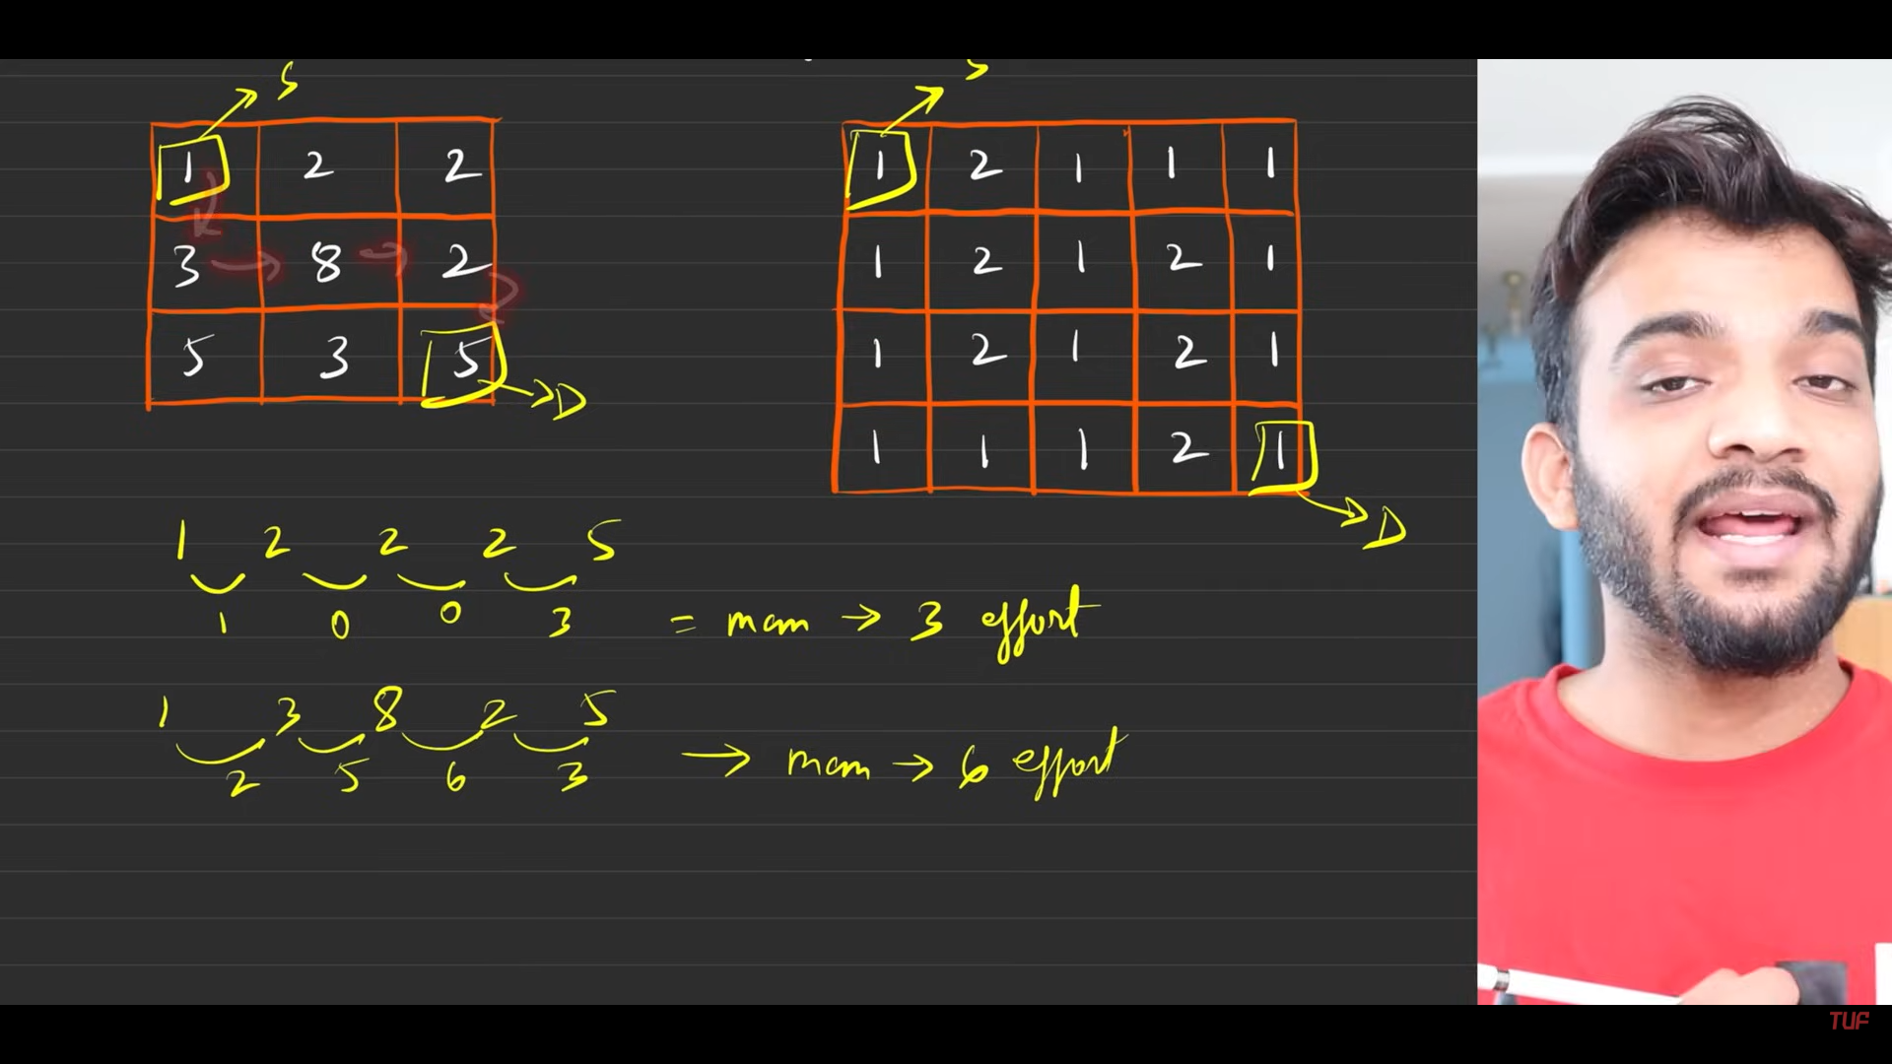
5. 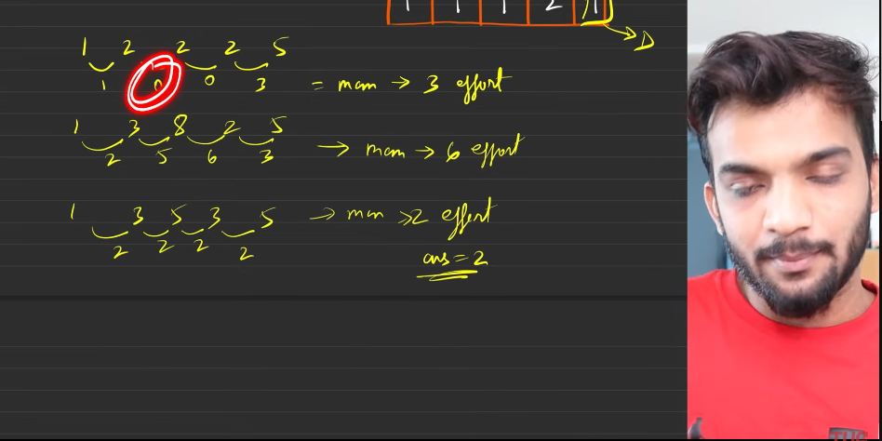
6. 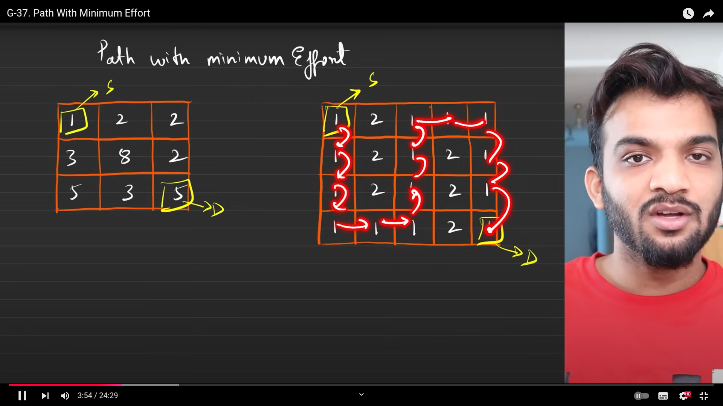
7. 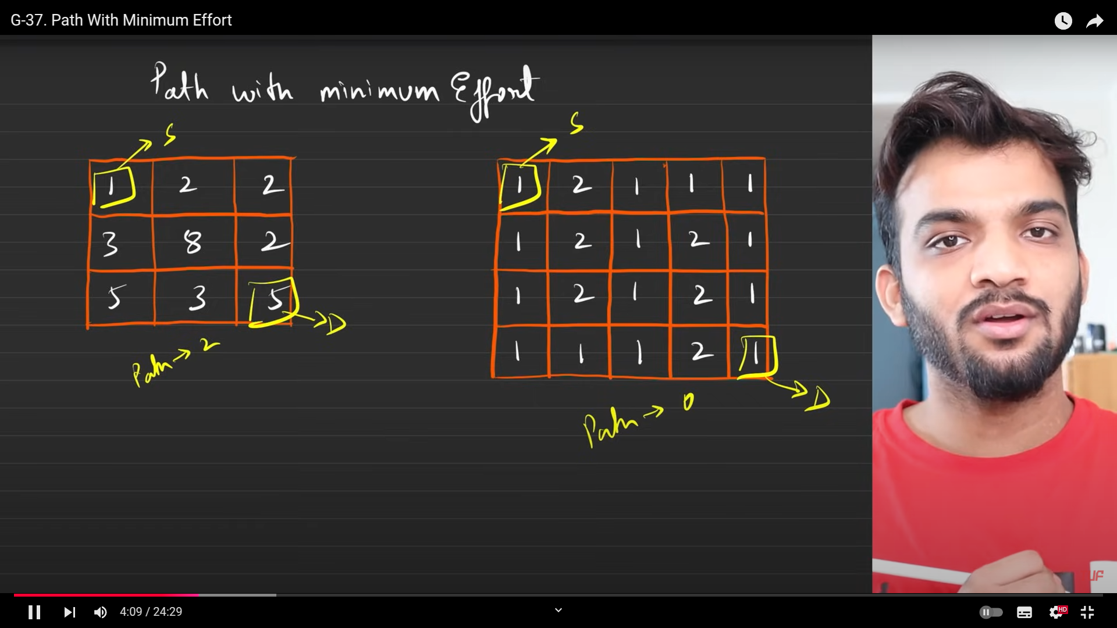
8. 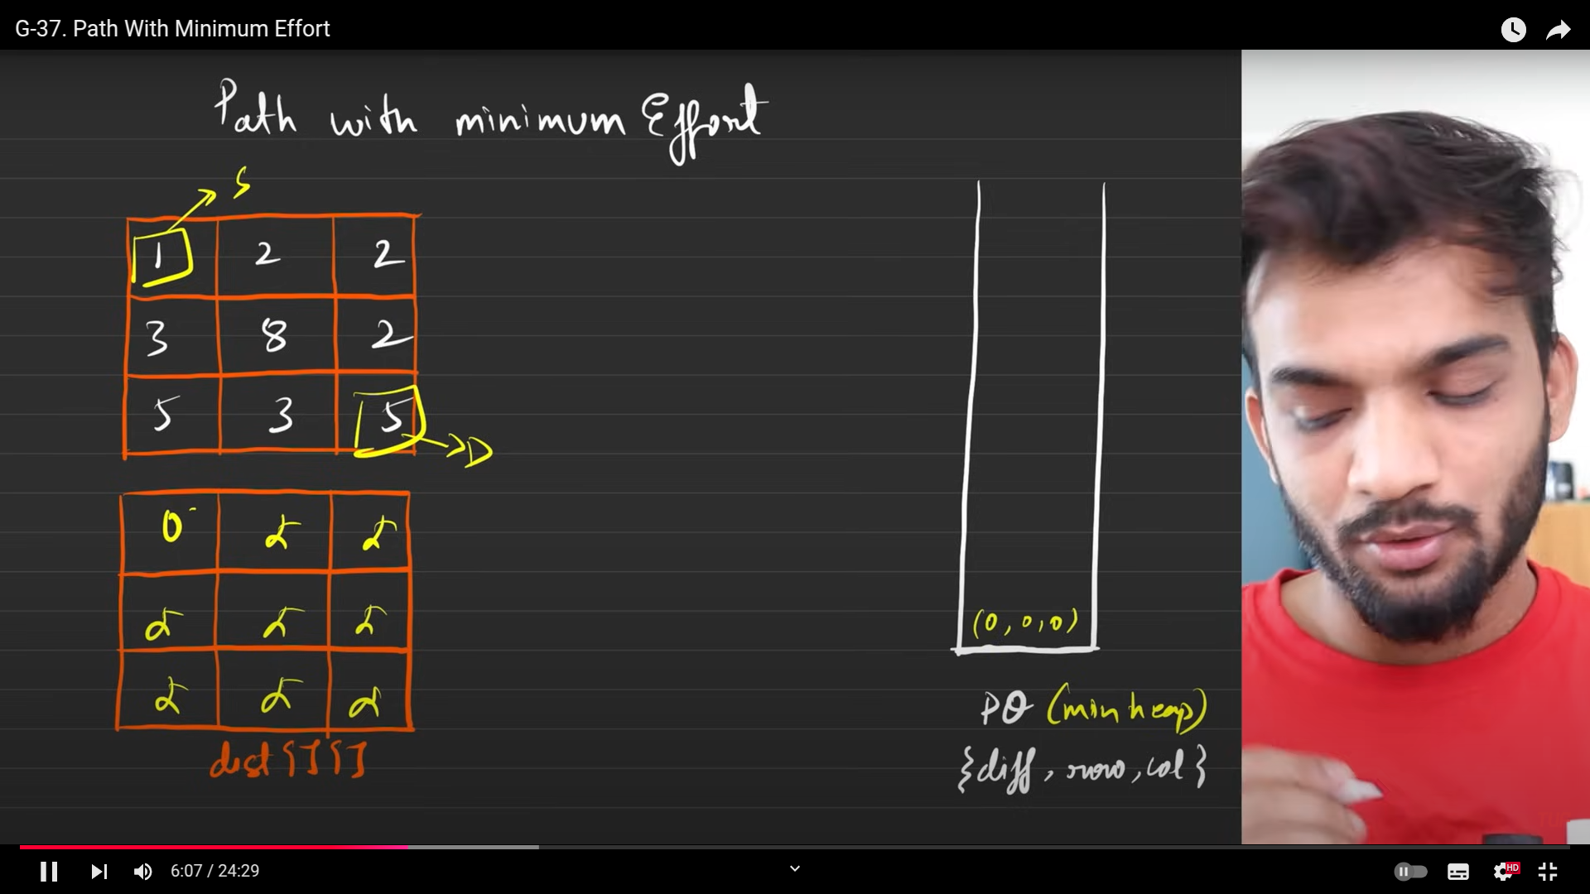
9. Problem:
   1. For a path, the maximum of all the diference of height.
   2. For the problem, minimum of all the maximum path.
10. 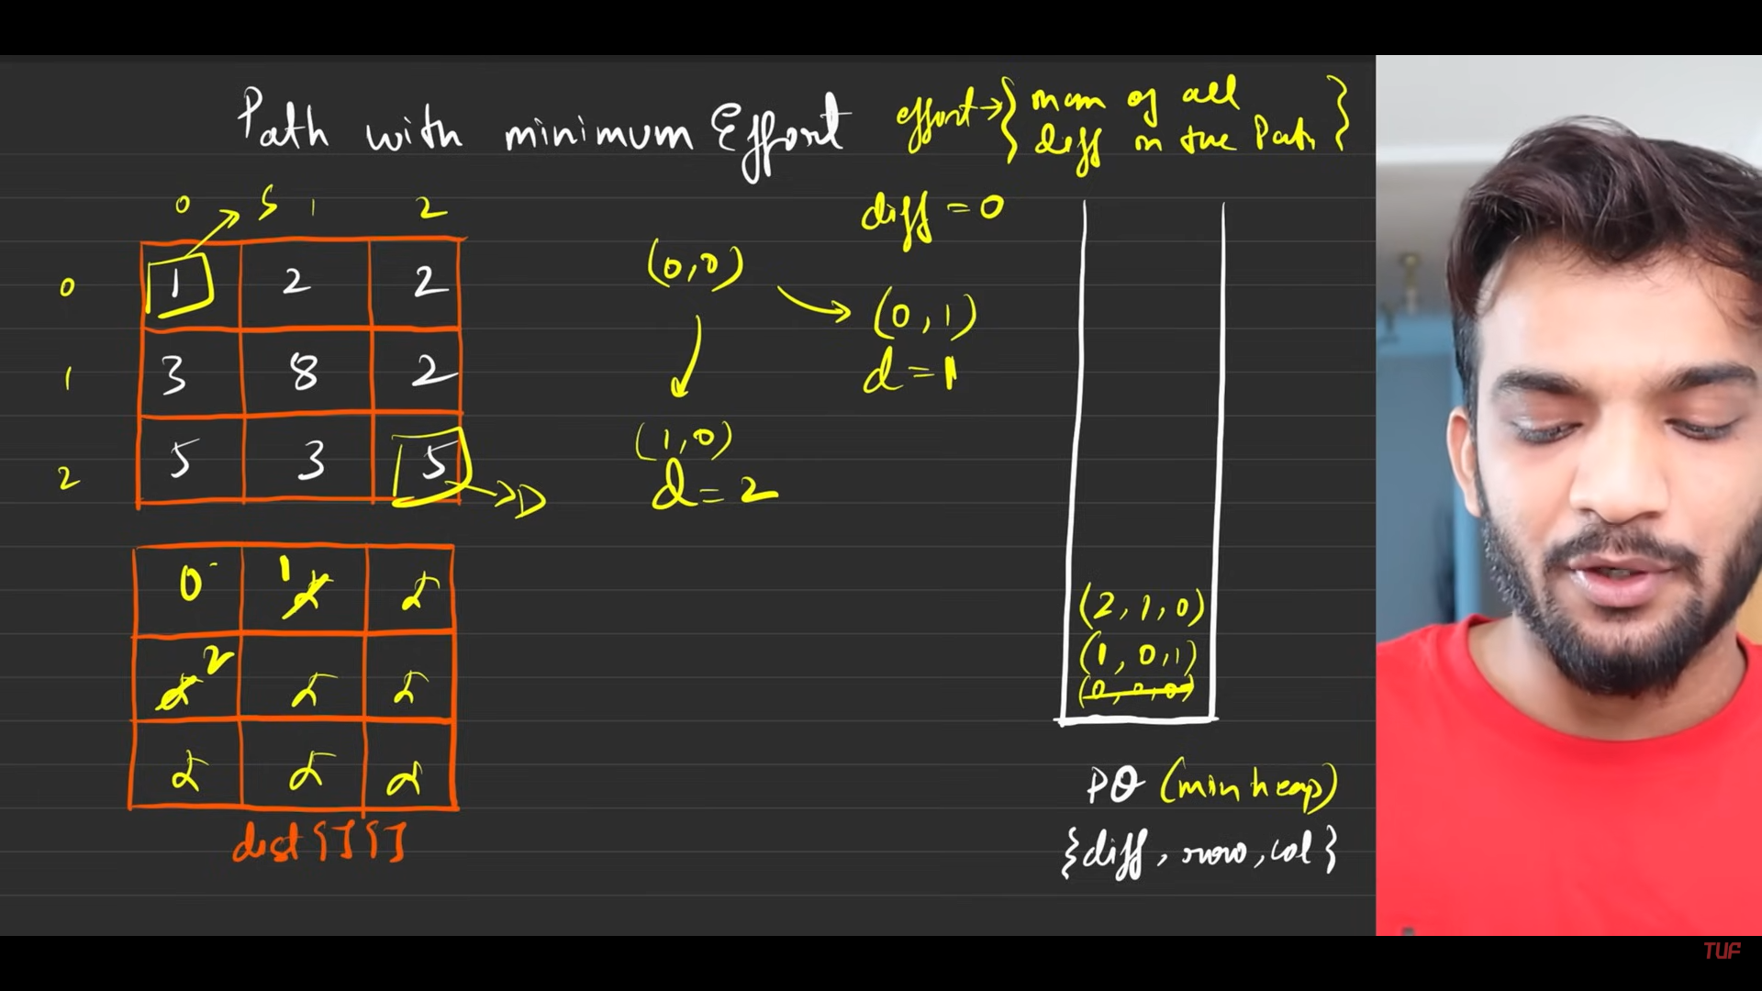
11. 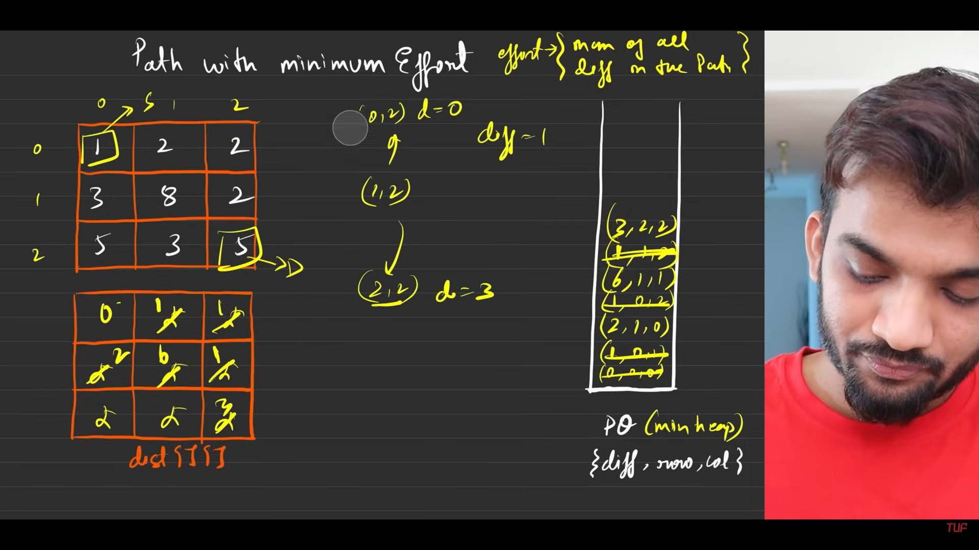
12. 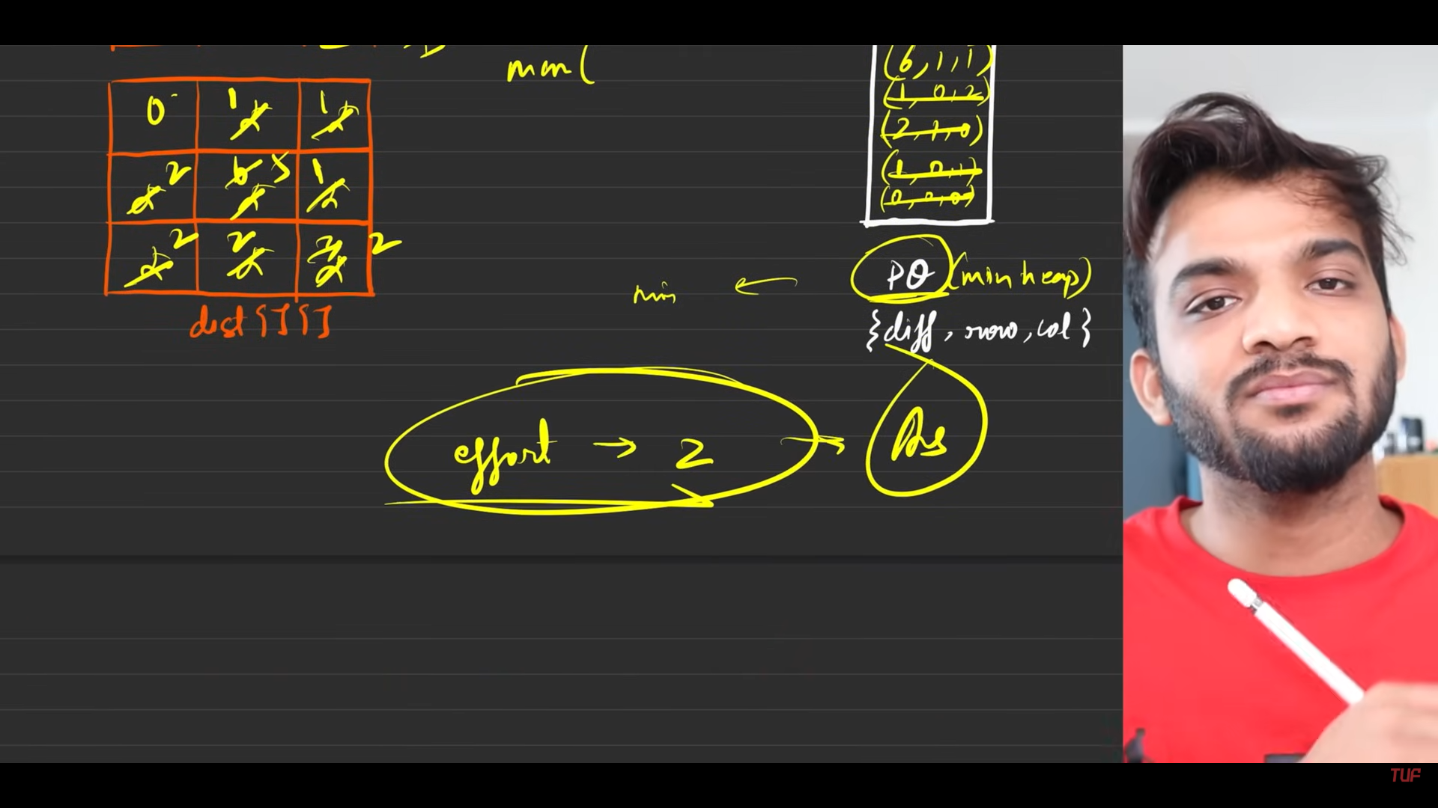
13. Algorithm:
    1. Dijsktras algo is nothing but:
       1. usage of a data structure which handles the minimum distance and the node. So that it is the datastructures which says, you have to stop at a point.
       2. I need another guy, which will store the minimum distance to the node, till now, there might be some modifications for others.
       3. Keyword: Minimum distance, path combination.
    2. This numerical:
       1. Inital configurations :
          1. The **min-heap**: priority\_queue<pair<int,pair<int, int>>>, vector<pair<int,pair<int, int>>>, <pair<int,pair<int, int>>> min\_heap;
          2. 2d vector which is having all the entries with inf, i.e. 1e9.
          3. The source(0,0) , destination(n-1,n-1). The above matrix with the source as 0.
          4. Till the min heap becomes empty, keep looping:
             1. travel in all 4 valid directions, maxi=max(given\_matrx[direction] - distance of popped node, maxi ) from the queue.
             2. if maxi<initially\_configured\_matrix\_point, then enter maxi to that cell.
             3. Enter PQ <maxi, row, col> to the PQ .
          5. min heap becomes empty, return the entry at the destination.
             1. s
14. 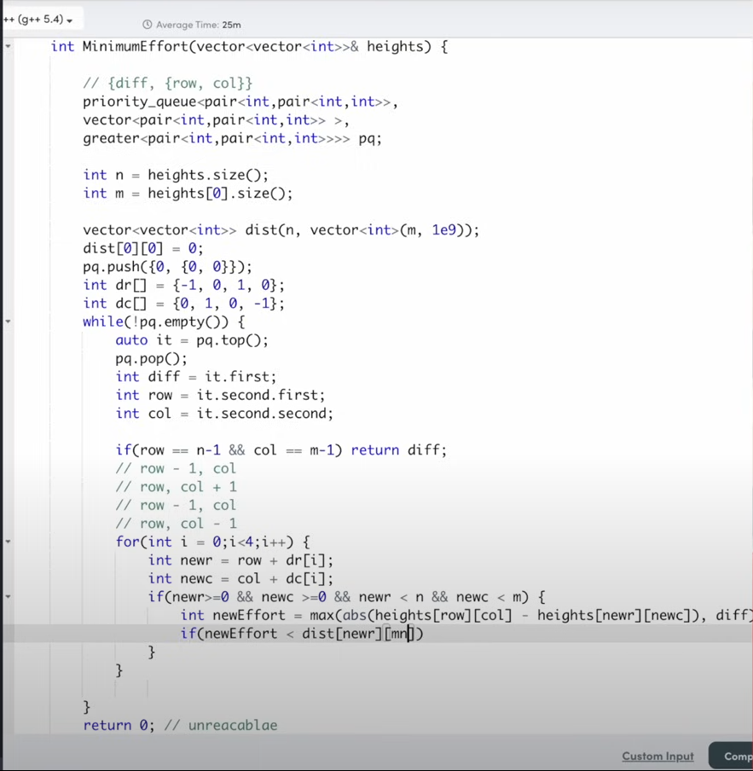
15. 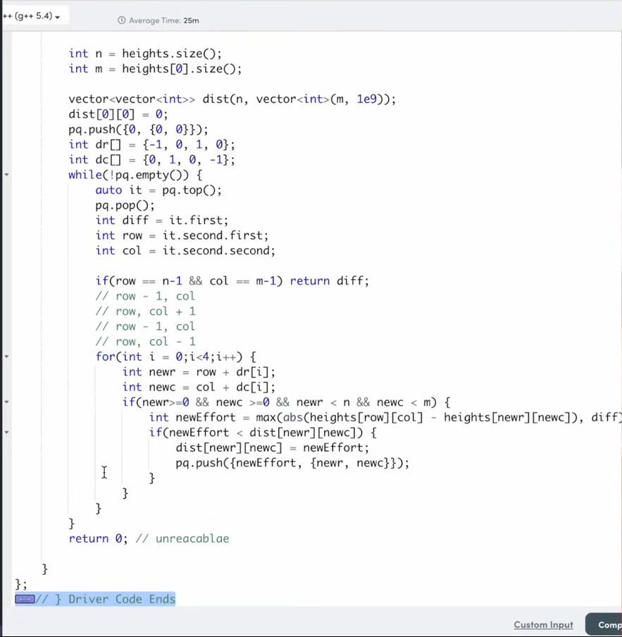
16. 

**Cheapest Flights Within K steps(IMPORTANT)**

1. 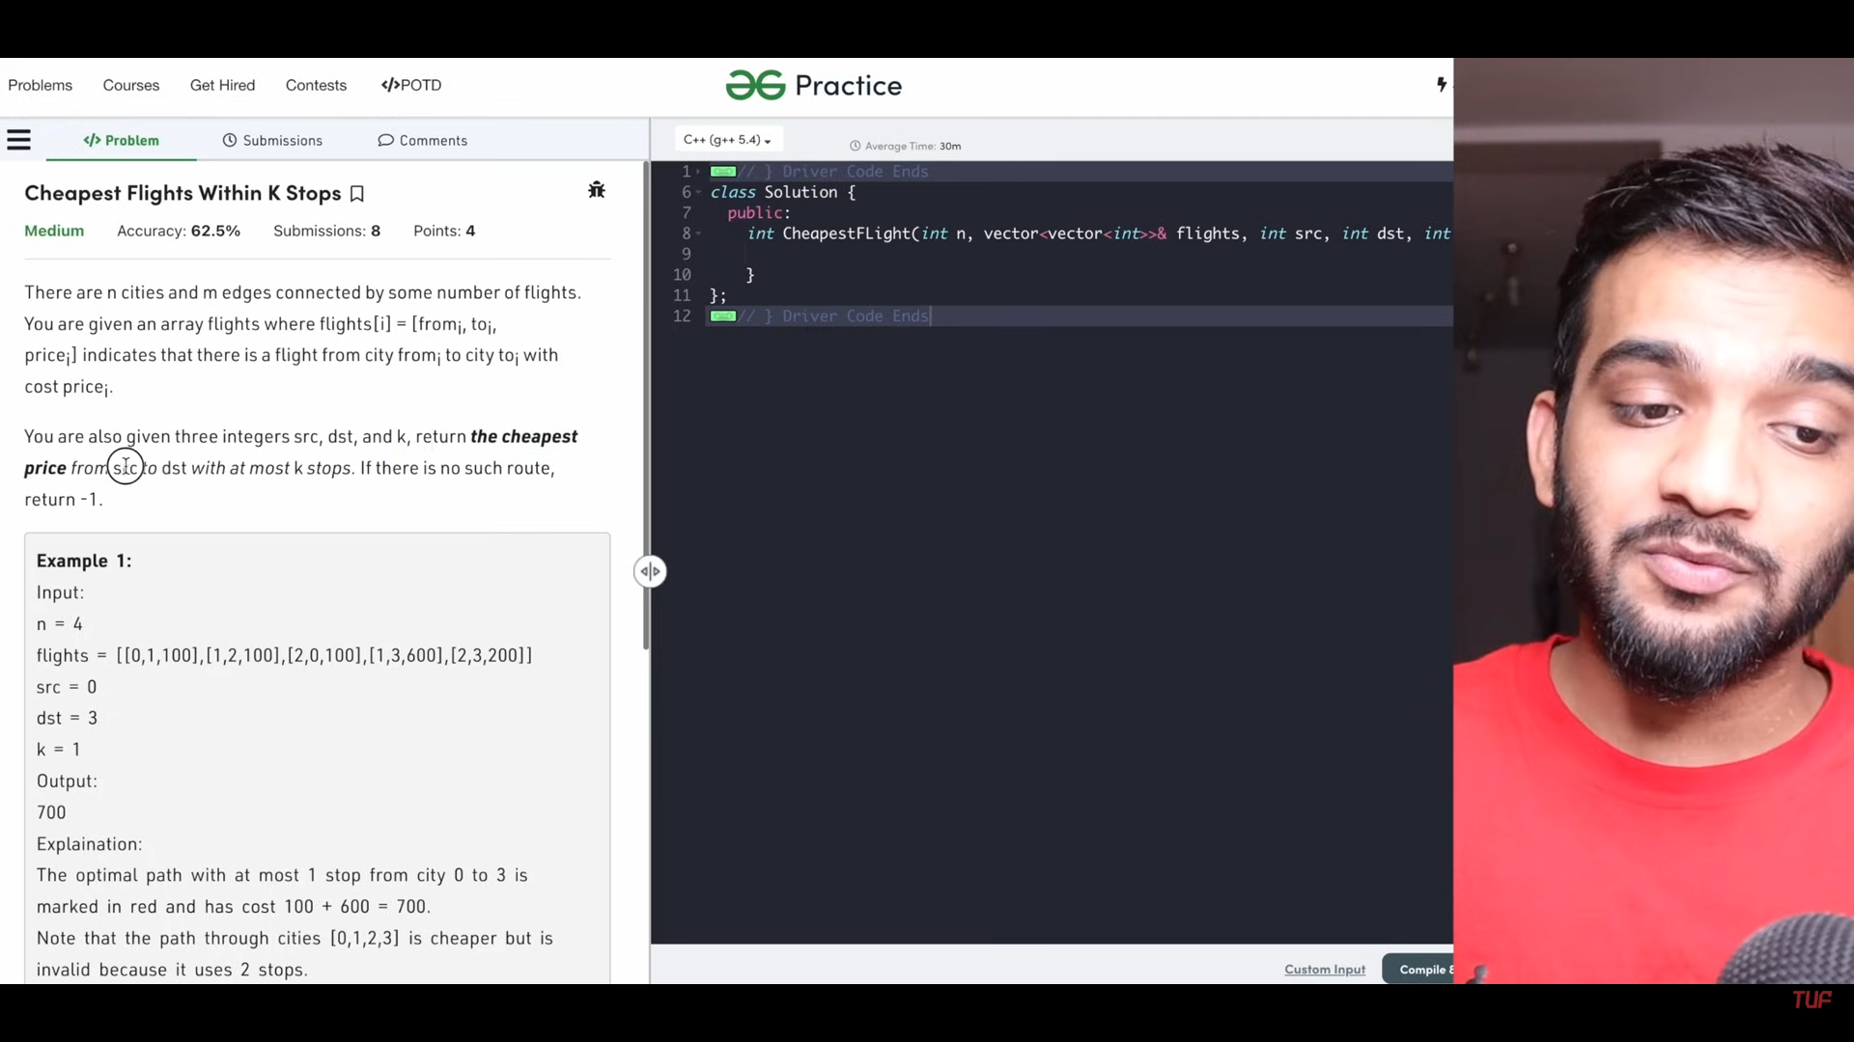
2. 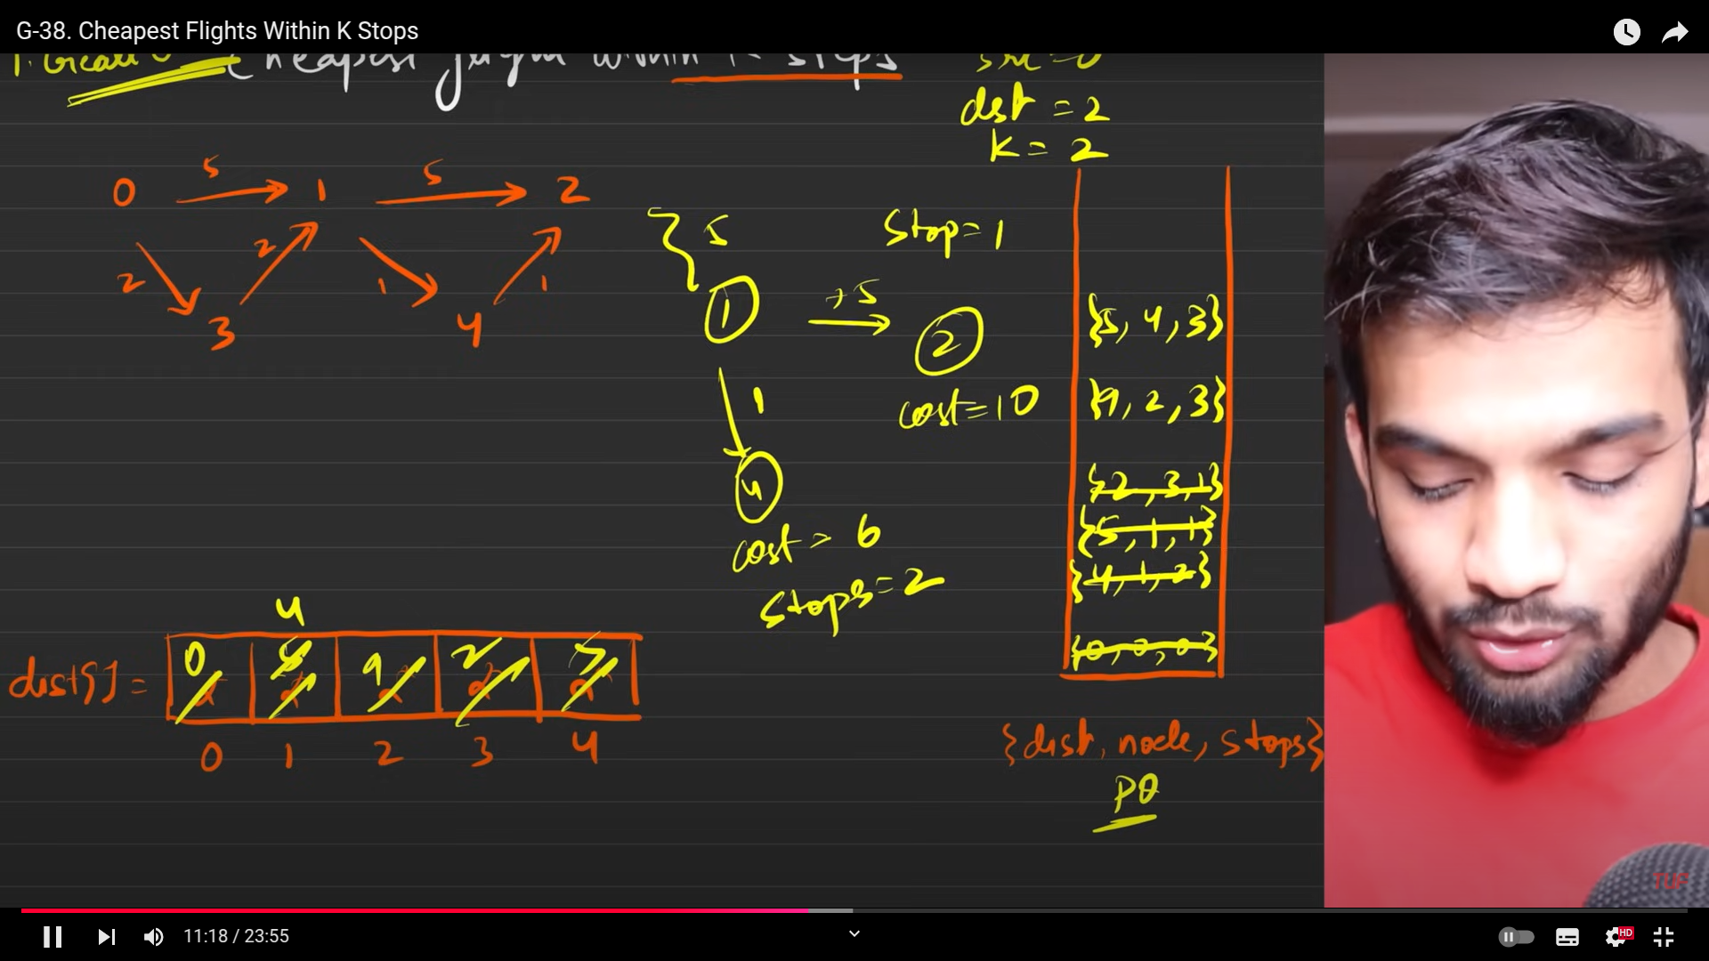
3. This is will not generate the correct answer, because my algorithm is designed to choose the dmaller distance, which will eventiuauy elimate the largest paths to the destination. Which has to obey the constraints. Without obeying the constraints it will not lead you to to the correct path.
4. So our first priority must be stops rathre than distance, so from problem to problem the condition to keep on the evaluation matters a lot. Hnce we will be removing the PQ and instead will implement this with the help of queue.
5. 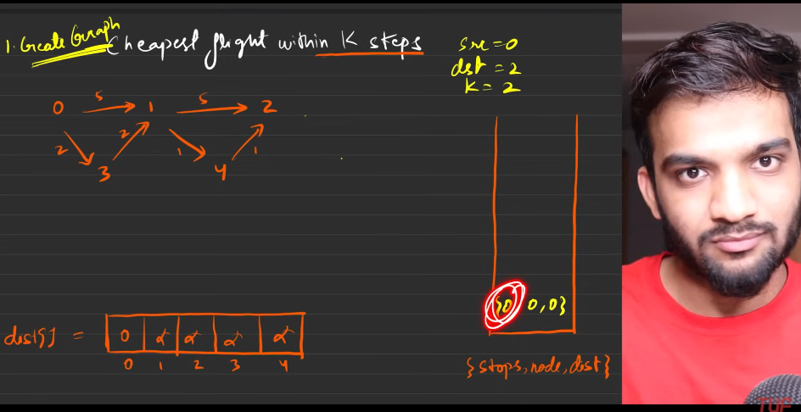
6. Here we do not need PQ, just queue is needed.
7. 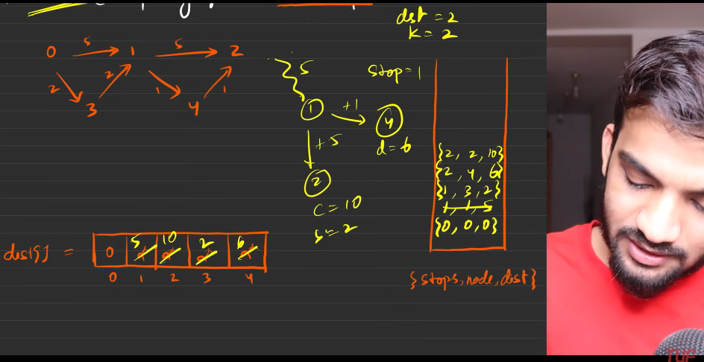
8. 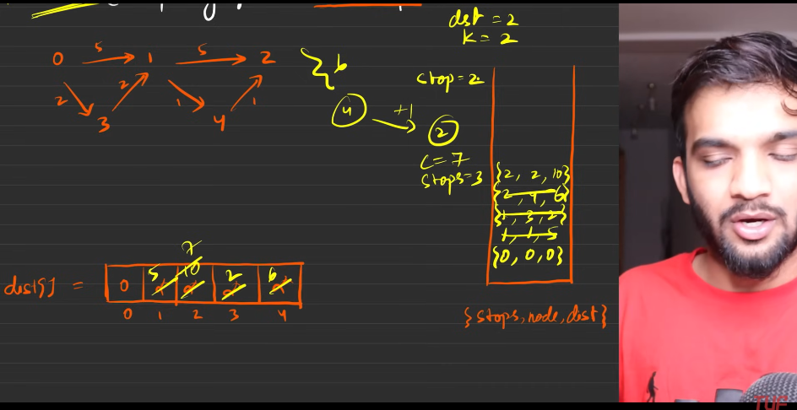
9. 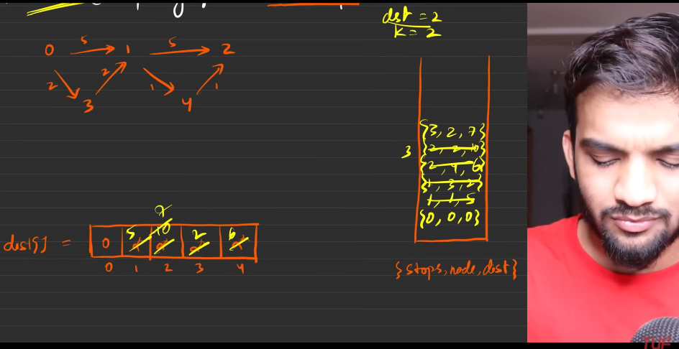
10. 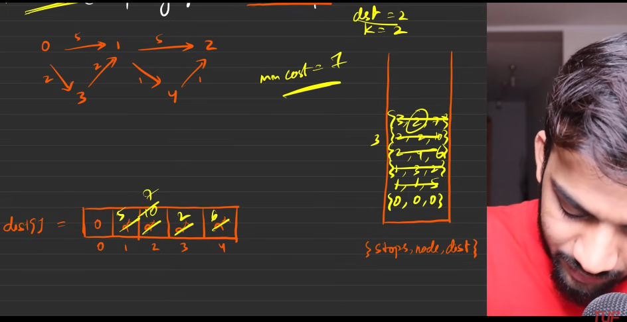
11. Insert till stops+1.
12. 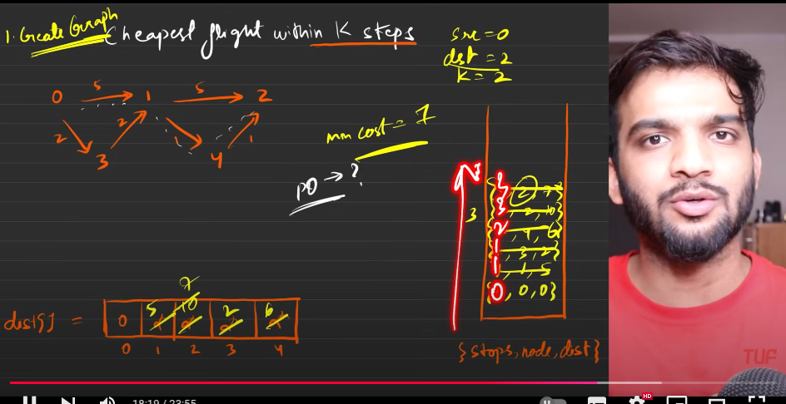
13. This is the one tells why PQ is no more needed.
14. 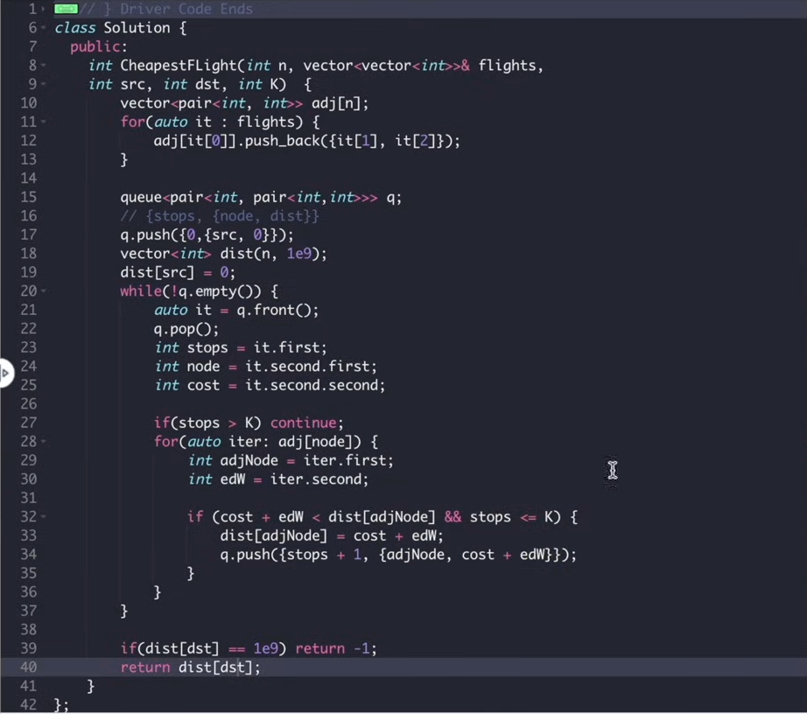
15. 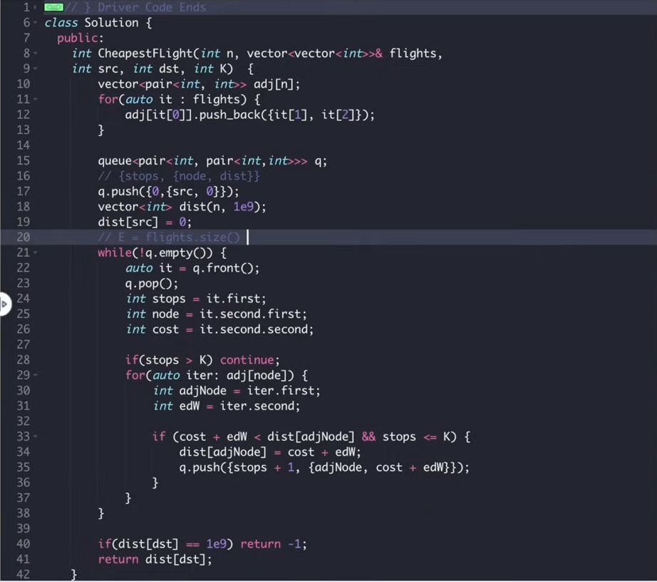

**Number of ways to arrive at destination at shortest.**

1. 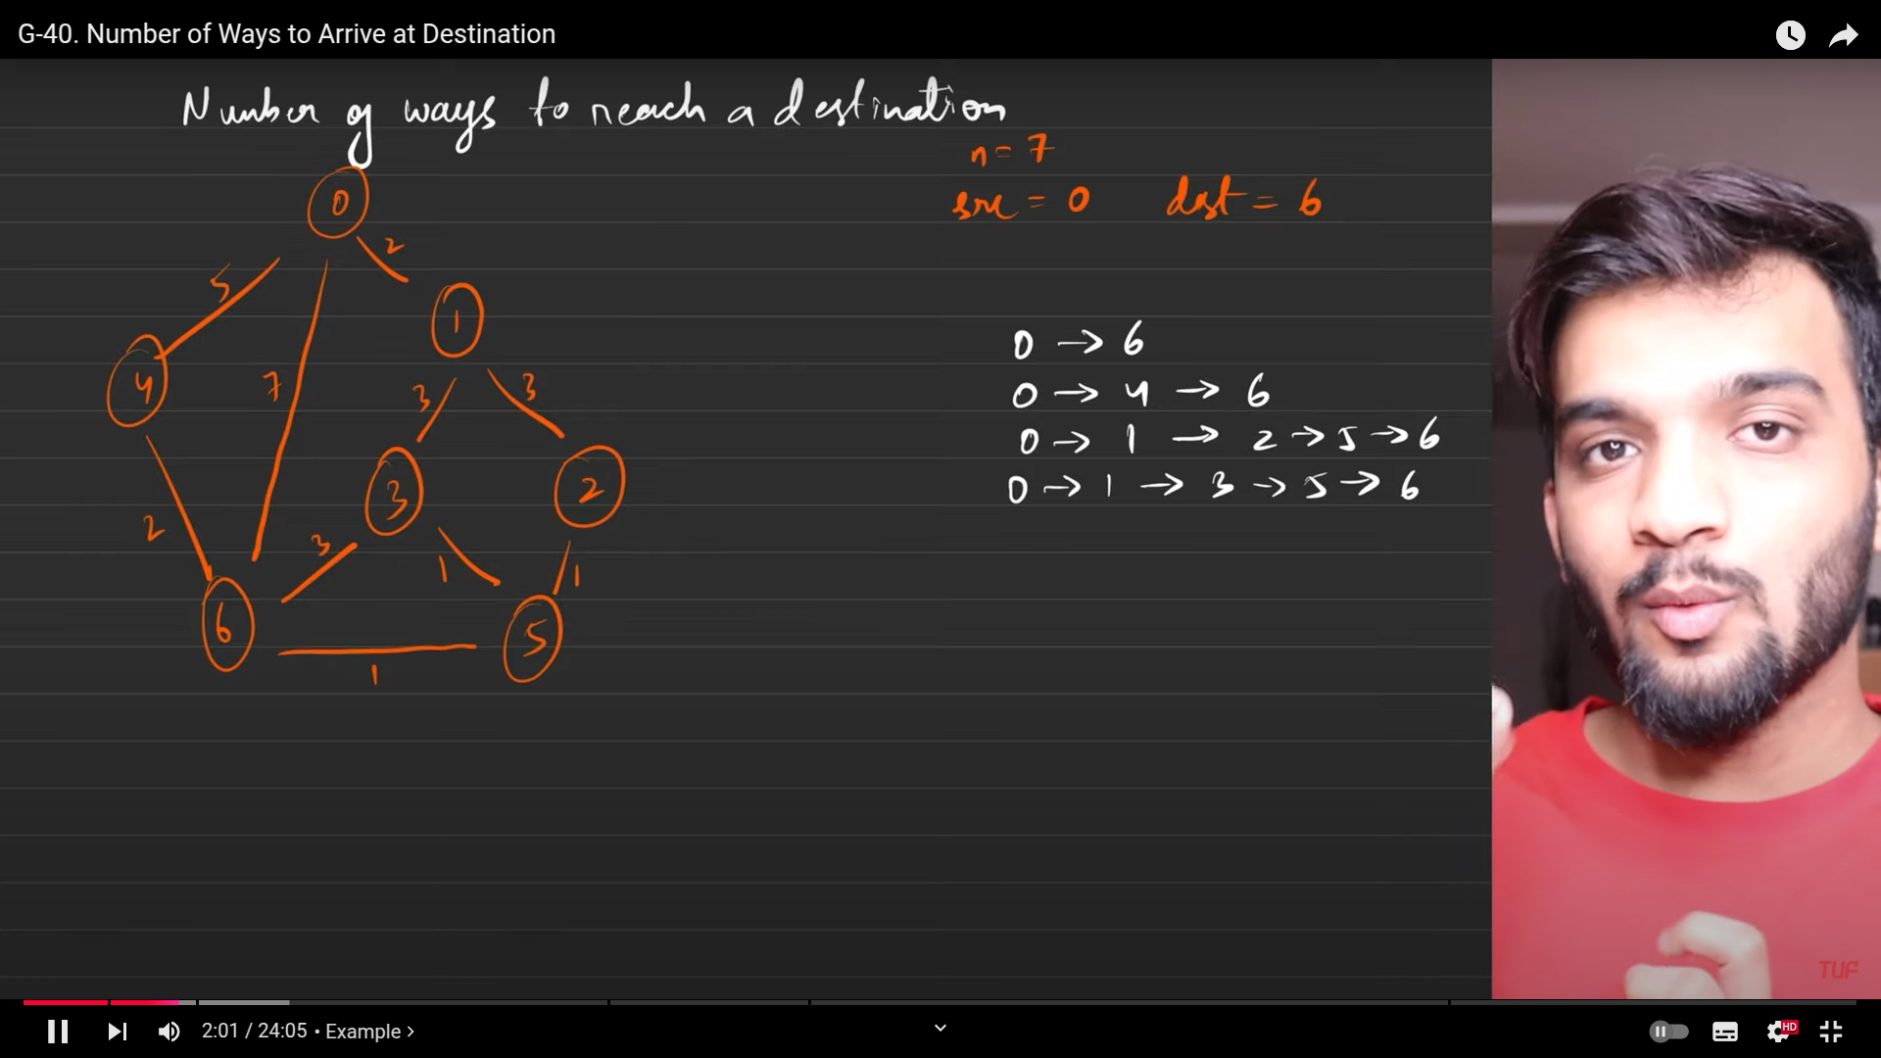
2. 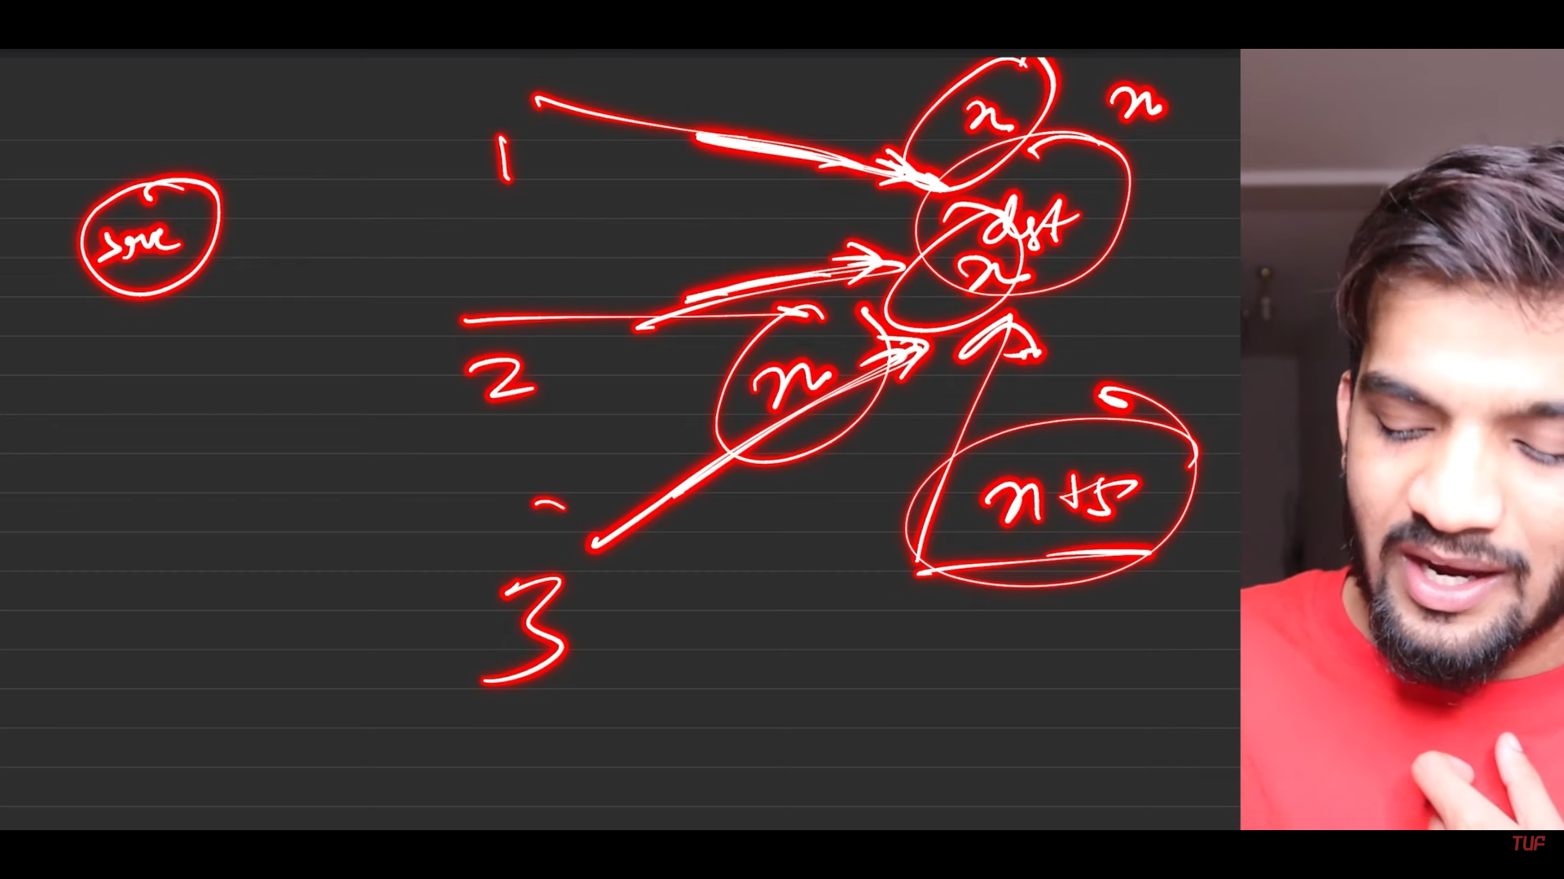
3. 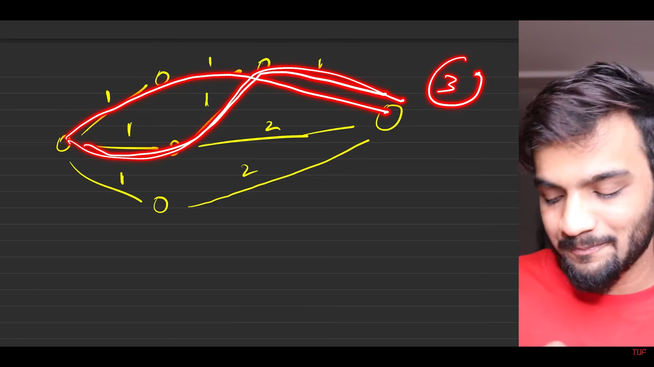
4. 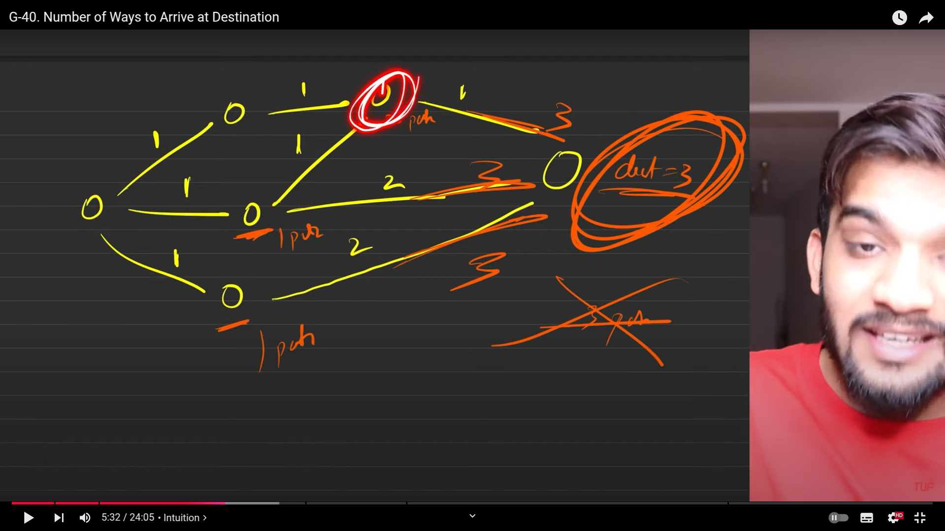
5. 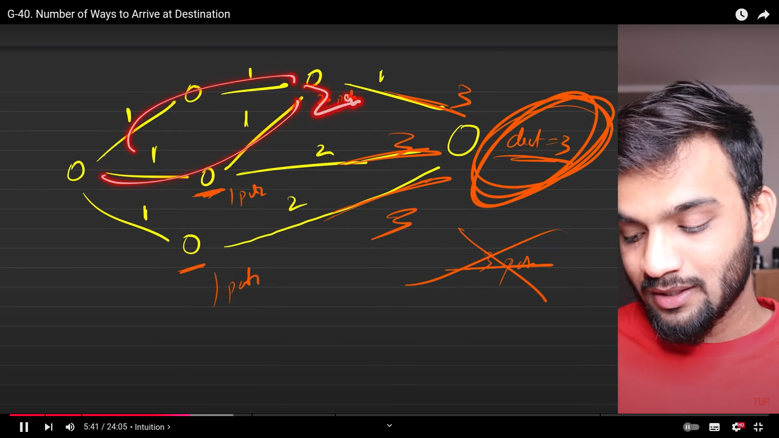
6. 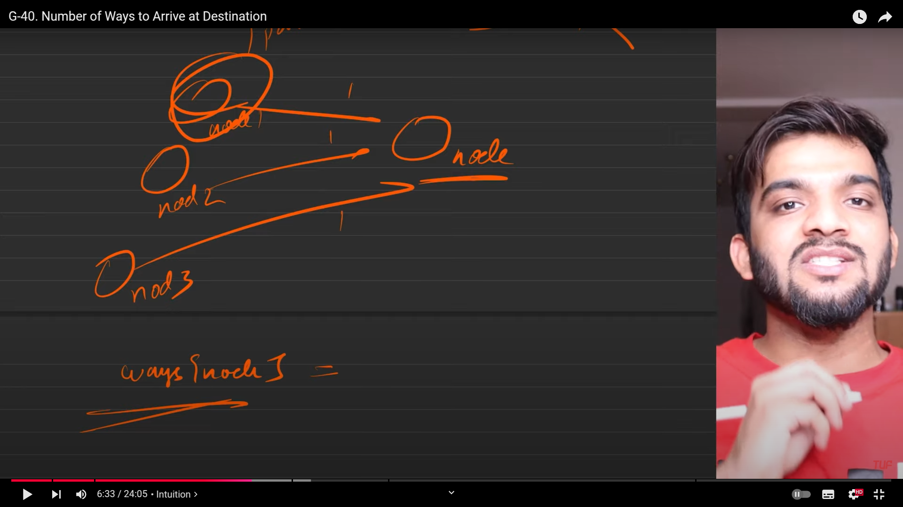
7. 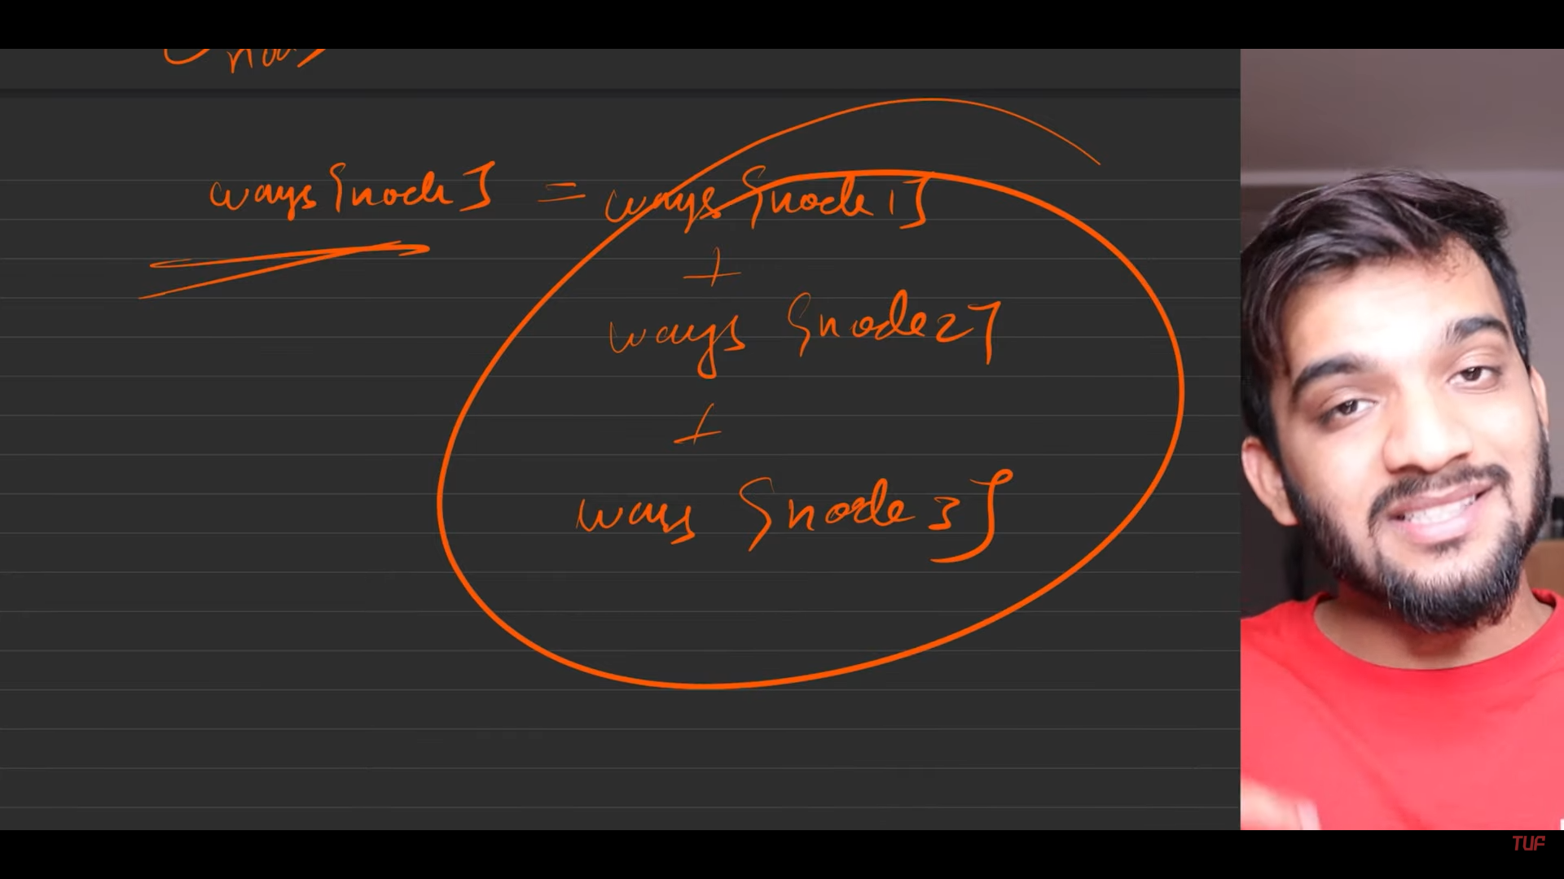
8. 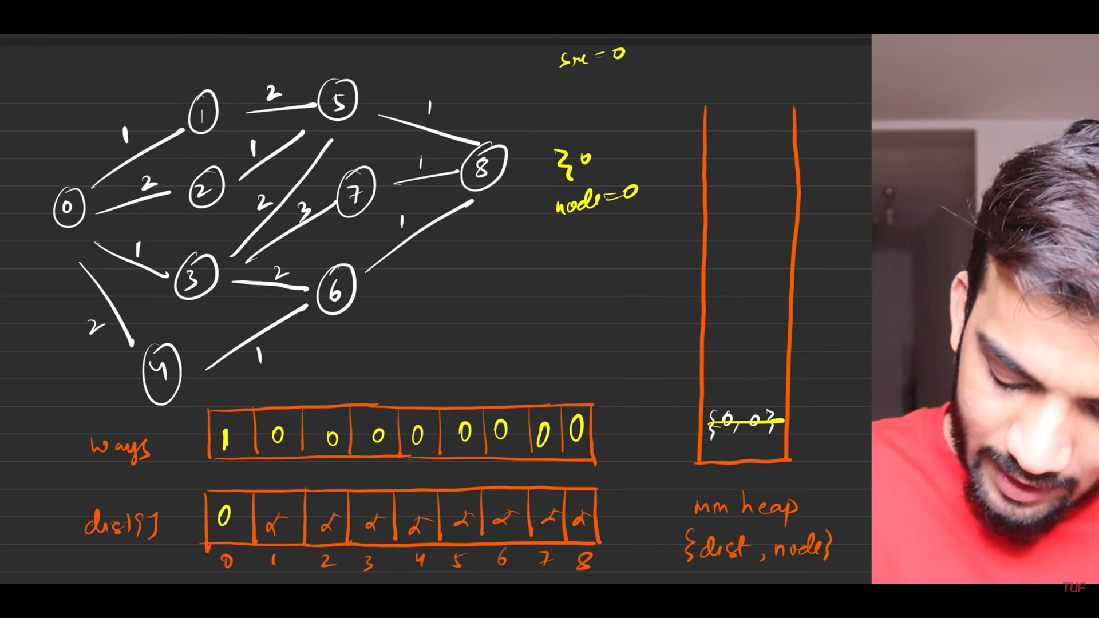
9. 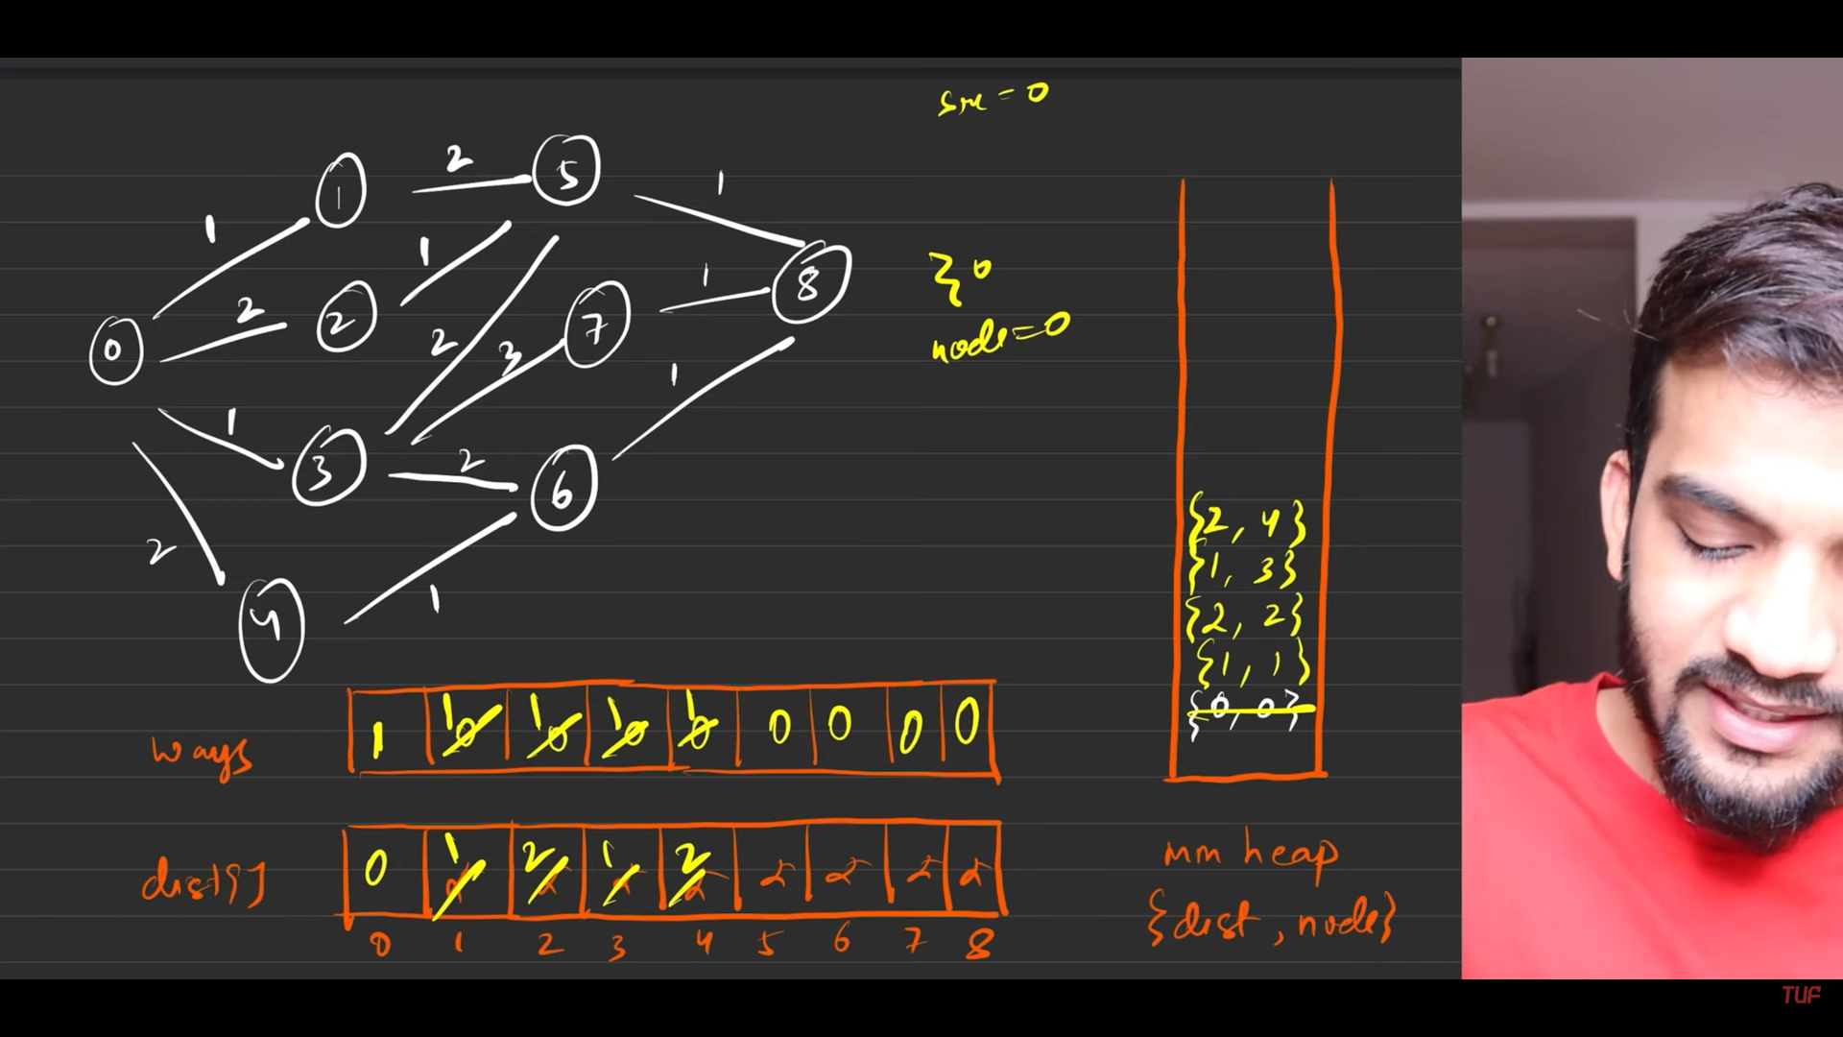
10. 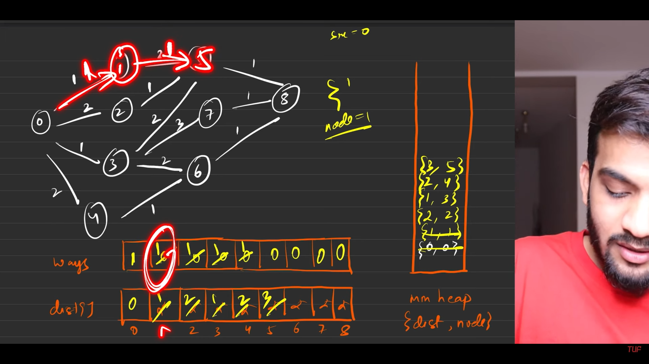
11. 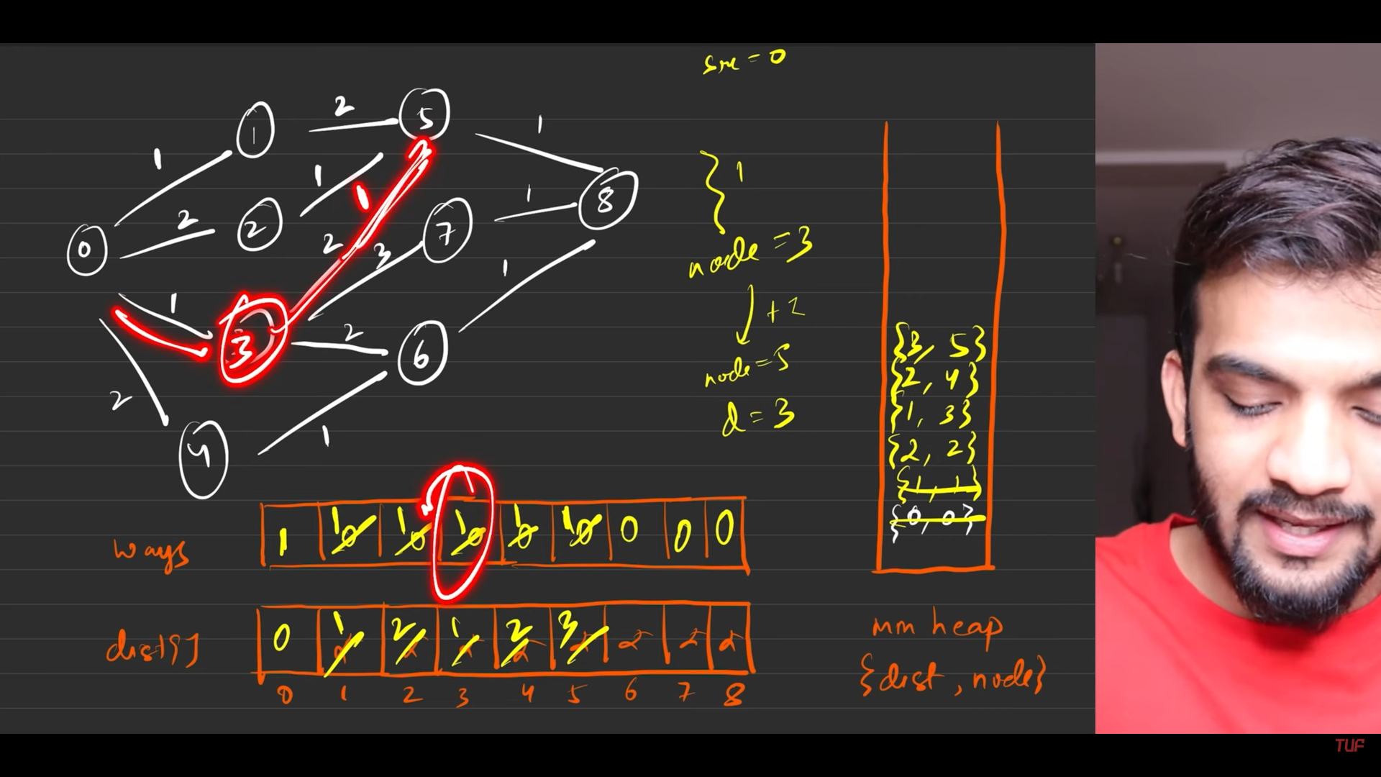
12. 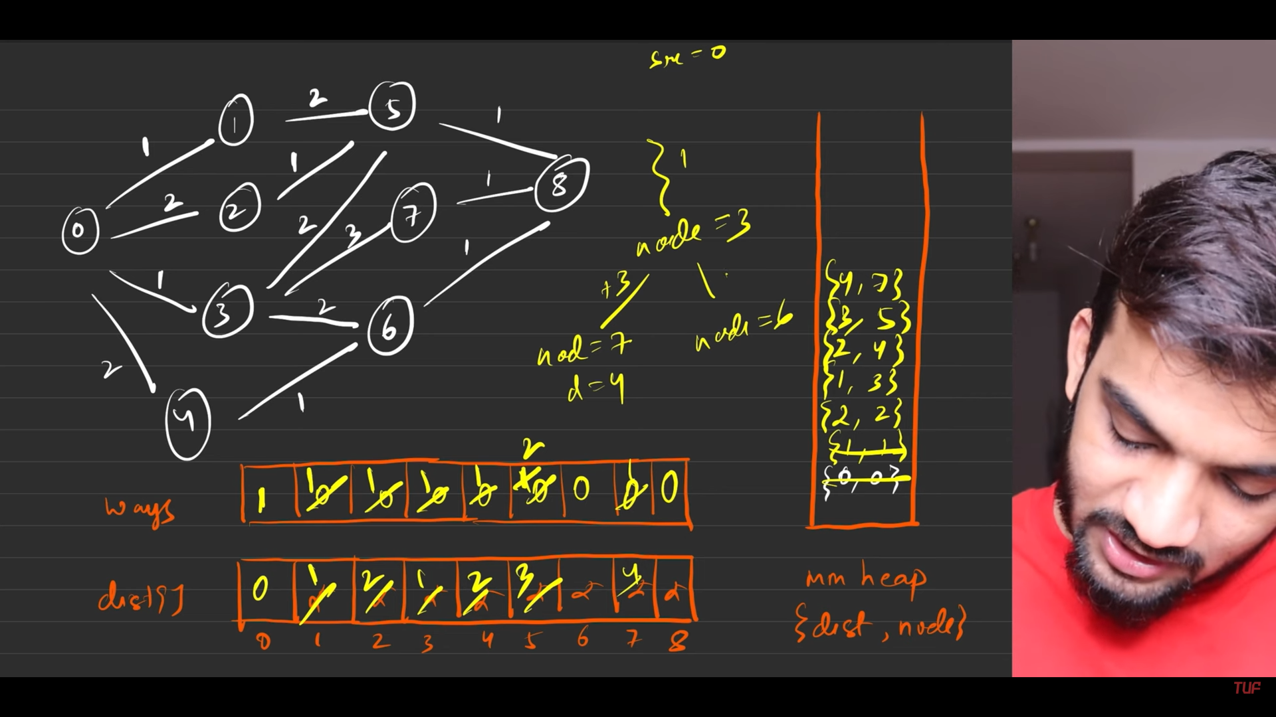
13. 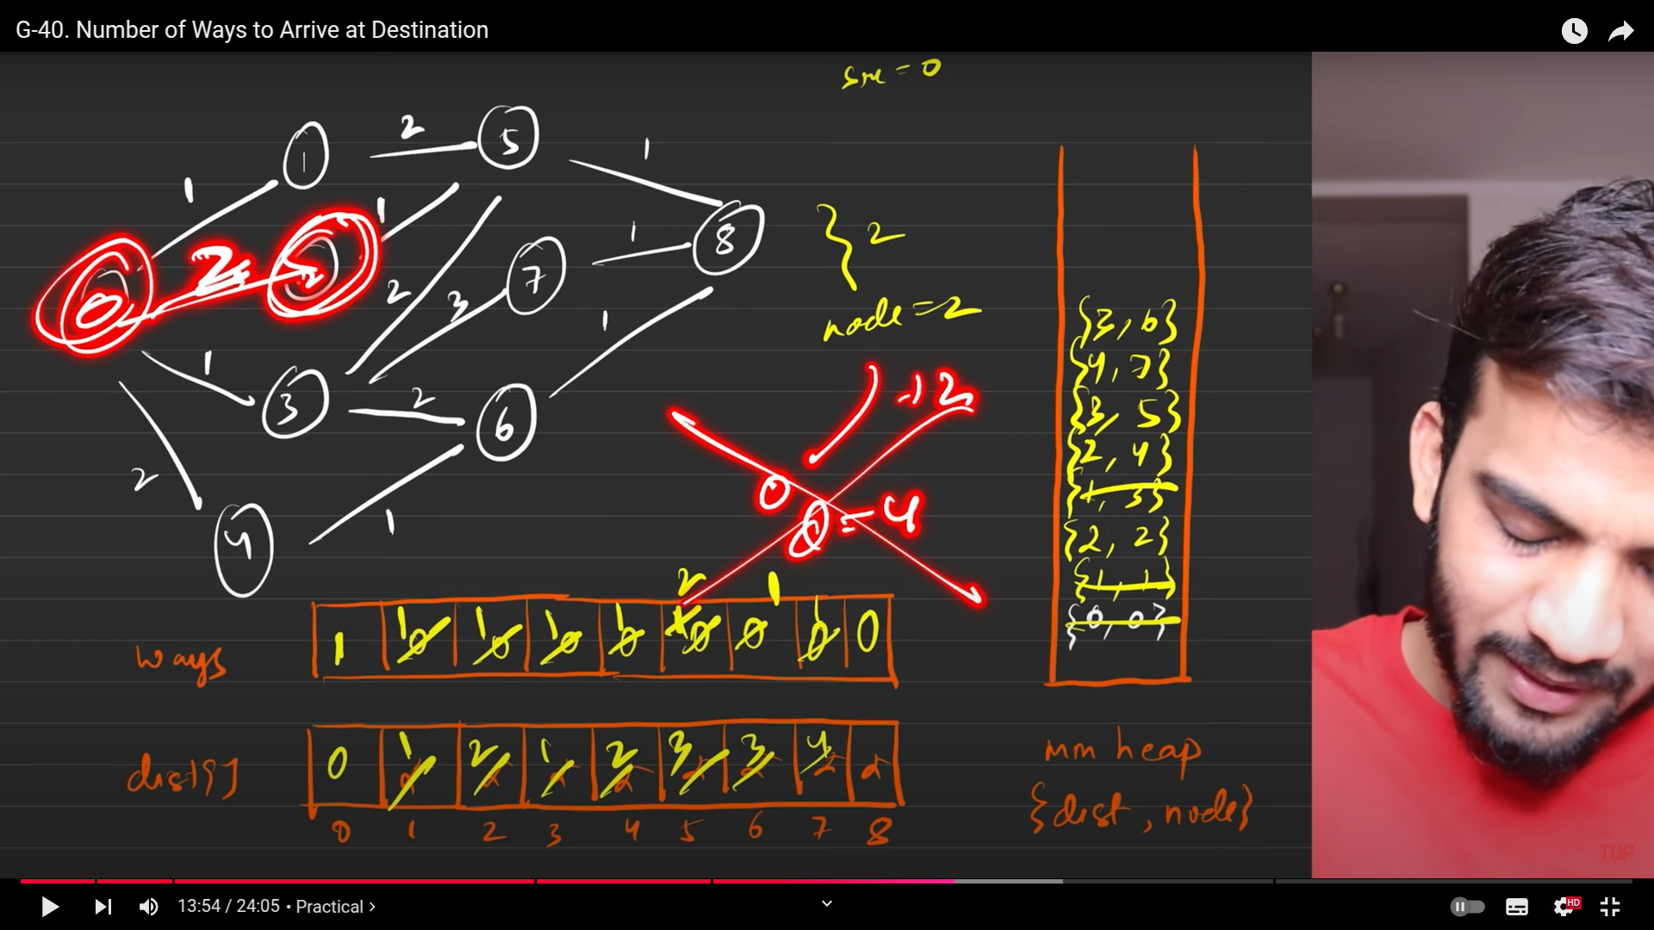
14. 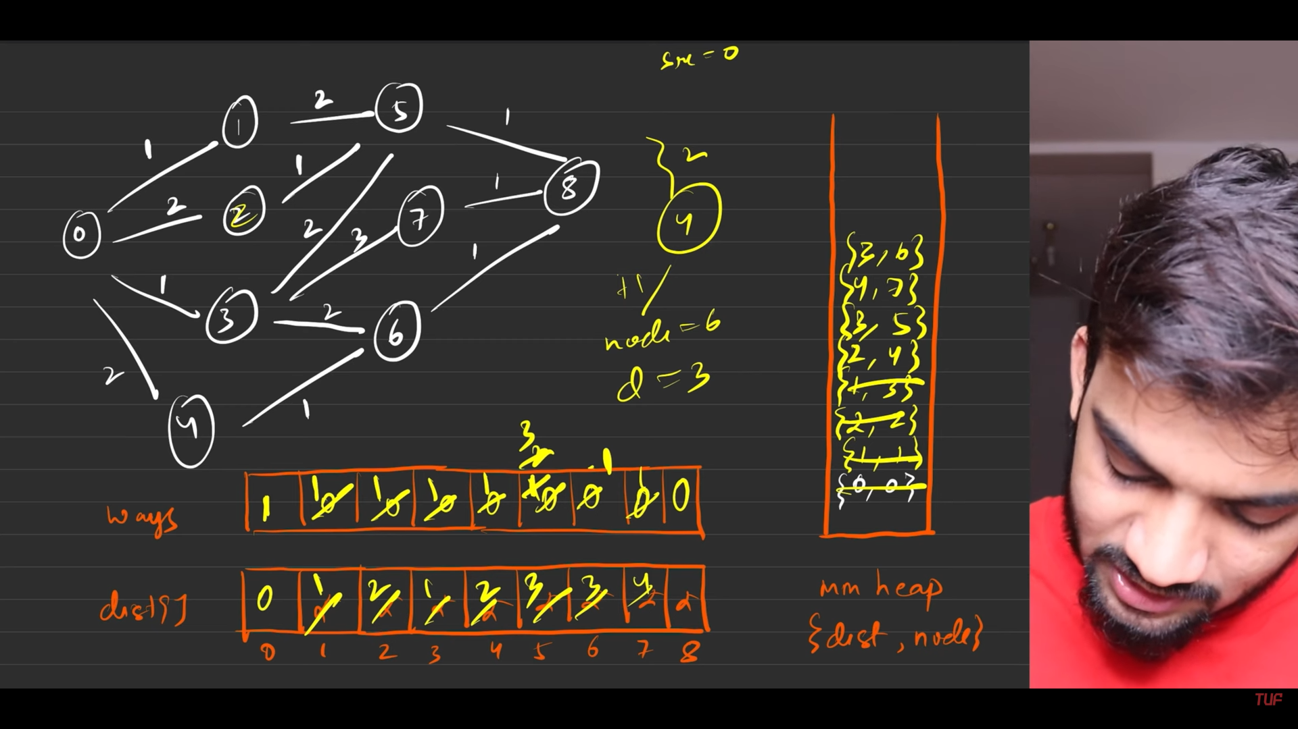
15. 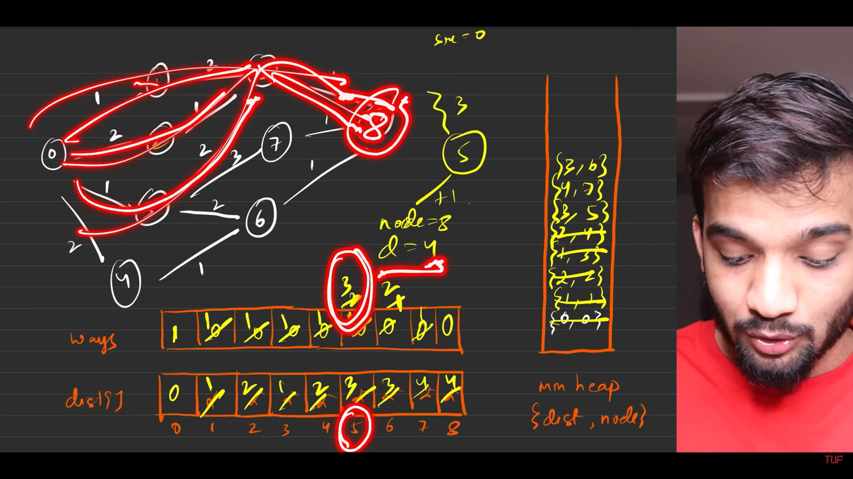
16. 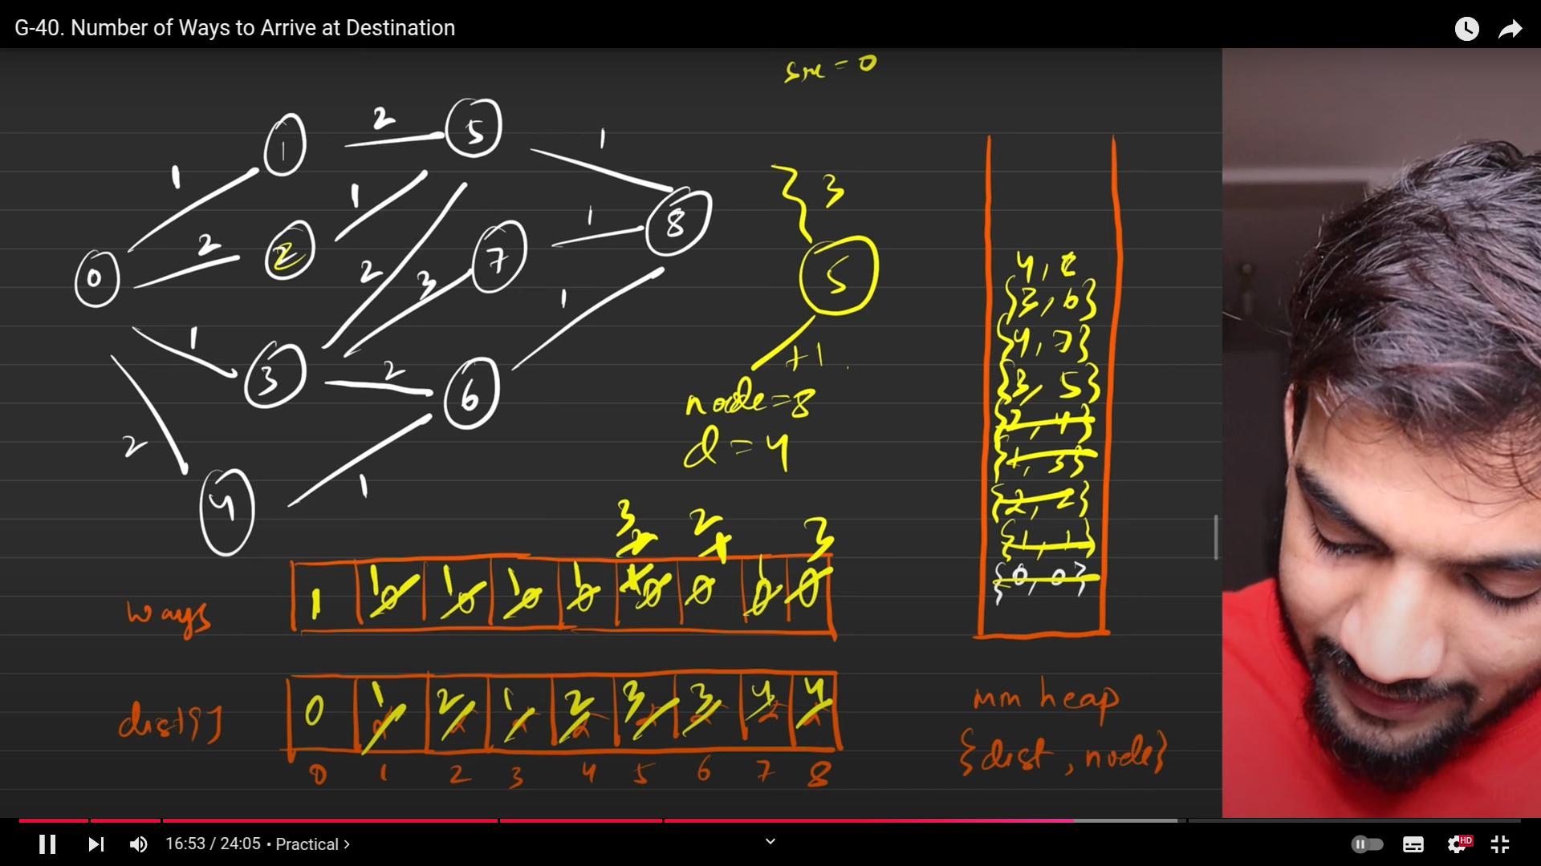
17. 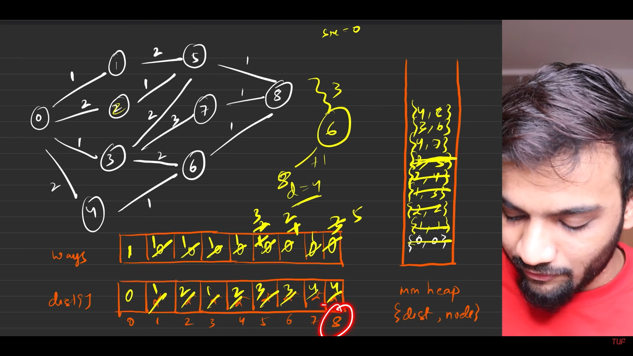
18. 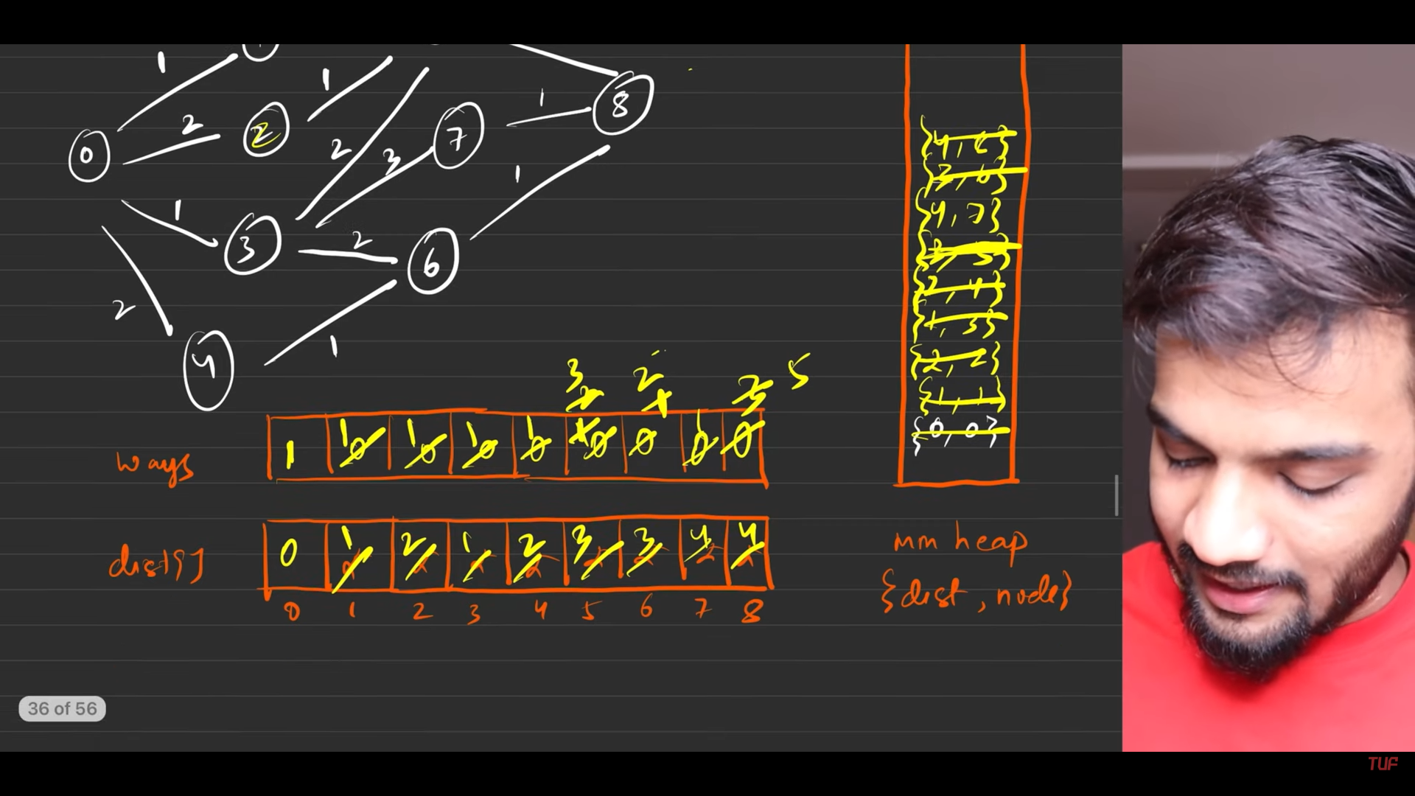
19. 
20. 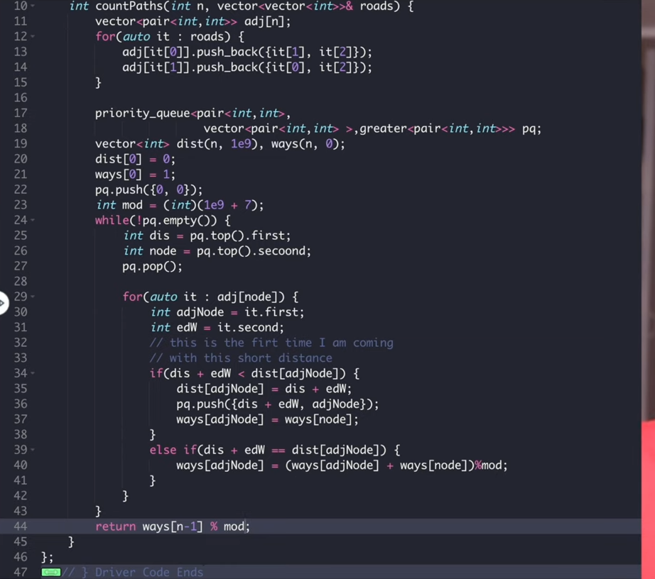

**[Minimum steps to reach end from start by performing multiplication and mod operations with array elements](https://takeuforward.org/graph/g-39-minimum-multiplications-to-reach-end/" \t "/home/hlgsagar/Documents\\x/_blank)**

1. 
2. 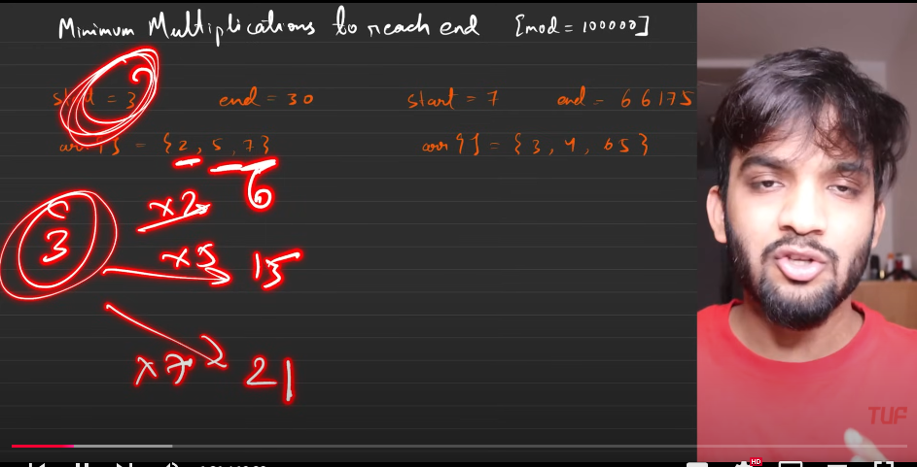
3. 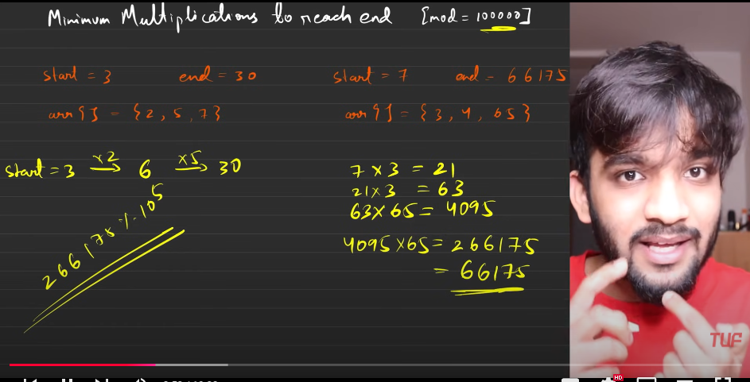
4. 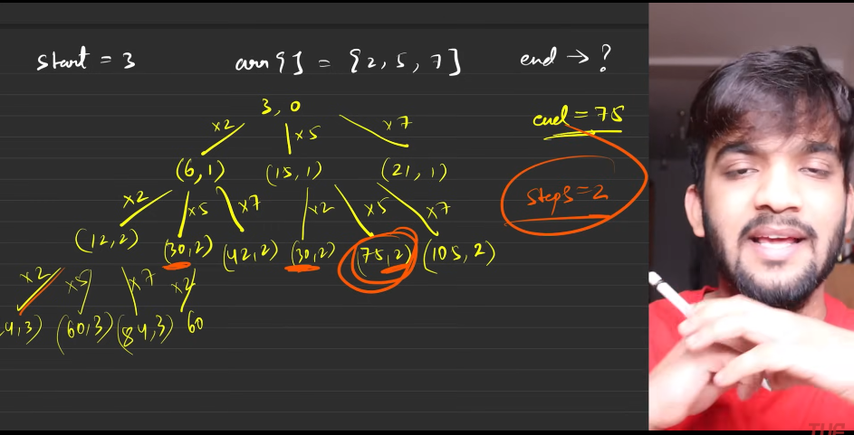
5. 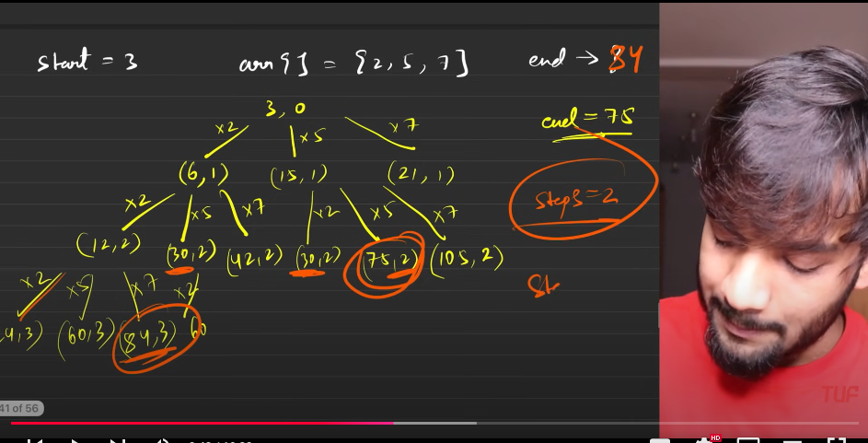
6. 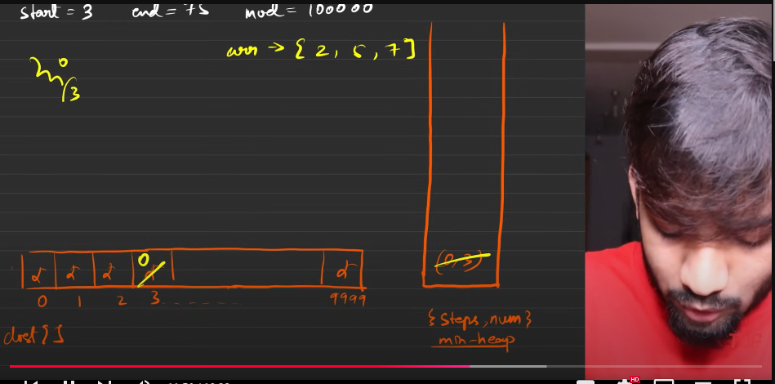
7. 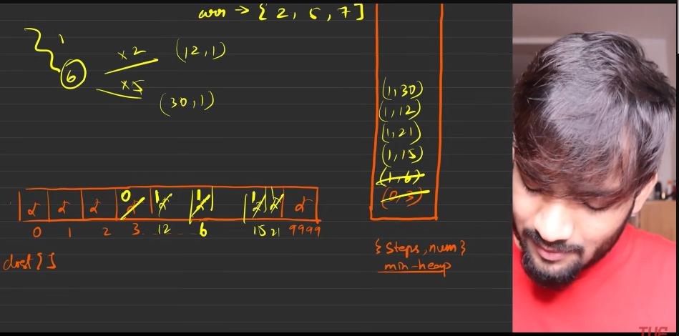
8. 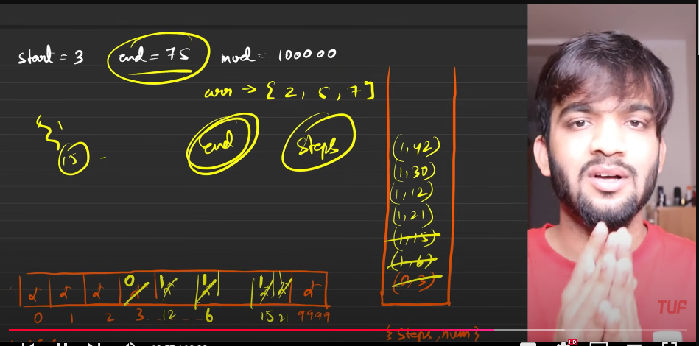
9. The only important things here is - number of entries to the array. Make sure the array with the limited size is according to the mod array. The problem is pretty muh solved.
10. 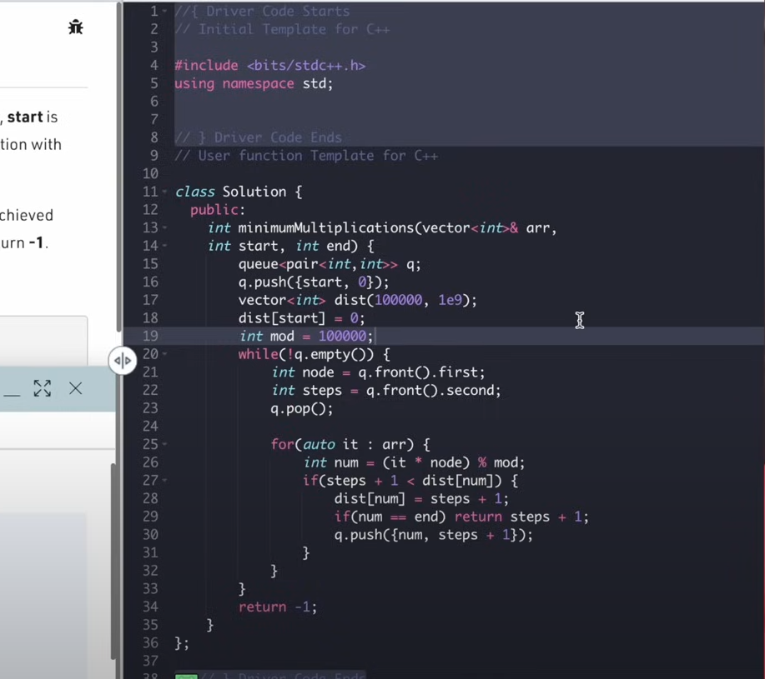

**Bellmann ford algorithm**

1. Dijkstras will fail if we have negative edges, Which will eventually fit to TLE.
2. Bellmann ford work only if we have directed edges. SO convert from undrected given to the directede then apply the bellammann ford algorithm.
3. This is mainly used detecting the negative cycyles in the graphs.
4. 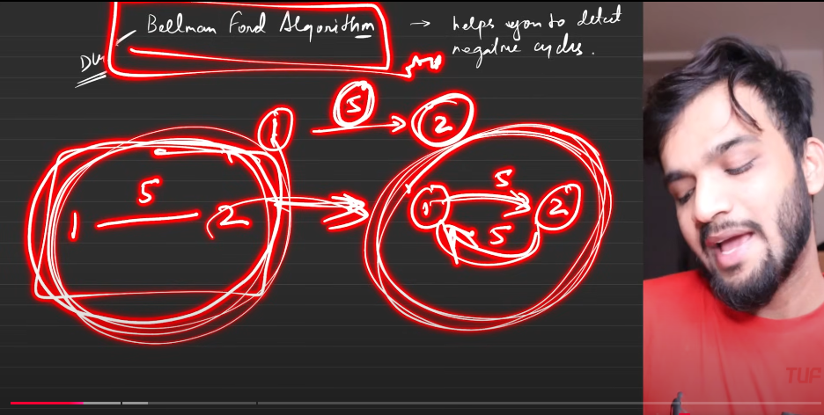
5. 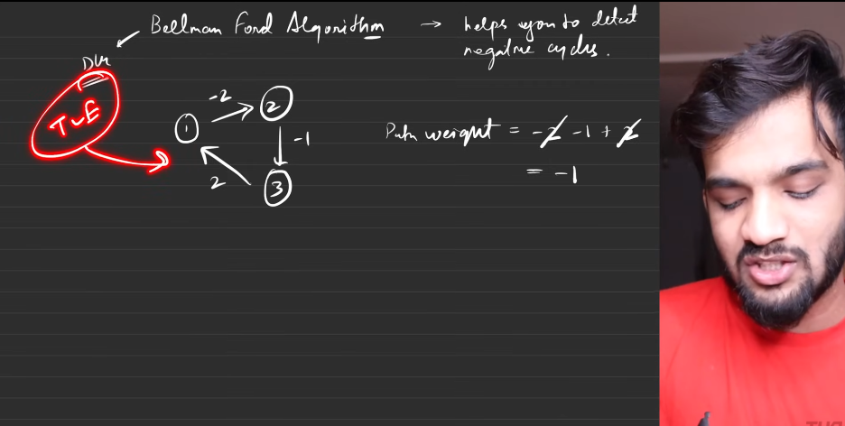
6. Dijsksras will go for TLE if the above is given.
7. 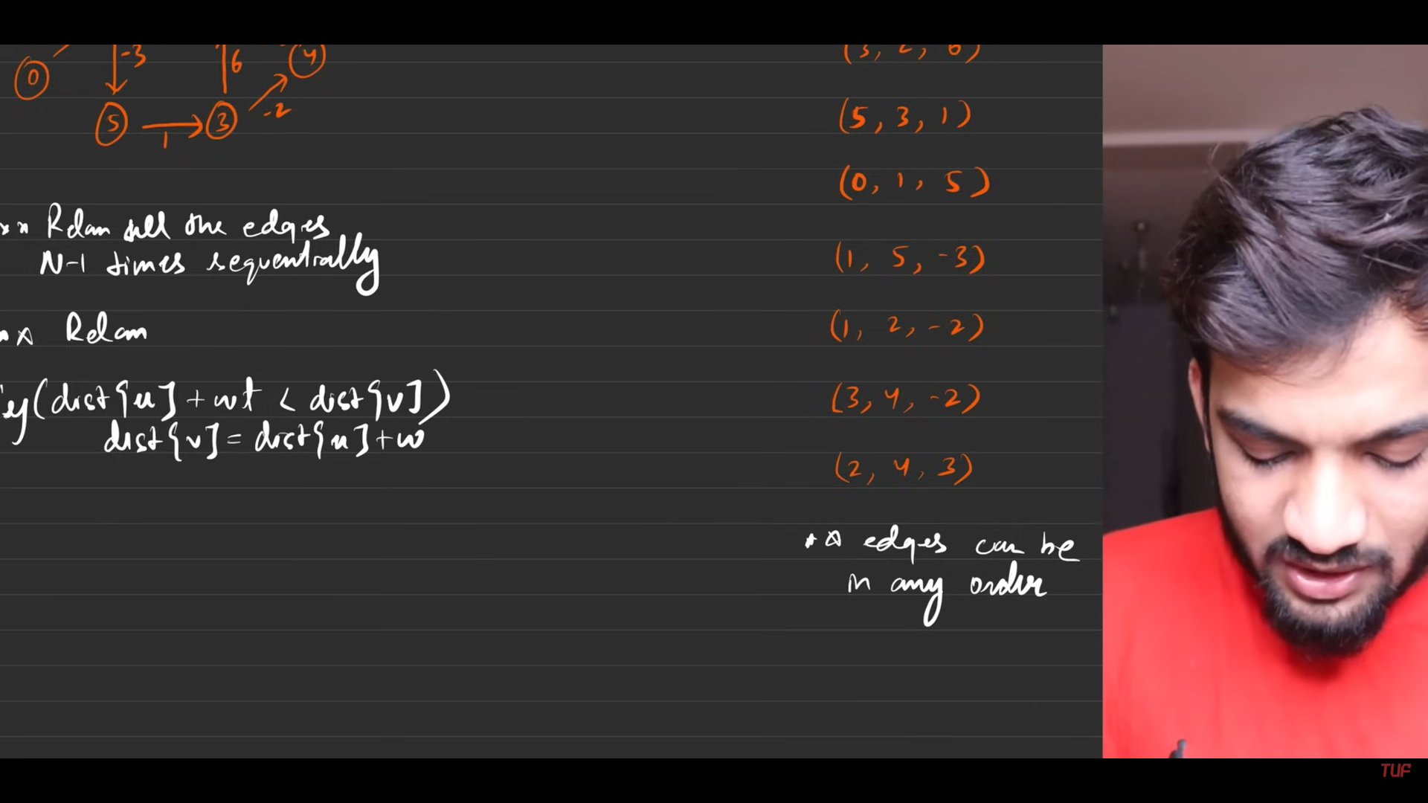
8. 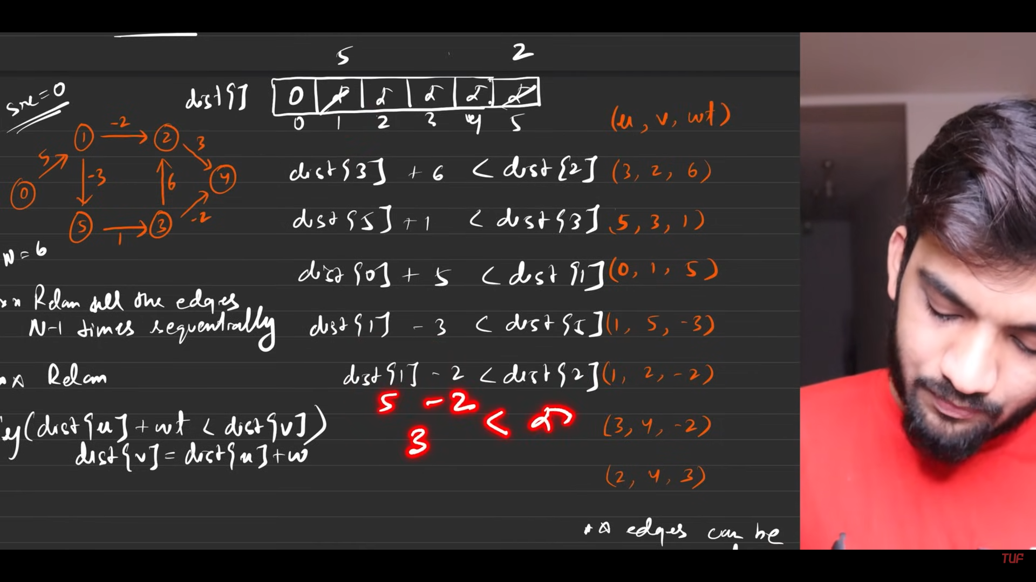
9. 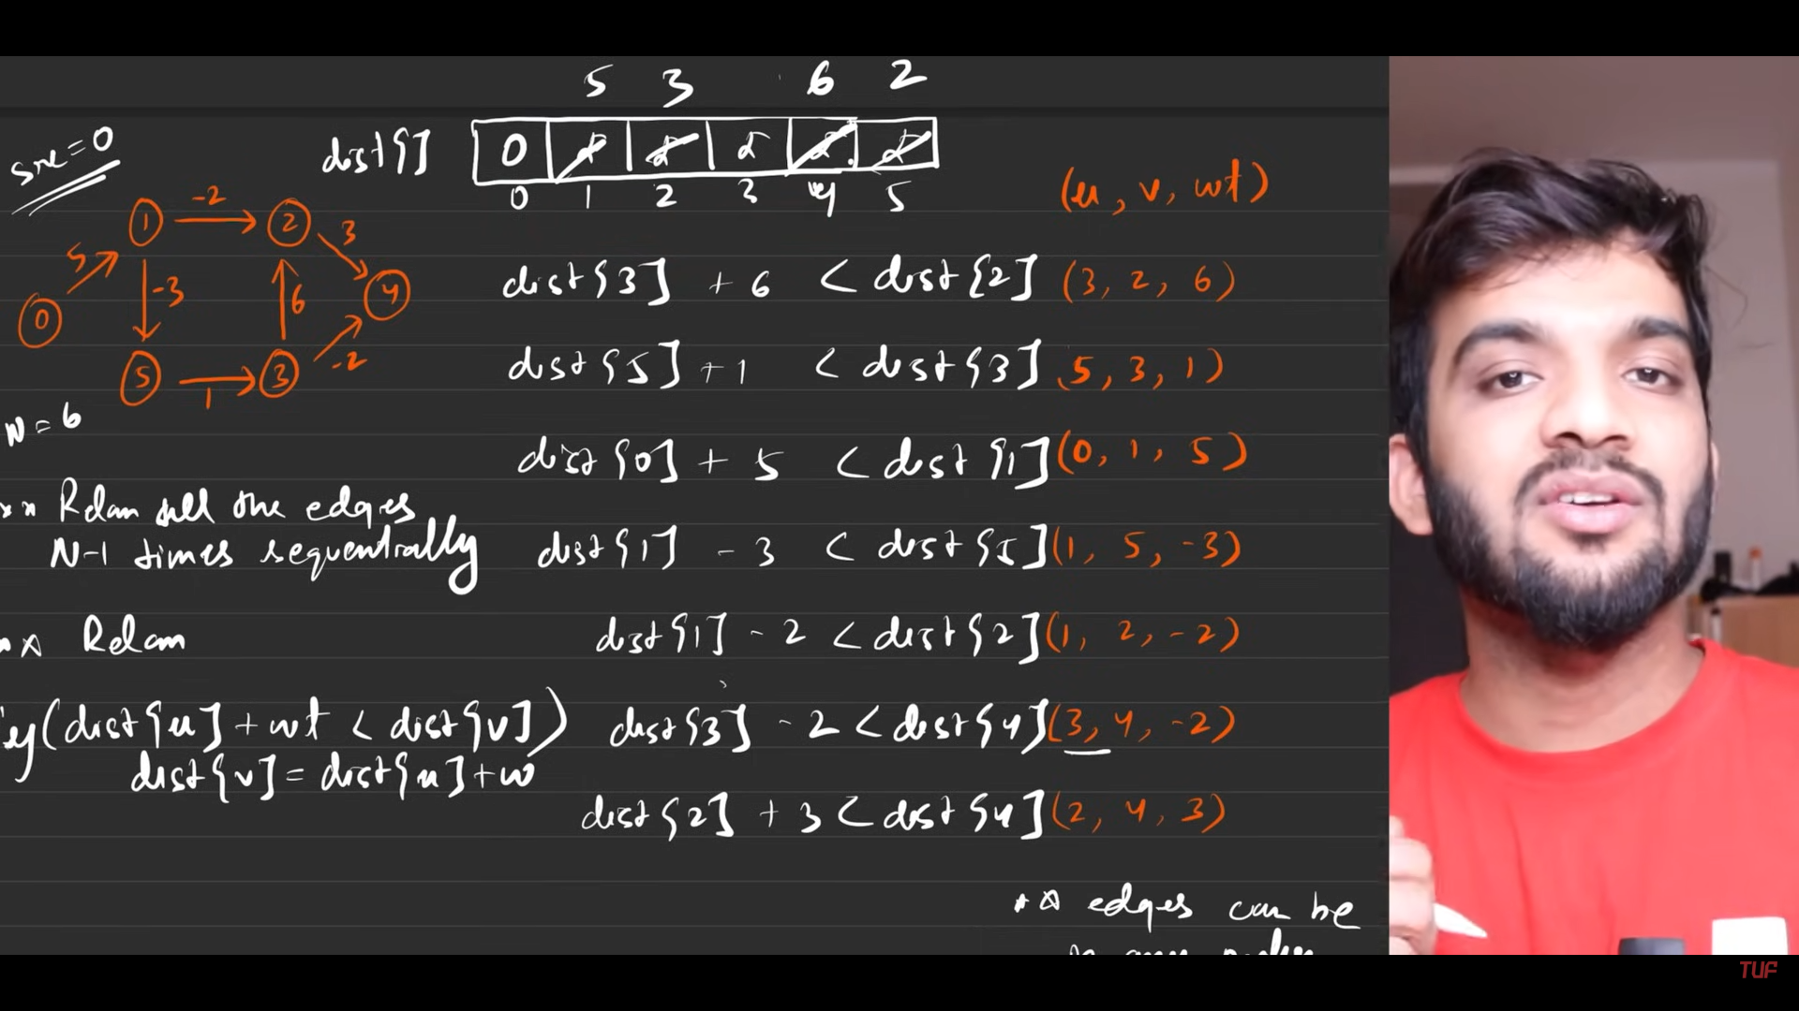
10. 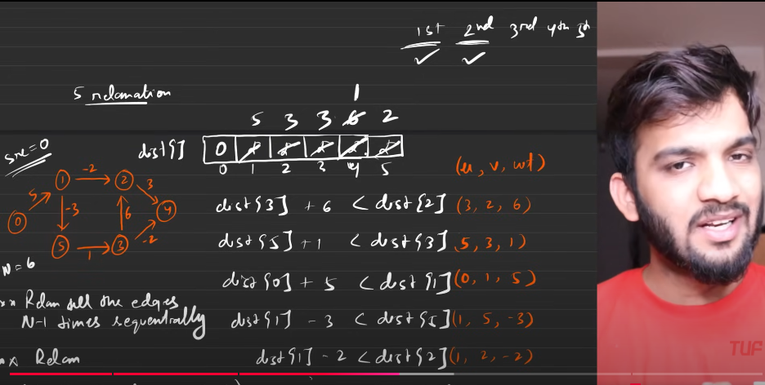
11. 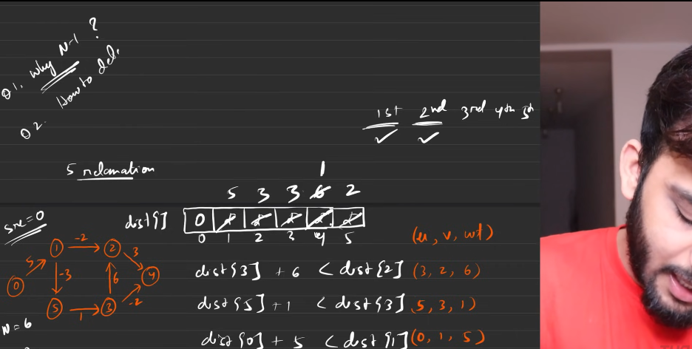
12. 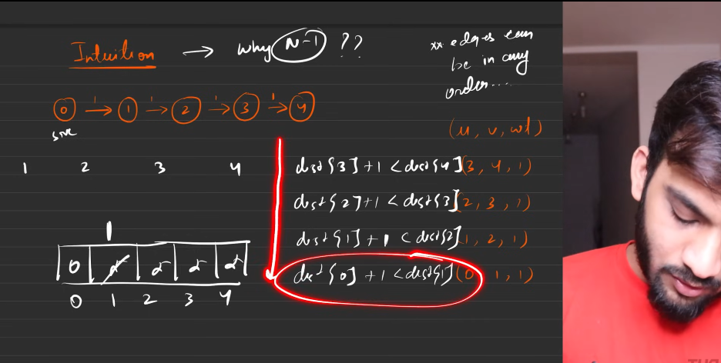
13. 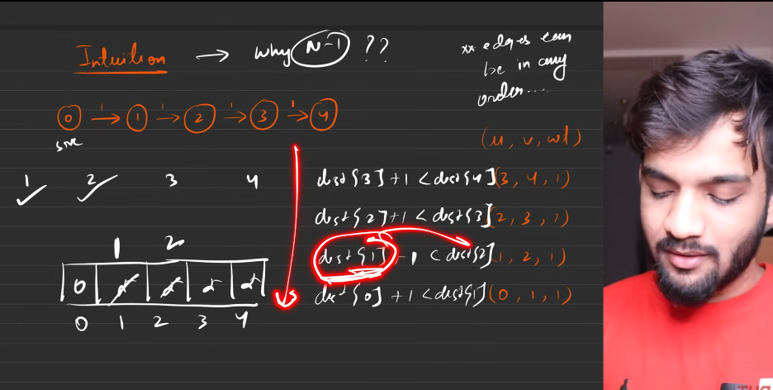
14. 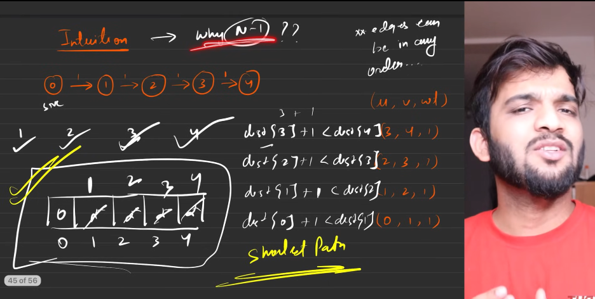
15. 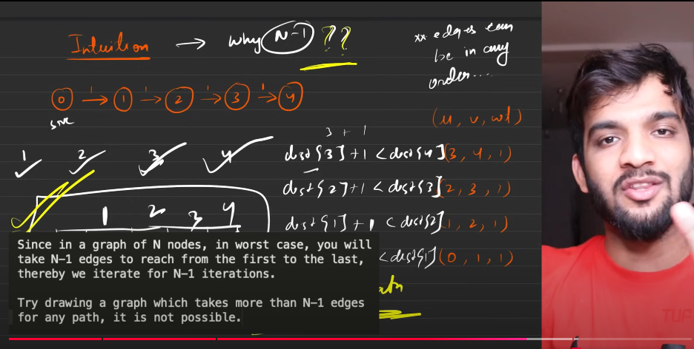
16. 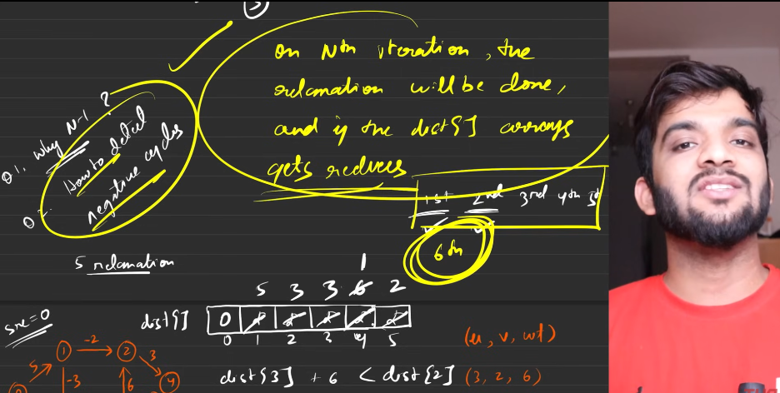
17. 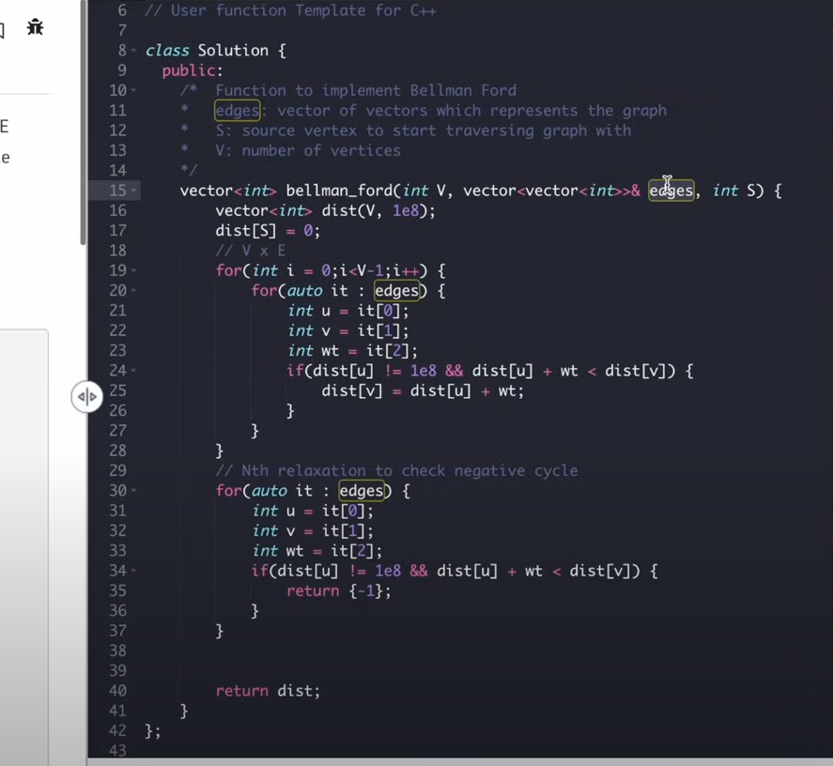
18. 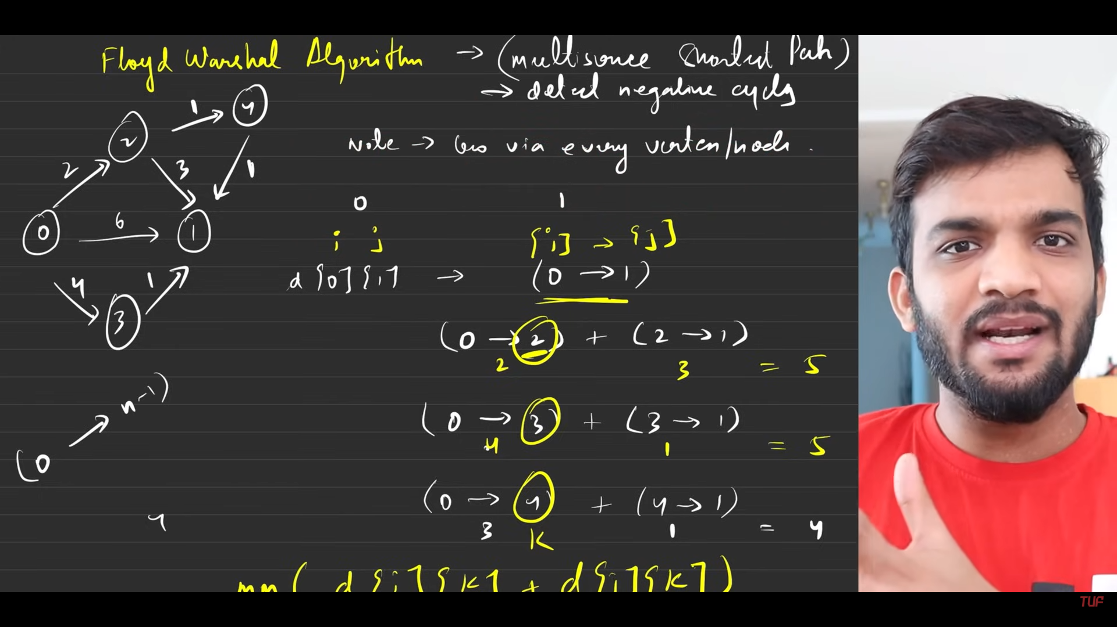
19. 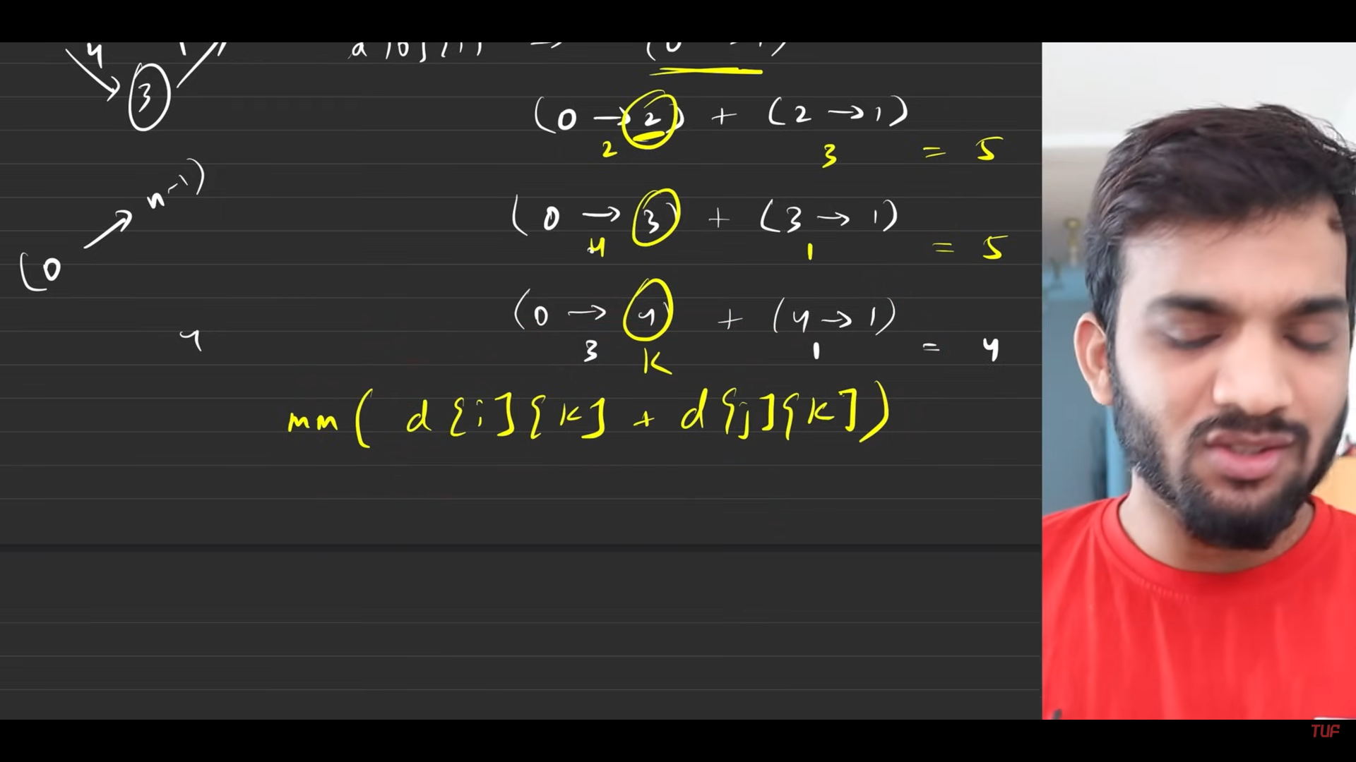
20. 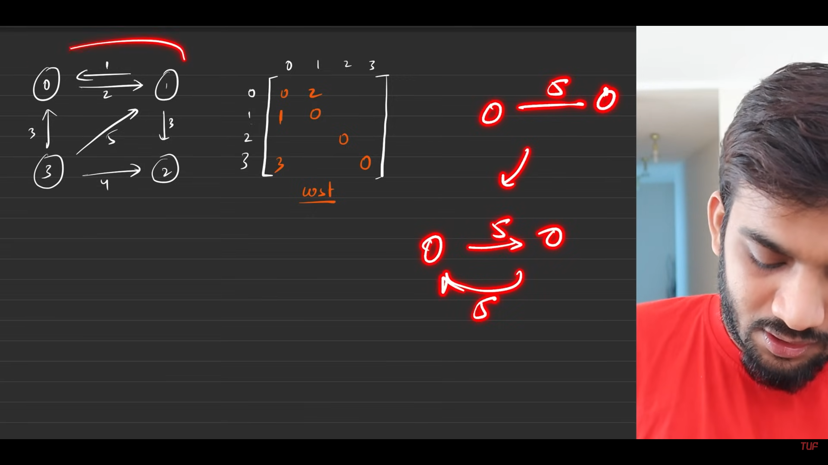
21. 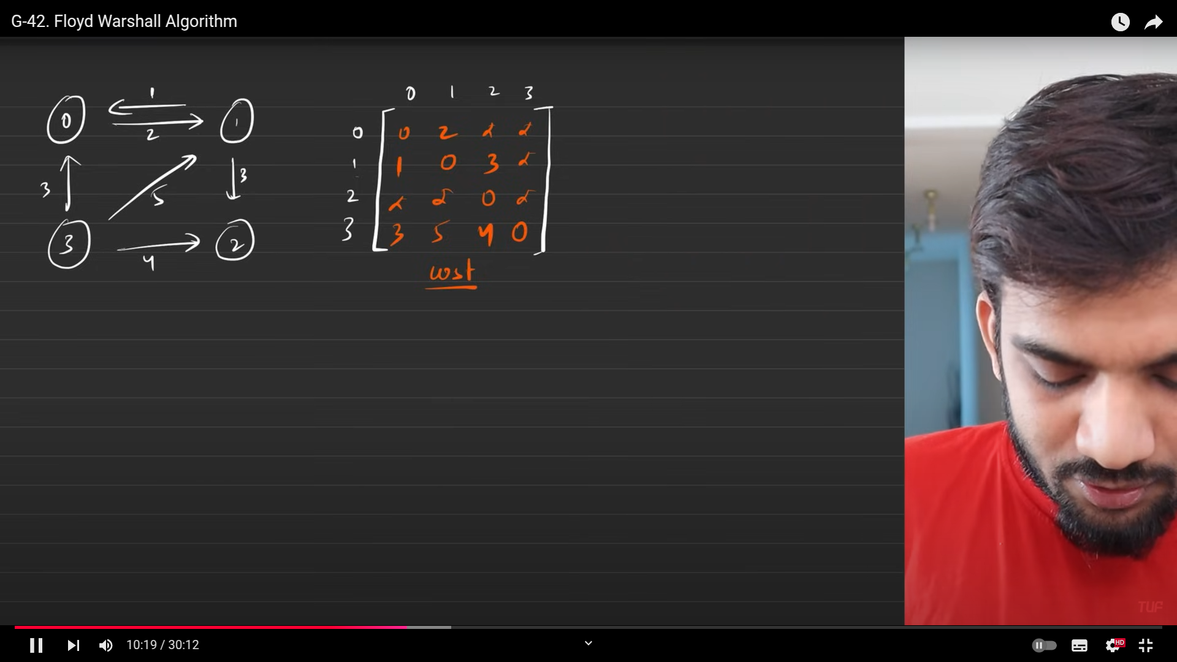
22. 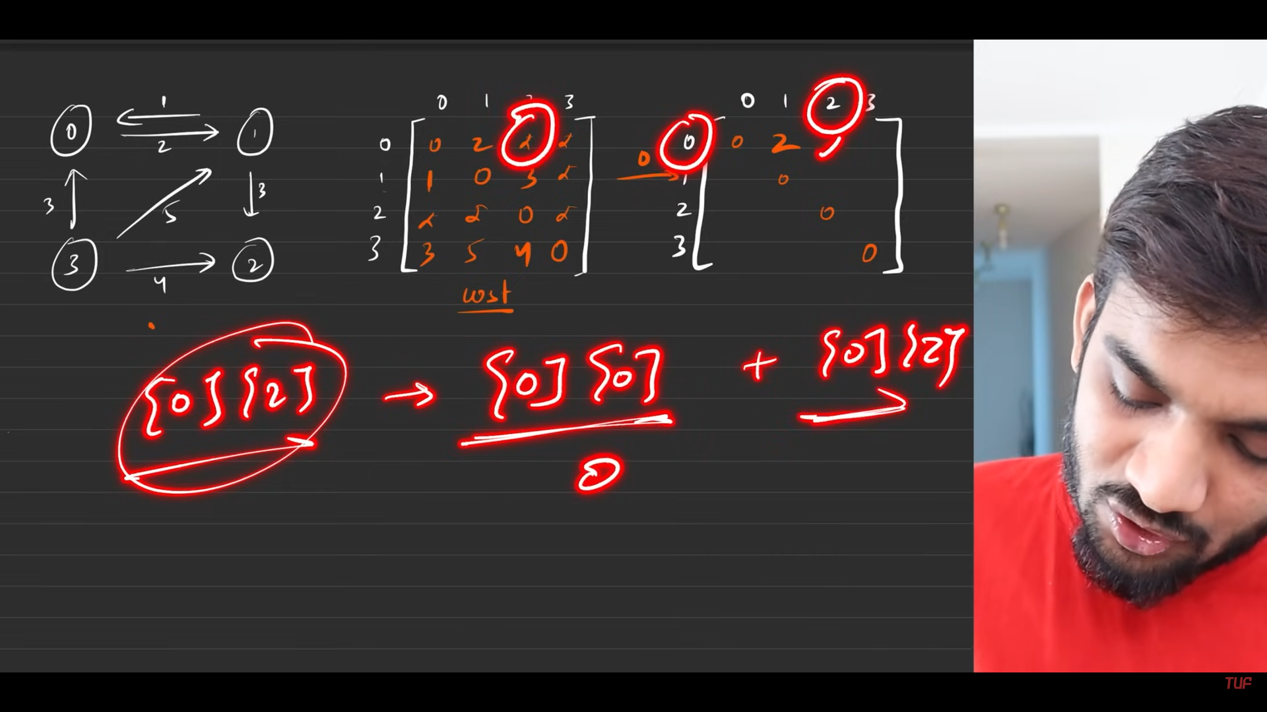
23. 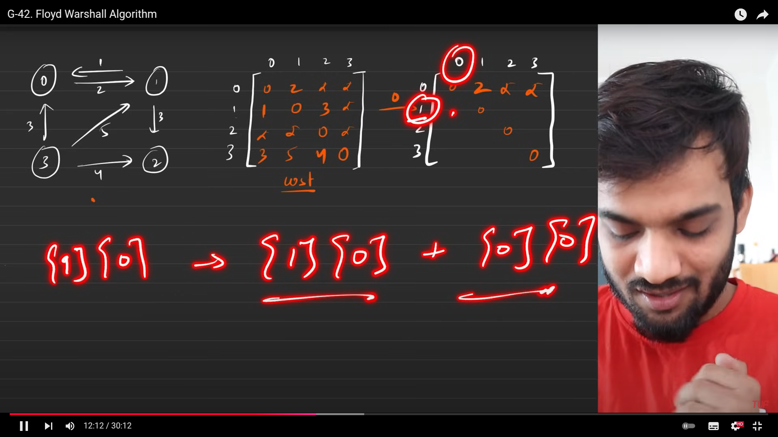
24. 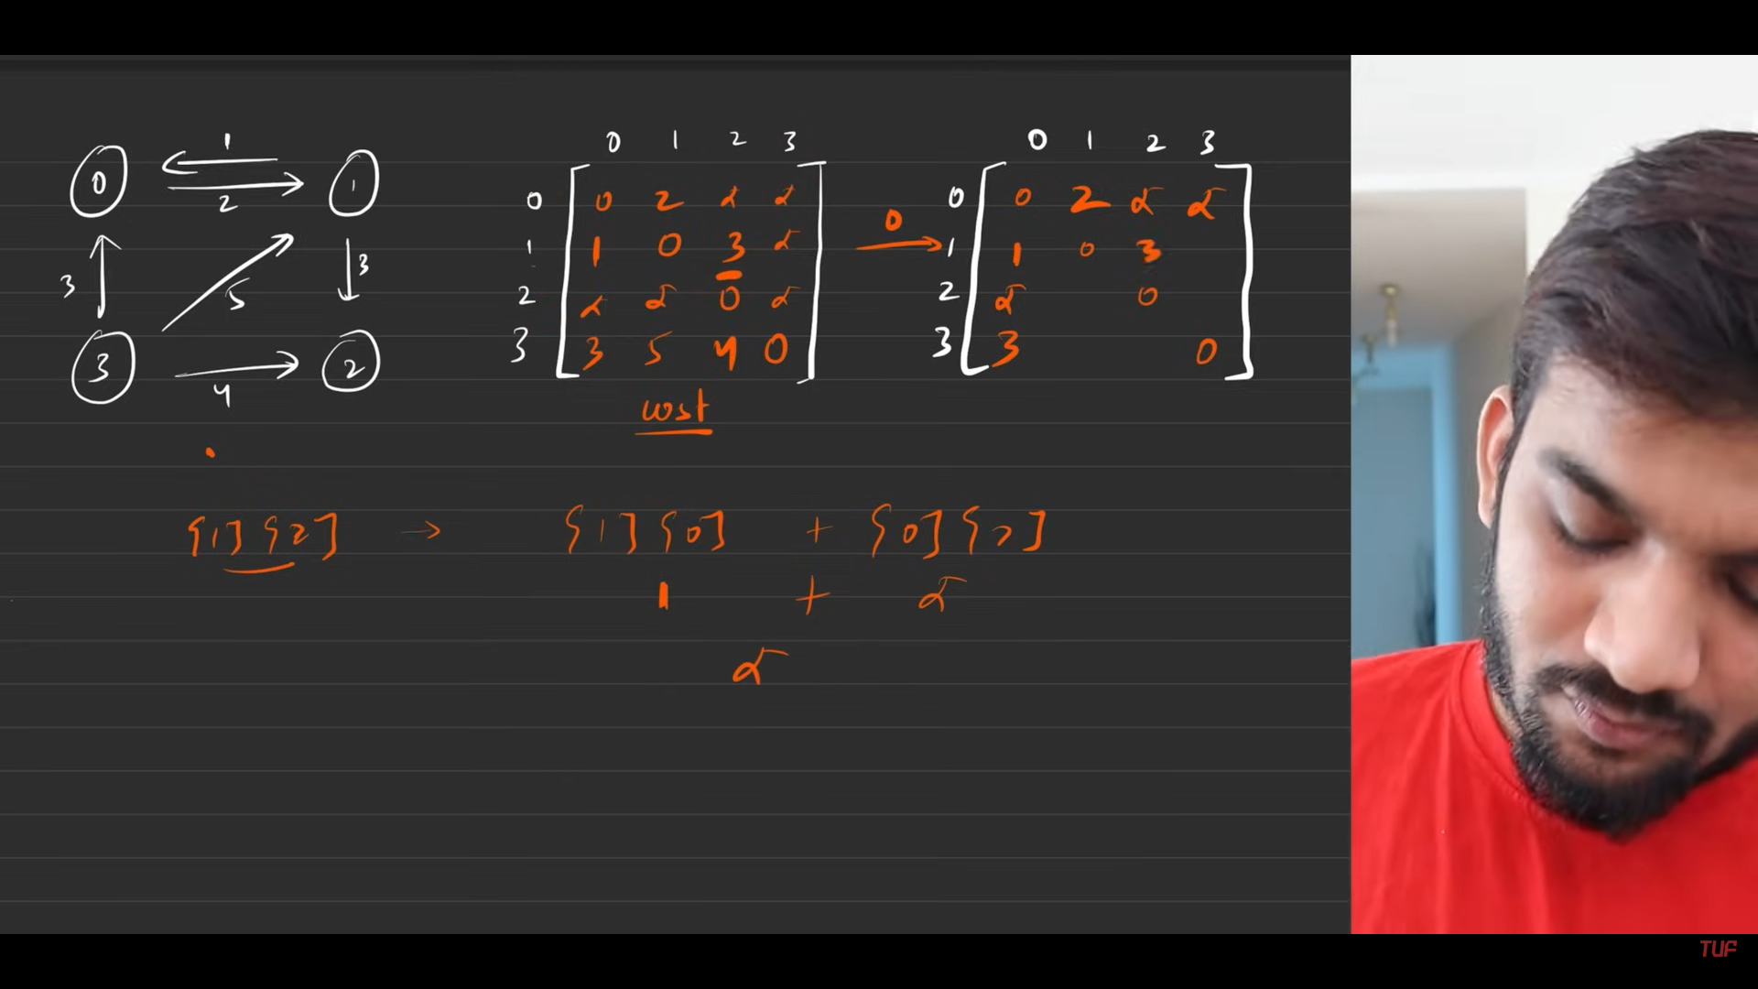
25. 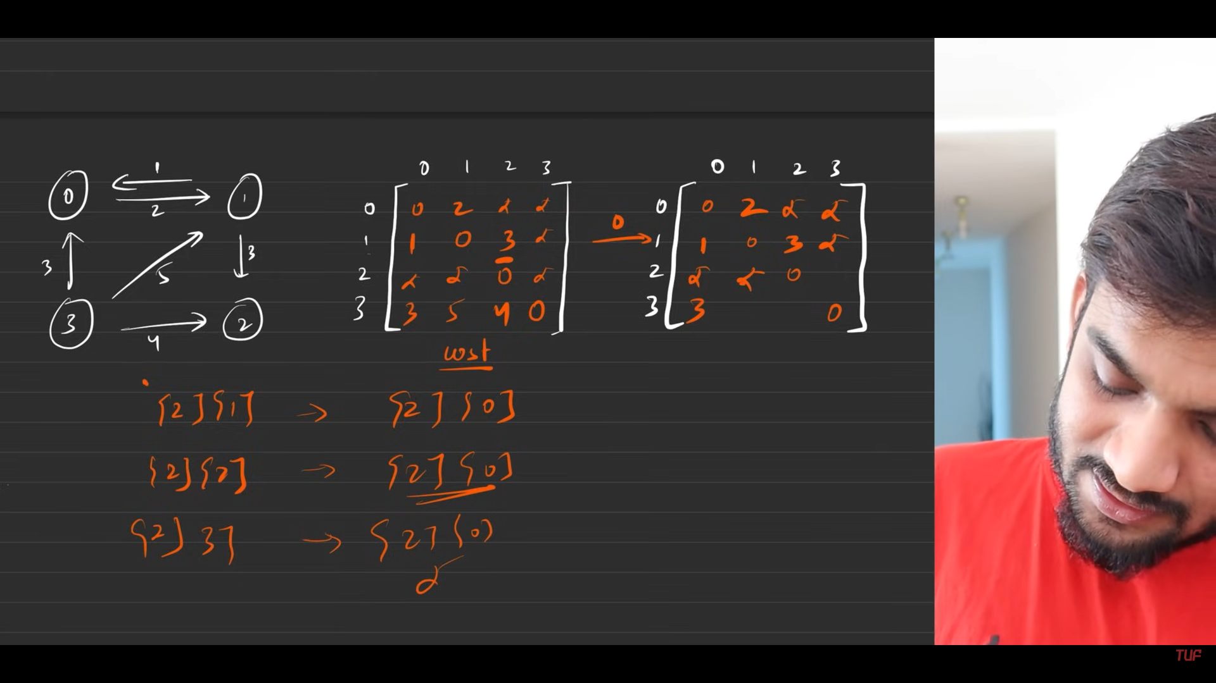
26. 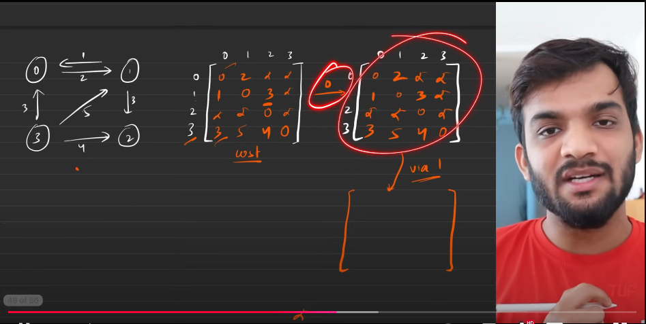
27. 
28. 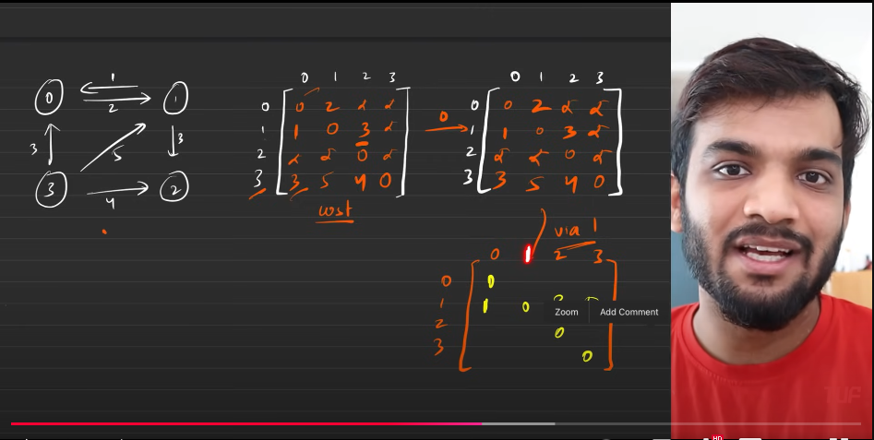
29. Algorithm:
    1. Initial configuarations:
       1. Given the graph, along with their weights.
       2. Start to prepare the matrix.
          1. Directed graph, matrix[u][v] = weight
          2. Undireccted graphs, the above + matrix[v][u] = weight.
          3. Both to be considered to be making the entry in the Matrix.
          4. The non given/ non reachble is to be considered as the hoghest value/ maximum value ie. 10^9 (1e9)
       3. PRoblem statement: all air shortest distance, the distance between every nodesmust be shortest. Using the precomputerd previous values in teh amtrix for the computations.
    2. 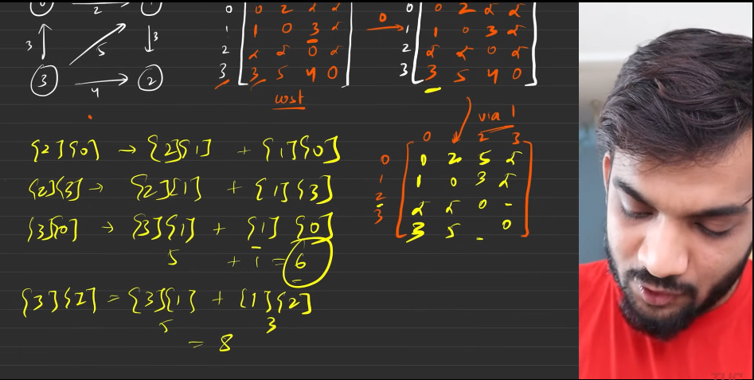
    3. 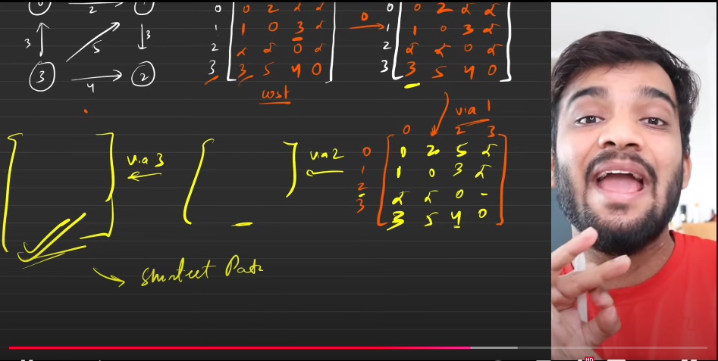
    4. 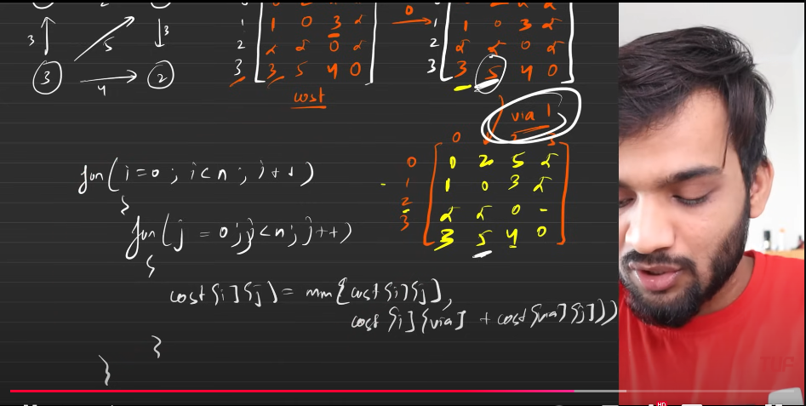
    5. 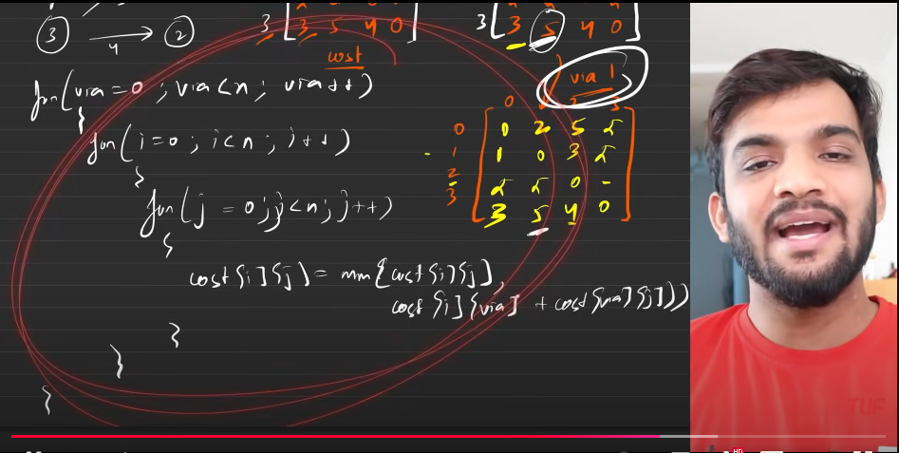
    6. 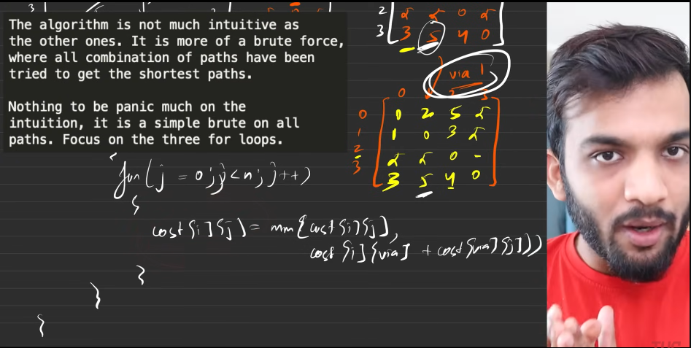
    7. 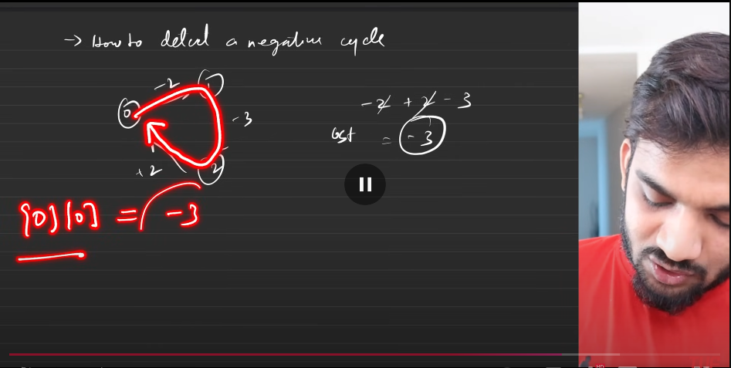
    8. 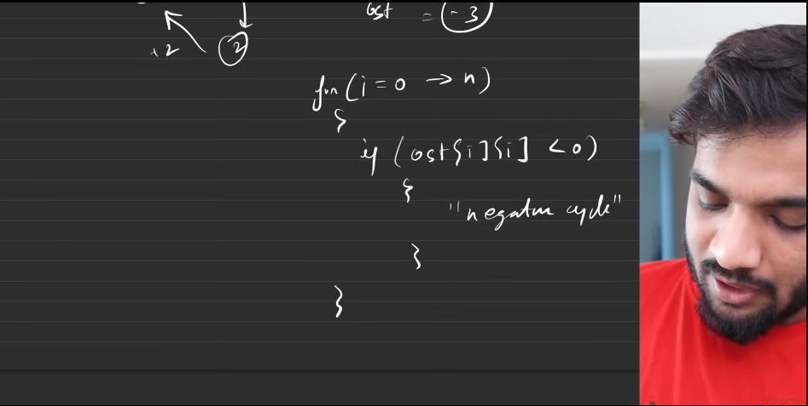
    9. 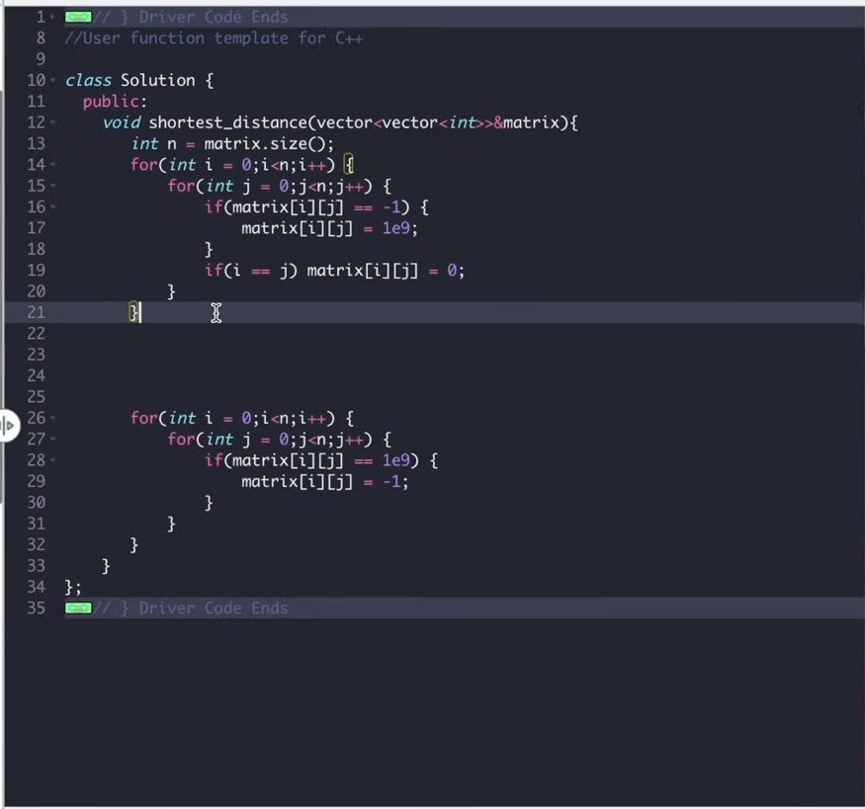
    10. The start is used for pre computation. The last is used for post computation.
    11. 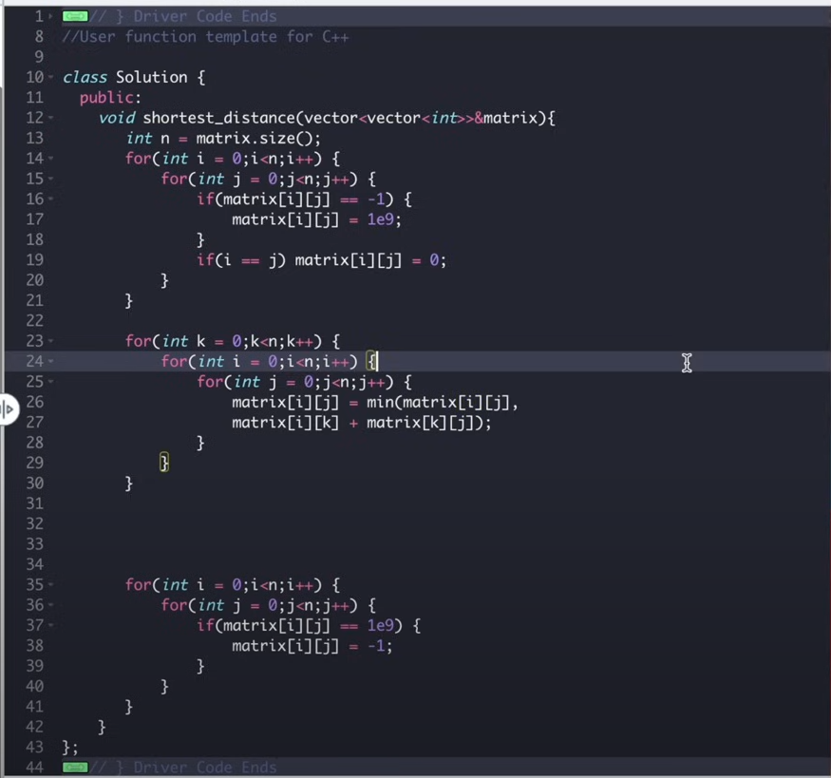
    12. Sc O(n^2) TC: O(n^3)
    13. If there is no negative cycles, then you can apply the dijkstras algorihm for every node, hence it is making the time comlexity. (N^2 \*logV)
    14. 
    15. Interview is always nothing but keeping more than what they ask, and only if you know about it.
30. s